2018年玉林市初中学业水平考试
英 语
本试卷共七大题。考试时间120分钟，满分120分。
注意事项：
1．本考卷分试题卷和答题卡。请将答案填写在答题卡上，在试题卷上作答无效。考试
结束后，将本试题卷和答题卡一并交回。
2．选择题：每小题选出答案后，请用2B铅笔把答题卡上对应题目的选项标号涂黑。
3．非选择题：请用直径0.5毫米黑色签字笔在答题卡上各题的答题区域内作答。
一、听力理解（共30分）
（一）听句子，选图画。（每小题1分，共5分）
你将听到5个句子。请根据所听到的内容，选出与句子内容相符的图画选项。每个句
子读一遍。
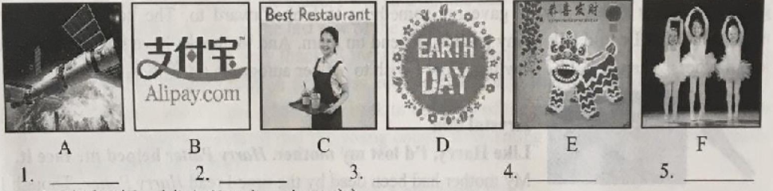
（二）对话理解。（每小题1分，共10分）
第一节：听下面五段短对话，每段对话后有一个小题，从题中所给的A、B、C三个选
项中选出最佳选项。每段对话仅读一遍。
6. Where are the two speakers?
A. In a restaurant. B. At a zoo. C. At a school.
7. What time of day is it?
A. It’s time for breakfast. B. It’s time for lunch. C. It’s time for bed.
8. How many languages are mentioned in the conversation?
A.One. B.Two. C.Three.
9. What will Kate do next?
A. She’ll read her e-mail. B. She’ll tell David a joke.
C. She’ll play computer games.
10. How much should the man pay?
A.$ 7. B.$24. C.$31.
第二节：听下面两段长对话，每段对话后有几个小题，从题中所给的A、B、C三个选
项中选出最佳选项。每段对话读两遍。
听第一段长对话，回答第11和第12小题。
11. When was Mark born?
A.In 2002. B.In 2003. C.In 2004.
12. How does the man like Dale?
A. Active. B.Serious. C.Funny.
听第二段长对话，回答第13、第14和第15小题。
13. Why does John feel so tired everyday?
A. Because of many tests. B.Because of his memories. C.Because of many activities.
14. What do Linda’s parents think of the activities?
A. It’s of great help to do them.
B. It’s a waste of time to do them.
C. It’s full of danger to do them.
15. What’s the probable relationship between the two speakers?
A. Classmates. B.Teacher and student. C.Husband and wife.
（三）短文理解。（每小题2分，共10分）
你将听到一篇短文。请根据所听到的短文内容，选择正确的答案。短文读两遍。
16. How long have the Smiths lived in the town?
A. For about 10 years. B.For about 15 years. C.For about 20 years.
17. The poor students often get____from the Smiths.
A. books and money B.food and books C. food and money
18. Why do friends like to visit the Smiths?
A. Because the Smiths are very rich.
B. Because the Smiths are very famous.
C. Because the Smiths are polite and kind to them.
19. When would the Smiths have their picnic?
A. On Friday. B.On Saturday. C.On Sunday.
20. What did Mrs. Smith’s last words really mean?
A. She didn’t like her friends any more.
B. She wished the visitors to leave right now.
C. She didn’t want her friends to come again.
（四）听短文，填信息。（每小题1分，共5分）
你将听到一篇短文。请根据所听到的内容，填入信息（每空一词）。短文读两遍。
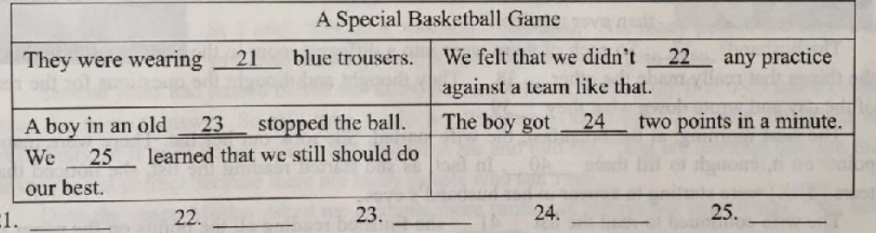
二、语言知识运用（共20分）
（一）单项选择（每小题1分，共10分）
26. —How often do you play tennis?
—Twice____week. AndI often play it in sports center in our schooL
A. the;／ B.a:an C.an； the D.a;the
27.—What would you like, meat or fish?
— . I prefer chicken.
A. Either B.Neither C.Both D.Each
28. —Lisa, how is your cousin?
—He is____now. Thank you.
A. more healthier B.much healthier C.very healthier D.healthiest
29. —Who got the First ever Friendship Medal(友谊勋章)of China?
—It’s Putin everybody knows so well in the world.
A. whom B.what C.which D.whose
30. —What do you know about the 2018 Russia FIFA World Cup?
—Oh, I only know that the last game on July 15.
A. was played B. is played C. will be played D. will play
31. —Hey, boys. Look at the falling .
—Well, it’s telling us that autumn is coming.
A.leaf B.leafs C.leafes D.leaves
32. —Mom, what does the word “attention”mean?
—Oh, my dear, you should the dictionary and then you will get the meaning.
A.look for B. look up C.look at D.look out
33. —Hello, Matt. How’s your life in Canada?
—I am used to it now. My host family always try their best to make feel at home.
A.me B.I C.my D.mine
34. —It’s said that the best way to relax is exercise.
—I see. But you should keep away dangerous sports.
A.with; from B. for; off C. through; from D. through; by
35. —Here are the jobs for you, young man.
—Thank you. Could I choose ?
A. what I like to do most
B. what I liked to do most
C. what do i like to do most
D. what did l like to do most
（二）完形填空（每小题1分，共10分）
阅读下面短文，掌握其大意，从各小题所给的A、B、C、D四个选项中选出最佳选项。
A wife came to her husband with a suggestion, “I read in an article on how to make our marriage（婚姻） stronger. I want each of us 36 a list of the things that make each other annoyed(令人恼怒的). Then, we can talk about how we can fix them together and make our lives happier than ever together.”
The husband 37 . So each of them went into a different room in the house and thought of the things that really made the other 38 . They thought and thought the questions for the rest of the day and wrote down what they 39 .
The next morning, at the breakfast, the wife started. She took out her list. There were many
points on it, enough to fill three 40 . In fact, as she started reading the list, she noticed that
tears（泪水） were starting to appear in her husband’s eyes,
The wife continued to read the list 41 she finished reading all the points on the paper to her husband. Then she placed her list on the table and put her hands over the top of it.
It’s time for her husband to read his list, But 42 the husband said, “I don’t have anything on my list. I think you are 43 .I don’t want you to change anything about you.”
The woman 44 by her husband’s words and began to cry.
In life, 45 we are disappointed, angry and sad, we shouldn’t lose heart because we always have wonderful time that it is full of beauty, light and happiness. Why waste time looking for the bad, disappointing things? Why not enjoy the wonderful things around us?
36.A.write B.writes C.writing D.towrite
37. A. agreed B. disagreed C. left D. disappeared
38.A.happy B.angry C.scary D.silly
39. A. dealt with B. began with C. came up with D. played with
40.A.baskets B.pages C.bottles D.bags
41.A.although B.unless C.until D.if
42. A. gradually B. quietly C. completely D. heavily
43. A. perfect B. lonely C. awful D. nervous
44. A. was beaten B. was hurt C. was cheated D.was moved
45.A. whoever B. whatever C. whenever D. where
三、阅读理解（共30分）
阅读下面A、B、C、D四部分信息或短文，根据信息或短文内容，从下列各小题所给
的A、B、C、D四个选项中，选出最佳答案。（每小题2分，共30分）
A
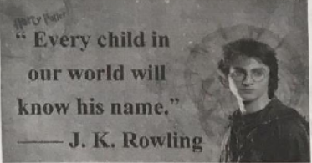
We all know that his name is Harry Potter.
And we all know that Harry Potter written by J.K. Rowling
has influenced the lives of its readers.
Here are some fans’ stories about the influence of the books on them.

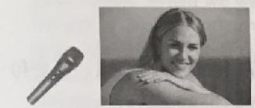
Melanie Martin
I was lonely, and Harry Potter helped me get better.
When I was 16, my family moved away to a foreign country. I lived with my uncle and his family. At that time, I was lonely. Times were grey, but Harry Potter always gave me something to look forward to. The books helped me understand that I could talk to my friends, depend on them. And the books have taught us to care about others. Thanks to J.K. Rowling. How I wish to get her autograph（亲笔签名） !
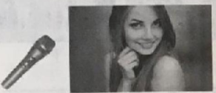
Krystal Sim
Like Harry, I’d lost my mother. Harry Potter helped me face it.
My mother had been dead by the time I read Harry Potter. Though I was an 11-year-old girl, I understood a little of how Harry felt, I remember staying up to read it through the night and ending up crying as Lily Potter, Harry’s mother, said to him—“You’ve been so brave.” Those are the kind of words you want to hear when you’ve lost a parent. They hit your heart sometimes, in the most beautiful way. I think I can be a lot stronger than before.

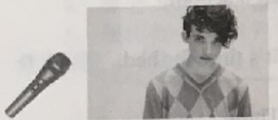
Matthew Lawrence
I didn’t want to read, until my friends told me about a wizard (魔法师) called Harry.
I didn’t like reading until I heard a lot of my friends reading Harry Potter. I read it from the first page to the last page. As Harry, Hermione and Ron grew up, I grew up, too. Harry Potter showed me that reading could be enjoyable. It changed my life because it led me to love reading.
46. Who will probably ask for J.K, Rowling’s autograph according to the passage?
A. Melanie Martin. B. Krystal Sim. C. Lily Potter. D. Matthew Lawrence.
47. Which of the following is TRUE in the passage?
A. Melanie Martin and Harry Potter both lost their mothers.
B. Matthew Lawrence always wanted to read with his friends.
C. Krystal Sim was 11 when her family moved to a foreign country.
D. Harry, Hermione and Ron might be the characters in Hany Potter.
48. What is the best title for the passage?
A. How to read Harry Potter B. How Harry Potter Changed My Life
C. Reading Harry Potter Is Enjoyable D. Every Child Knows Harry Potter
B
Recently, my husband and I had the chance to do something good for two people who were complete strangers to us. It made us feel so good to be able to do it that I thought I should share, We were traveling to Thailand on New Year’s Day with our family. Since I travel a lot for work, we have had enough flying miles to become the VIP (very important person. ) of the flight to enjoy first class（头等舱） seats.
As we were sitting in the very first two seats in the first row of first class waiting for the plane to take off, I heard one of the flight attendants (航班服务员) telling the others that there was a young couple sitting in the back of the plane that had just been married several days before and
were going on their honeymoon(蜜月). They had ordered their flight eight months before but, for
some reason, had not been able to get seats together. No one else on the plane wanted to move and
the bride(新娘) was in tears.
I turned to my husband and told him what I heard. We agreed without thinking twice and I
called the flight attendant over to tell her that we would be happy to give up our seats for this
young couple, The flight attendant seemed shocked and amazed and said. “Really? Are you sure?”
We said. “Sure!”
So, we moved to the back of the plane, I was in a middle seat in the back part and my husband,
who is 63, in the window seat of the last row of the plane.
The flight attendants were very thankful for what we had done and cared for us carefully even though we were no longer sitting in first class, and we both made friends with the people sitting
around us and had a great flight. I had to go back to the front of the plane to get a forgotten object
back during the flight and noticed that the young couple were sitting very close together, happily
sipping champagne (品尝香槟)．
It really made my New Year to get on to such a wonderful start!
49. When did the writer travel to Thailand?
A. On the first day of April. B. On the first day of January.
C. On the first day of March. D。 On the first day of February.
50. Why could the writer get the first class seats?
A. Because she was old. B. Because she was sick.
C. Because she often traveled. D. Because she had much money.
51. Where did the writer sit at last?
A.In the first row. B. In a middle seat.
C. In the last row. D. In the window seat.
52. What’s the passage mainly about?
A. A young couple gave their seats to the old.
B. The flight attendants helped the old couple.
C. All the passengers helped the young couple.
D. An old couple offered their seats to the strangers.
C

Do you know what makes lightning（闪电）?Why does lightning strike（击打）?
Lightning strikes happen when ice and water in clouds rub（摩擦）together, and cause atmospheric（大气层的）changes. When this happens, it creates a static charge（静电）．Lightning can strike inside the cloud, between two clouds or between a cloud and Earth. It’s the last kind of strike that is the most dangerous for humans.
Lightning can be very dangerous. Every year, lightning kills people because it can start big
fires or because it reaches a temperature of 28, 000 C. About l, 000 people are hit by lightning every year in the United States, and about 100 of them die as a result.
Lightning makes people shocked, and it happens all over the world! Scientists think that there are more than three million lightning strikes every day in the world—that’s thirty strikes every second（秒）. An American mant Roy Sullivan, who worked in a park, survived from the most lightning strikes. Between 1942 and 1983, he was hit seven times! And he keeps the highest world record.
Lightning is sure not something to play with. When lightning strikes, it’s best to stay inside a
large building. To stay safe, do not stand under trees, on hills or near water. Also, do not lie down
on the ground, or the electricity may go through you and cause a heart problem.
53. Lightning strikes .
A. happen thirty times each day B. happen when there are big fires
C. can reach a very high temperature D. can kill all those who work in a park
54. What does the underlined word “ survived” mean in Chinese?
A. 幸存 B. 选择 C. 遇难 D. 失忆
55. How many people hit by lightning die every year in America?
A. About 1000 people. B. About 28,000 people.
C. About one tenth of people. D. About one fourth of people.
56. Where’s the safest place to stay when lightning strikes?
A. Under a tree. B. Near a river.
C. On the top of a hill. D. Inside a building.

D
My mother used to ask me what was the most important part of the body. Through the years I would guess at what I thought was the correct answer.
When I was younger, I thought sound was very important to us as humans. So I said, “My ears, Mommy.” She said, “No, many people are deaf. But you keep thinking about it and I will ask you again soon.”
Several years had passed before she asked me again, Since making my first try, I had thought
over the correct answer. So this time I told her, “Mommy, sight（视力） is very important to everybody, so it must be our eyes.” She looked at me and told me. “You are learning fast, but the
answer is not correct because there are many people who can’t see.”
Over the years, Mother asked me a couple more times and always her answer was, “No, but
you are getting smarter every year, my boy.”
Then last year, my grandpa died. Everybody was hurt. Everybody was crying at the funeral
(葬礼). My mom looked at me when it was our turn to say our final goodbye to grandpa. She asked me, “Do you know the most important body part yet, my dear?”
I was shocked when she asked me this now. I always thought this was a game between her
and me. She saw the confusion (团惑) on my face and told me, “This question is very important. It shows that you have really lived your life.” I saw her eyes in tears.
She said, “My dear, the most important body part is your shoulder.”
I asked, “Is it because it holds up(抬起) your head ?”
She replied, “No, it is because it can hold the head of a friend or a loved one when they cry. Everybody requires a shoulder to cry on sometimes in life, my dear. I only hope that you have enough love and friends that you will have a shoulder to cry on when you require it.”
Then and there I knew the most important body part is not a selfish (白私的) one. It is
Sympathetic (体谅的) to the pain of others.
57. Why did the writer first think “ears” were the most important part ofbody? Becausc he thought
that sound .
A. was sweet to hear B. was important to humans
C. can be heard by people D. can pass through quickly
58. What happened to the writer’s family last year in the passage?
A. His grandpa died. B. His mother left home.
C. His house was burnt. D.His father was hurt.
59. Where did the writer get the correct answer from his mother?
A, At home. B. At the school. C. At the funeral. D. At the station.
60. What can we leam from the passage?
A. We should often cry in life. B. We should hold up our head high.
C. We should listen to our mothers’ words. D. We should learn to understand other’s pain.
四、情景交际（每小题1分，共5分）
从方框中选择恰当的句子补全下面对话。(其中有两项是多余选项)
W: Good morning, Jack! You look so sleepy today! What’s wrong?
M: Em...I stayed up late last night.
W: Why? It was Friday. 61
M: No, I weren’t. I just watched the news on CCTV And I was too excited to fall asleep.
W: Oh? 62
M: Of course, the SCO summit (上合峰会) will begin in Qin Dao in June, 2018.

W: What is it about?
M: 63
w: So it’s the main event of 2018.
M: I think so.
W: Do you often watch CCTV news?
M: Yeah, I watch it almost every weekend. What about you?
W: Seldom. 64
M: That’s not good. 65
W: You’re right, and maybe I should spend some time on it.
M: I think you should at least have a try,
W: All right!
A. Did you read the news on the Internet?
B. The safety, travel, culture around the world,
C. Anything important?
D. What kind of TV shows do you like?
E. Were you still busy with your homework?
F, If so, you don’t know what is going on in the world.
G. I have little time to care about it.

61. 62. 63. 64. 65.
五、语法填空（每小题1分，共10分）
阅读下面短文，在空白处填入1个适当的单词或括号内单词的正确形式。
Let’s share this article about the importance of family in our life. As soon as the man goes into the world, the first persons he meets are his family 66 (member). The first person is the mother who has taken great pain to bring him to this 67 (beauty) world. Then is his father who is always there to look 68 him. Then come the brothers or sisters.
Family is the first place for a person 69 (learn) things in this world. He learns everything from his family from baby time till old age, He sees his family walking and then he tries to follow them. He sees his family talking and then he tries to repeat the words. He also 70 (slow) learns the basic communication among the people in the family. He learns how to love, 71 to do, when to go to bed, and how to get on with others well. This develops a kind of love among all family.
The family works like a chain. You know, kids know 72 (little) than other people, so they should learn from elders while elders depend on 73 (they) kids for a lot of things. When kids grow up, get married, have children, the circle repeats again. Your family always come to your help when you are in trouble. They always support you in different ways 74 it is on money or just on spirit. You can always share your problems with the family, and you always find a better way to solve your problems after 75 (discuss) them in the house.
Considering all these things, we can say family is one of the greatest gifts that God sends us.
66. 67. 68. 69. 70.
71. 72. 73. 74. 75.
六、短文改错（每小题1分，共10分）
此题要求改正所给短文中的错误。对标有题号的每一行做出判断：如无错误，在该行
右边横线上画一个勾(√)：如有错误（每行只有一个错误），则按下列情况改正：
此行多一个词：把多余的词用斜线(＼)划掉，在该行右边横线上写出该词，并也用
斜线划掉。
此行缺一个词：在缺词处加一个漏字符号(^)，在该行右边横线上写出该加的词。
此行错一个词：在错的词下划一横线，在该行右边横线上写出改正后的词。
注意：原行没有错的不要改。
My sister is one of a best friends of mine. We haven’t always been 76.
good friends. When we were younger, she always fights with me. 77.
We didn’t like each other very much but we would argue about everything. 78.
When she moved out of our parents house and got married, we became 79.
friends. She’s three years old than I am, but it doesn’t matter. Every 80.
moming we talk on the phone. She tells me what she’s going to do for 81.
the day and I tell her about my plans. She always gives me good advices. 82.
She’s having a baby in next month and I’m really excited. I’m going to 83.
be an aunt. My sister wants me totake care the baby for her.I can’t wait. 84.
I will take all the things that I want to do with the baby serious. 85.
七、书面表达（共15分）
假如你叫李涛，是一名初中学生。你的英国笔友Tom很想了解中国优秀传统文化，恰
辑你校暑假将举办中国传统文化展(The Traditional Chinese Culture Fair)。请你给Tom写一
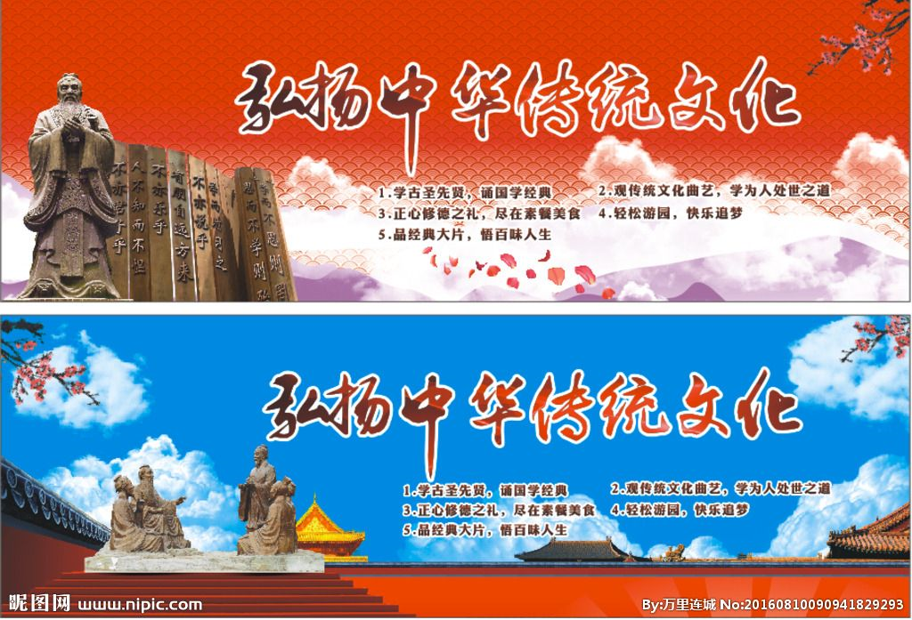
封电子邮件，邀请他参加。
内容要点：
1.展会目的：使更多人了解中国传统文化；
2.展会时间：2018年7月15日；
3.展会地点：学校艺术中心；
4.参会人员：全体师生、家长以及其他有兴趣的人：
5.展出内容：相关书籍、图片、录像。
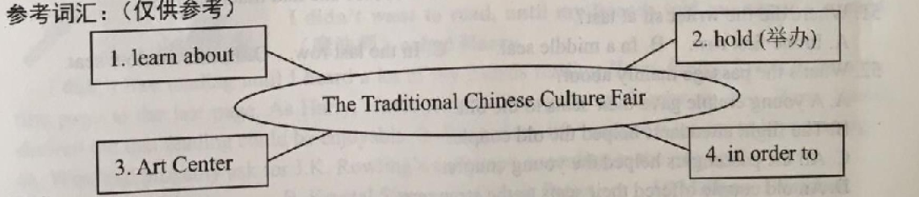
要求：
1.包括所有内容要点，不要逐句翻译，可以适当发挥。
2. 80词左右，语句通顺，语法正确。（开头和结尾己给出，不计入总词数）
3.文中不得出现考生真实的姓名、地点和所在的学校名称。
Dear Tom,
How’s it going?

Looking forward to your coming.
Yours,
Li Tao

