邵阳市2018年初中毕业学业考试试题卷
英 语
温馨提示：
1.本学科试卷分试题卷和答题卡两部分，考试时量为90分钟，满分为120分;
2.请你将姓名、准考证号等相关信息按要求填涂在答题卡上;
3.请你在答题卡上作答，答在本试题卷上无效。

Ⅰ. 听力技能（三部分，共20小题，计25分）
A）反应 根据你所听到的内容，选择正确答语完成对话。（共5小题，每小题1分）
1. A. Nice to meet you, too. B. Good afternoon. C. I’m OK.
2. A. Beautiful. B. Spring C. Ten kilometers.
3. A. Ten days. B. Once a week. C. From Monday.
4. A. I don’t agree. B. I have a headache. C. It doesn’t matter.
5. A. Don’t worry. B. Not at all. C. Good idea.
B）理解 根据你所听到的对话，选择最佳答案回答问题。（共10小题，每小题1分）
听下面的对话，回答第6至7小题。
6. Where does Chen Lin’s uncle work?
A. In a factory. B. In a school. C. In a hospital.
7. How does Chen Lin’s uncle go to work?
A. By car. B. On foot. C. By bus.
听下面的对话，回答第8至9小题。
8. What day is it today?
A. Women’s Day. B. Mother ’s Day. C. May Day.
9. What has Lucy bought for her mom?
A. A black dress. B. A blue dress. C. A cake.
听下面的对话，回答第10至12小题。
10. What did Mary do yesterday?
A. She made an apple milk shake.
B. She made a banana milk shake.
C. She made an orange milk shake.
11. Who taught Mary to make it?
A. Her brother. B. Her mother. C. Her father.
12. How much milk do they need?
A. A cup of milk. B. Two cups of milk. C. Three cups of milk.
听下面的对话，回答第13至15小题。
13. What did Zhang Lan do last weekend?
A. She stayed at home. B. She went hiking. C. She visited her aunt.
14. What did Li Hua do on Saturday morning ?
A. He played soccer ball. B. He played basketball . C. He played volleyball.
15. Are they students?
A. Yes, they are. B. No, they aren’t. C. I don’t know.
C）听写 根据你所听到的内容，填写下面的表格。每空不超过3个单词（共5小题，每小题2分）
Fantastic Summer Camp
How long to stay | 16.
Where to camp | In a small 17.
What to eat | Special local food
What activities to do | In the morning | Learn how to 18.  Learn how to make works of art
What activities to do | In the afternoon | Ride bikes around the lake  19. in the lake
What activities to do | 20. | Have a party

Ⅱ. 知识运用（两部分，共20小题，每小题1分，计20分）
A）语法填空 从A、B、C三个选项中选择最佳答案填空。（共10小题，每小题1分）
21. – Is this your English book?
–No, it’s my brother’s. is over there.
A. Mine B. My C. Me
22. My daughter is years old. Today is her birthday.
A. nine; nineth B. nine; ninth C. ninth; nine
23. – Where is Jim?
–Look! He _______ under the tree.
A. is standing B. stood C. stands
24. –_______do you watch TV?
–Twice a week.
A. How often B. How long C. How soon
25. Remember _______ some fruit when you come back.
A. buying B. to buy C. buy
26. Guangzhou is one of _____cities in China.
A. the biggest B. big C. bigger
27. –Must I go home now?
–No, you_______.
A. mustn’t B. needn’t C. shouldn’t
28. _____ Wugang Airport_____ last year?
A. Did; build B. Had; built C. Was; built
29. T h e man______ is talking to my math teacher is my father.
A. who B. which C. what
30. –My mother was badly ill in hospital yesterday. I had to look after her, so I didn’t go to have the picnic.
– ______.
A. Never mind B. I am sorry to hear that C. No problem
B）完形填空 阅读短文，掌握其大意，从A、B、C三个选项中选择最佳答案填空。（共10小题，每小题1分）
Mr. White lived in a house less than two miles from his office, so he could 31 home for lunch every day. Every time he drove back home, 32 cars were parked outside his house and there was no room for his car. He had to park his car somewhere else, and then walked back home. This made him very 33 .
Then he wrote “NO PARKING” 34 a small board. in the garden facing the road, but it didn’t work. People seem to obey only a public notice.
Mrs. White asked him to 35 a police notice. But he was afraid to do so. Then Mrs. White asked him to make 36 just like a police notice. But he said he was not a 37 and couldn’t use the word “police”. However, after a few days, Mr. White made a notice board.
“Oh, dear!” Mrs. White looked at the board and said. “You told me you couldn’t use the word‘police’, 38 why do you use it?”
“ 39 at it again, please.” Mr. White said. Mrs. White looked at it 40 this time and found it was a “polite” notice. She started to laugh, “You are really clever.”
31. A. drive B. walk C. fly
32. A. some B. many C. no
33. A. angry B. happy C. excited
34. A. in B. on C. under
35. A. buy B. bring C. steal
36. A. one B . it C. that
37. A. policeman B. teacher C. worker
38. A. or B. so C. but
39. A. Look B. Looking C. Looked
40. A. quietly B. carefully C. quickly
Ⅲ.阅读技能（四部分，共20小题，每小题2分，计40分）
A）阅读短文，根据短文内容判断所给句子正（T）误（F）。（共5小题，每小题2分）
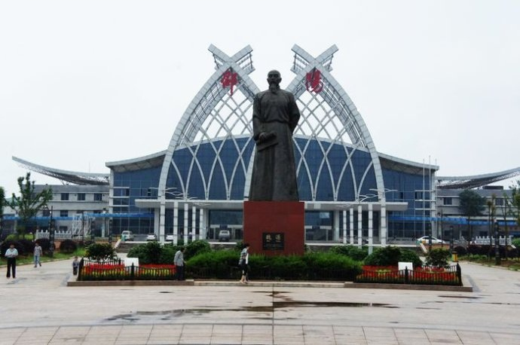
Shaoyang is in the southwest of Hunan province. It covers an area of 20,876 square kilometers and has a population of about 8.3 million. Shaoyang has a history of over 2,500 years and remains an important city in Hunan.
There is lots of beautiful scenery(风景) all over Shaoyang. Mount Nanshan with large green hills, grassland and clear water won high praise from Tao Yuanming. Mount Langshan has different kinds of stones and its peaks(山峰) are in strange shapes and different sizes. Mount Yunshan is well-known for it’s mysterious fairyland(神秘的仙境) .Huangsang has a well-kept forest with unusual birds and animals, which is worth a visit.
Many famous people in Chinese history such as Wei Yuan and Cai E left their footprints in Shaoyang. Wei Yuan was famous for his HaiguoTuzhi and Cai E was best known for his role in fighting against Yuan Shikai.
Now the transportation in Shaoyang is very convenient. Welcome to Shaoyang.
41.Shaoyang is in the northwest of Hunan province.
42. Shaoyang has a history of over 2,500 years.
43. The peaks in Mount Langshan are in different shapes and sizes.
44. Huangsang has many unusual birds and animals.
45. Wei Yuan was famous for fighting against Yuan Shikai.
B）阅读短文，从A、B、C三个选项中选出最佳答案回答问题或完成句子。（共5小题，每小题2分）
Clothes are traditionally made of natural materials, such as cotton, leather and wool. They are all from plants or animals, but that doesn’t mean they’re friendly to the earth. For example, farmers have to use a lot of chemicals to grow cotton plants.
Scientists are now looking for new ways to make clothing materials. They hope the new materials are both comfortable and good for the earth. Scientists have worked out how to make materials out of corn husks(棉籽), chicken feathers and rice straws.
“They used to be useless things. We always have a problem of how to deal with them,” Yang, a scientist says, “Now, we can turn them into beautiful materials. Chicken feathers are better than other things. They have small air pockets like honeycombs. That means it will be very warm if you use them to make a jacket or sweater, and I think more and more people will like to buy these kings of clothes.”
46. Clothes are traditionally made of______
A. natural materials. B. chicken feather. C. rice straws.
47. What are the new clothing materials?
A. corn husks and rice straws. B. cotton and wool. C. leather and wool.
48. What does the underlined word “honeycombs” in paragraph 3 mean in Chinese?
A. 鸟巢 B. 蜂窝 C. 渔网
49. Why are chicken feathers better than other materials?
A. They are from plants.
B. They are traditional clothing materials.
C. They have small air pockets like honeycombs.
50. What’s the best title of this passage?
A. New clothing materials. B. New clothes C. Natural materials.
C）匹配 阅读下篇材料，从所给的A-F六个选项中，选出正确的选项填空，使短文通顺，内容完整。（共5小题，每小题2分）
If you want to be successful, you should learn how to start your day. Although you cannot achieve all your goals in one day, starting your day in a correct way is still important. Here are some ideas on how to start your day right.
Get up an hour early.
51. .This means that people who get up early can have a good start and are more likely(可能的)to succeed.
52.
Health experts say drinking a cup of water in the morning can speed up our body’s metabolism(新陈代谢).Then we can study or work more actively.
53.
Your breakfast is ready. But you decide to check WeChat quickly. Well, you’d better not.
54.
Exercise in the morning.
Some people may disagree with this one. Some people like to exercise after work.
55. because by the end of the day, you may not have the time or energy to exercise. Exercising in the morning prevents that from happening.
- The early bird gets the worm.
- Drink a glass of water.
- An apple a day keeps the doctor away.
- Experts suggest doing exercise in the morning.
- It will waste your morning time.
- Don’t check Wechat when you get up.

D）摘录 阅读短文，然后完成内容摘要。每空不超过三个单词（共5小题，每小题2分）
Stories and Art of Chinese Fans
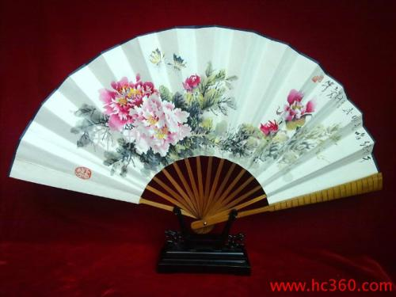
You may think you cannot live through summer without air conditioners. But in ancient China，hand fans were almost the only ones to help people keep cool.
Chinese people started to use hand fans over 2,000 years ago. The fans came in different shapes，such as round and square. They were also made from a11 kinds of materials．Palm leaf fans were cheap and easy to make. Feather fans(羽毛扇) showed the owner’s high status．Sandalwood(檀香)fans could send out a sweet smell.
Later, hand fans became far more than just something that could cool you down. They developed into art works，in which tuanshan (round fans)and zheshan(folded fans)were the most common．
In the shape of a full moon，tuanshan was usually made of silk．They had beautiful birds and flowers on them．Women especially those in the imperial palace(皇宫),liked to use them．Meanwhile,men，especially the literati(文人)，used zheshan．The literati liked them because zheshan were usually made of paper and they could paint and write poems on them．It was a way for them to show off their ability in literature,painting and handwriting．Almost anything can be painted on zheshan．
Today，Chinese people still use these fans，only not many people write or paint on them any more．Next time when you are waving a fan, you may think of the stories behind it.
Name | Features(特征)
Palm leaf fans | 56 and easy to make
57 | Show the owner’s status
Sandalwood fans | Send out 58
Tuanshan | In the shape of 59
Zheshan | Paint and write 60
Ⅳ.写作技能（三部分，共11小题，计35分）
A)英汉互译 阅读短文，将文中画线的句子译成汉语或英语。（共5小题，每小题2分）
Mrs. Luo is a teacher from Shaoyang. She asked her students to hand in their homework through a QR code(二维码). “61.When students finish the homework, they keep it on Wechat. So I can check their homework everywhere using my computer or mobile phone.” said Luo.
62.大多数学生喜欢这种新方式，认为它有趣. “We are living in the information age. Many students like to work with computers, which makes learning more fun.” said Tingting, a student of Luo’s.
“The paper is not easy to keep, but the code is easy to keep and share,” Luo said, “It is worth trying to use new technology in education. Education itself is a kind of creation.63. I don’t want my students to fall behind the times.”
64.然而，一些父母有担忧. They are afraid that their children will spend too much time on computers and less time communicating with teachers. But in fact, it is unnecessary. Students still need to look up information in books and write it down when they do their homework. They only use the code when they hand in their work, which doesn’t take them too much time. 65.As for teachers, it allows them to check the students’ work at any time. And it is also an easy way to share homework with other students.

B)简答 阅读下面短文，然后根据短文内容简要回答下列问题。（共5小题，每小题2分）
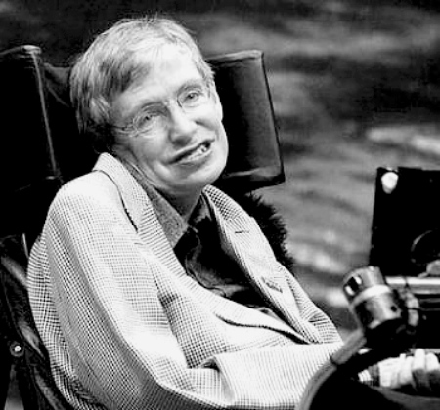
Stephen Hawking was born in England in 1942. He is one of the most well-known scientists on space and time in the world. Hawking is researching how the universe began and how it ends. He is called the King of the Universe.
When he studied math and science at Oxford University, he became seriously ill, which made him unable to speak or breathe without the help of machines. Till now, he can’t move or feed himself and he is helped to dress, eat and wash by a nurse. However, he has a wheelchair with a special computer, with which he can communicate with others.
In spite of all these difficulties, he refused to give up his hope of living and went on to study at Cambridge University after graduating from Oxford University. In 1965, he got a Doctor’s Degree of philosophy(哲学). Because of his serious illness, it was difficult for him to draw diagrams or to write. So he started to think in pictures. With this new way of thinking, he is respected by people in the world. Then in 1988, he wrote his first important book, A Brief History of Time. It has been sold more than 5.5 million copies in 33 different languages. He was once invited to China to give lectures. His self-confidence and humorous conversations impressed us deeply.
From Hawking’s unusual experiences , we learn that nobody should lose hope, no matter how bad the situation is .As he once said, “Life is not fair, you just have to do the best you can in your own situation.”
66. Is Hawking one of the most famous scientists in the world?
67. Why was Hawking unable to speak or breathe without the help of machines?
68. When did Hawking get a Doctor’s Degree of philosophy?
69. What’s the name of Hawking’s first important book?
70. What can we learn from Hawking’s unusual experiences?
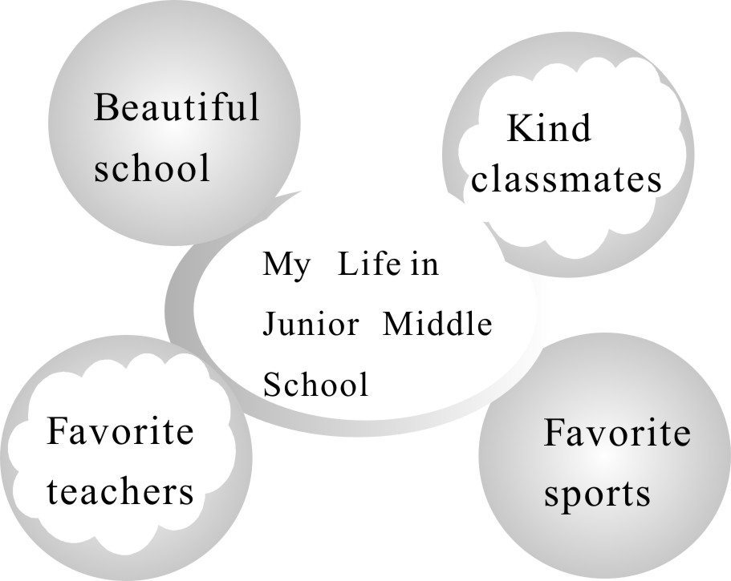
C）情景作文（15分）
初中生活马上就要结束了,三年的时光一定给你留下了很多挥之不去的记忆,请你根据图表提示简要描述这段时间的学习生活情况。
要求：1. 80词左右，开头已给出，
不计入词数。
2. 语法正确，文理通顺，流畅。
3. 文中不得出现真实姓名、校名。

My Life in Junior Middle School
I have studied in my junior middle school for three years. My life in junior middle school was rich and I have learned a lot.

邵阳市2018年初中毕业学业考试试题卷
英语听力材料
Ⅰ. 听力技能（三部分，共20小题，计25分）

A）反应 根据你所听到的内容，选择正确答语完成对话。（共5小题，每小题1分）
1. Nice to meet you！
2. Which season do you like best?
3. How many days have you stayed here?
4. What’s the matter with you, Jim?
5. Let’s go swimming this afternoon.
B. 理解 根据你所听到的对话，选择最佳答案回答问题。（共10小题，每小题1分）
听下面的对话，回答第6至7小题。
W: Where does your uncle work, Chen Lin?
M: He works in a school. He is a teacher.
W: Where is the school?
M: It’s near the park.
W: How does he go to the school?
M: He usually goes there by bus.
听下面的对话，回答第8至9小题。
W: Tom, what’s the date today?
M: It’s March the eighth ，Lucy. It’s Women’s Day.
W: You ’re right. It is a day to show love and thanks to mothers.
M: Oh, yes. Then how shall we celebrate this special day?
W: Well, I’ve bought a dress for mom.
M: A dress? What color?
W: Blue. It’s mom’s favorite color.
M: That’s a nice present. Er… what shall I do for mom?
W: Why not make a cake?
M: Good idea. Let’s start now.
听下面的对话，回答第10至12小题。
M: Did you do anything special yesterday, Mary ?
W: Yes, I made a banana milk shake.
M: Sounds great! Who taught you to make it?
W: My father. He is a good cook.
M: Can you tell me how to make it?
W: Of course! First, peel some bananas, and cut them up. Next, put the bananas in the blender. Then, pour some milk into the blender. Finally, turn on the blender.
M: How much milk do we need?
W: About three cups.
M: OK, I’ll try it tonight.
听下面的对话，回答第13至15小题。
M: Hey, Zhang Lan! I didn’t see you last weekend. Did you go anywhere?
W: No, I stayed at home.
M: Why?
W: Well, I had lots of things to do.
M: Like what ?
W: Well, I cleaned my room. And I did my homework.
M: You did? Not much fun, huh?
W: Well, it wasn’t too bad. On Sunday I went to the library. How about you, Li Hua? What did you do?
M: Well, I played basketball on Saturday morning. On Sunday afternoon, I visited my friend’s house.
W: Wow! You had fun.
M: Yeah, I had fun. But I didn’t do my homework this school morning , so it wasn’t fun!
C）听写 根据你所听到的内容，填写下面的表格。每空不超过3个单词（共5小题，每小题2分）
The summer holiday is coming soon. Come to our Fantastic Summer Camp.
You will spend fifteen days in a small village far away from the city. Special local food will be served. In the morning, you’ll have fun classes. You can learn how to cook and how to make works of art. In the afternoon, you’ll ride bikes around the lake near the village. You can also fish in the lake. In the evening, you will have a party. I’m sure you’ll have a wonderful summer holiday. Come and join us!

邵阳市2018年初中毕业学业考试试题卷
英语(参考答案及评分标准)
Ⅰ. 听力技能(三部分，共20小题，计25分)
- 反应（每小题1分）1-5 ABABC
B）理解（每小题1分） 6-10 BCABB 11-15 CCABA
C) 听写（每小题2分）
16. fifteen/15 days 17. village 18.cook 19. Fish 20.In the evening
Ⅱ.知识运用 （两部分，共20小题，计20分）
A) 语法填空（共10小题，每小题1分） 21-25 ABAAB 26-30 ABCAB
B）完形填空（共10小题，每小题1分） 31-35 ABABC 36-40 AACAB
Ⅲ.阅读技能（四部分，共20小题，每小题2分，计40分）
41—45 FTTTF 46—50 AABCA 51—55 ABFED
56.Cheap 57.Feather fans 58. a sweet smell 59. a full moon 60.poems
Ⅳ.写作技能（三部分，共11小题，计35分）
A)英汉互译 阅读短文，将文中画线的句子译成汉语或英语。（共5小题，每小题2分）
61.当学生完成家庭作业时，他们把它保存在微信上面。
62. Most students like the new way and think it is interesting.
63.我不想让我的学生落后于时代。
64. However, some parents are worried.
65.对教师而言，这允许他们随时检查学生的作业。
B).简答 阅读下面短文，然后根据短文内容简要回答下列问题。（共5小题，每小题2分。）
66. Yes, he is.
67. Because he became seriously ill.
68. In 1965.
69. A Brief History of Time.
70. We learn that nobody should lose hope, no matter how bad the situation is.

71.参考范文：
My Life in Junior Middle School
I have studied in my junior middle school for three years. My life in junior middle school was rich and I have learned a lot. I have made a lot of friends in my school. They often helped me when I was in trouble. Our teachers were friendly and patient, especially my English teacher. She often helped me with my English. So my favorite subject was English. I liked sports. In my free time, I often played basketball or football with friends. It was good for health and it is a good way to relax from the busy study.
In a word, my life in junior middle school was colorful and unforgettable.

