武汉市第二初级中学＆武汉二中广雅中学
九年级（下）英语中考模拟（二）
听力部分（25分）
一、听力测试。（共三节）
第一节（共5小题，每小题1分，满分5分）
听下面5个问题。每个问题后有三个答语，从题中所给的A、B、C三个选项中选出最佳选项。听完每个问题后，你都有5秒钟的时间来作答和阅读下一小题。每个问题仅读一遍。
（ ） | 1. A Tom’s father | B. He’s sick. | C. Very soon.
（ ） | 2. A. For the guests. | B. Two chairs. | C. At night.
（ ） | 3. A. In a week. | B. By plane. | C. With my brother.
（ ） | 4. A. Some delicious food. | B. At Mary’s home. | C. At 7 tonight.
（ ） | 5. A. It’s dirty. | B. On the playground. | C. Not expensive.
第二节（共7小题，每小题1分，满分7分）
听下面7段对话。每段对话后有一个小题，从题中所给的A、B、C三个选项中选出最佳选项。听完每段对话后，你都有10秒钟的时间来回答有关小题和阅读下一小题。每段对话仅读一遍。
（ ）6. What does the man think of the coffee?
 | A. Too sweet. | B. Not strong enough. |  | C. Not weak.
（ ）7. How many guests will arrive?
 | A. 8. | B. 10. |  | C. 12.
（ ）8. What are they talking about?
 | A. A parking lot. | B. An apartment. |  | C. A hotel.
（ ）9. Where are they talking?
 | A. At a store. | B. At a house. |  | C. In a hotel.
（ ）10. Where did the conversation take place?
 | A. In a kitchen. | B. In a garden. |  | C. At a picnic.
（ ）11. What is the probably relationship between the two speakers?
 | A. Interviewer and interviewee |  | B. Teacher and student.
 | C. Boss and secretary.
（ ）12. What does the man mean?
 | A. Drunk drivers are not guilty. |  | B. He doesn’t agree with the woman.
 | C．Drunk driving is a serious problem.
第三节（共13小题，每小题1分，满分13分） www.wh111.com
听下面4段对话或独白。每段对话或独白后有几个小题，从题中所给的A、B、C三个选项中选出最佳选项。听每段对话或独白前，你将有时间阅读各个小题，每小题5秒钟；听完后，各小题将给出5秒钟的作答时间，每段对话或独白读两遍。
听下面一段对话，回答13至15三个小题。
（ ）13. Why does Diana say sorry to Peter?
 | A. She has to give up her travel plan. | B. She wants to visit another city.
 | C. She needs to put off her test.
（ ）14. What does Diana want Peter to do?
 | A. Help her with her study. | B. Take a book to her friend.
 | C. Teach a math lesson.
（ ）15. What can we learn from the conversation?
 | A. Diana takes the test seriously. | B. Peter won’t visit Hong Kong, either.
 | C. Sally bought a book for Diana.
听下面一段对话，回答16至18三个小题。
（ ）16. Why does the man call the woman?
 | A. To tell her about her new job. |  | B. To ask about her job program.
 | C. To plan a meeting with her.
（ ）17. Who needs a new flat?
 | A. Anna. | B. Alex. |  | C. Miranda.
（ ）18. Where is the woman now?
 | A. In Baltimore. | B. In New York. |  | C. In Avon.
听下面一段对话，回答19至22四个小题。
（ ）19. What does the man want to drink?
 | A. Water. | B. Tea. |  | C. Coffee.
（ ）20. What is the man doing?
 | A. Watching TV. | B. Writing some reports. |  | C. Listening to the radio.
（ ）21. When does the conversation take place?
 | A. Late at night. | B. In the afternoon. |  | C. In the morning.
（ ）22. What’s probably the relationship between the two speakers?
 | A. Manager and clerk. |  | B. Customer and Salesman.
 | C. Husband and wife.
听下面一段对话，回答23至25三个小题。
（ ）23. How did Joan know something about Humphrey?
A. From another officer.
B. From the newspaper.
C. From Humphrey himself.
（ ）24. What was wrong with Humphrey?
 | A. He got lost. | B. He was wounded. |  | C. He caught a cold.
（ ）25. What can we learn from the passage?
 | A. Joan’s lie was discovered.
 | B. The nurse was Humphrey’s sister.
 | C. Joan was Humphrey’s sister.
笔试部分（95分）
二、单项选择（每小题1分，共15分）
（ ）26. —Hi, haven’t seen you for ages! You look fine! — .
 | A. Great |  | B. Thanks |  | C. Oh, no |  |  | D. Not at all.
（ ）27. —How is the young man ? — .
 | A. He’s twenty B. He’s much better C. He’s a doctor D. He’s Smith
（ ）28. —It’s very kind of you to help me. Thank you very much.
— .
 | A. Thank you  C. Sorry to help you very little |  |  |  | B. Don’t thank me  D. You are welcome
（ ）29. My sister the piano very well, but she hasn’t had time to play recently.
 | A. will play |  | B. have played |  | C. played |  |  | D. plays
（ ）30. —I still don’t know what while I was away from home?
—You’ll know it all some day, I believe.
 | A. had happened |  | B. would happen |  | C. has happened |  |  | D. happened
（ ）31. —Do you still play basketball ? —Oh, no. I it for the past two years.
 | A. haven’t played |  | B. didn’t play |  | C. won’t play |  |  | D. hadn’t played
（ ）32. —What are you doing?
—I’m looking the kids. They should be back for lunch now.
 | A. after |  | B. at |  | C. for |  |  | D. up
（ ）33. —You look very pretty, if I say so.
—Thanks.
 |  | A. must |  | B. may |  | C. will | D. have to
（ ）34. The seat a driver greater freedom of movement, so it’s widely used in cars nowadays.
 |  | A. allows |  | B. expects |  | C. lends | D. costs
（ ）35. Hearing the good news, a small laugh her.
 |  | A. appeared |  | B. managed |  | C. escaped | D. expressed
（ ）36. The bedroom light and I could see nothing.
 |  | A. went over |  | B. went out |  | C. went through | D. went away
（ ）37. In order to win the people’s support, the Queen has now made a towards public opinion.
 |  | A. mistake |  | B. decision |  | C. will | D. gesture
（ ）38. —Tai Gai is a tea shop in Wuhan Tiandi.
—Yeah. Many young people wait in line to have its drink every day.
 |  | A. smart |  | B. spare |  | C. serious | D. smooth
（ ）39. —Excuse me, where can I buy a drink?
—There are shops at end of the street.
 |  | A. both |  | B. either |  | C. none | D. every
（ ）40. —Could you tell me ?
—He drove here himself.
 |  | A. how he comes here |  |  |  | B. how did he come here
 |  | C. when he came |  |  |  | D. how he came here
三、完形填空（每小题1分，共15分）
The other day, I was taking in a wonderful folk music performance at a coffee shop, lapping my feet and singing along with the relaxing tunes.
Not until I got up to get a cup of coffee and a cookie did I 41 a middle-aged woman nearby. She had obviously been caught in a fire of some sort. Her face had been 42 so seriously . She almost had no nose, and her eyes were tiny. I took a deep breath, and went back to my seat, thinking how 43 she was to come out and appear in public. In the meanwhile, I also felt 44 of myself for shuddering（战栗）and 45 while I headed back to my seat, unable to send even a weak smile her way.
As I was sipping my coffee and eating my cookie, I was haunted by the thinking 46 I should ignore(忽视） this moment and just mind my own business, or do something about my 47 . I couldn’t let it go. I went for a refill of coffee and to get another cookie. 48 , this time I made my way slowly 49 the woman, said, “Isn’t he a wonderful performer?”, and gave her a largest smile I was able to give. To my delight，she looked right at me and gave me a huge smile 50 .
I’m sure it took this woman a 51 time to find her smile after her terrible 52 . I believe that my smile 53 her day. She seemed to have 54 to find peace with herself, and I was glad, because her smile had made her beautiful.
Sometimes it takes 55 to smile, considering how hard life can be.
（ ） | 41. A. recognize | B. understand | C. imagine | D. notice
（ ） | 42. A. lost | B. burned | C. killed | D. wounded
（ ） | 43. A. courageous | B. competitive | C. anxious | D. nervous
（ ） | 44. A. frightened | B. ashamed | C. tired | D. embarrassed
（ ） | 45. A. breaking down | B. standing up | C．giving up | D. looking down
（ ） | 46. A. whether | B. how | C. when | D. where
（ ） | 47. A. expressions | B. feelings | C. memories | D. impressions
（ ） | 48. A. Though | B．However | C. Otherwise | D. Therefore
（ ） | 49. A. out | B. toward | C. around | D. through
（ ） | 50. A. in turn | B. in return | C. in order | D. in place
（ ） | 51. A. good | B. special | C. limited | D. long
（ ） | 52. A. accident | B. dream | C. event | D. journey
（ ） | 53. A. marked | B. lengthened | C. brightened | D. reminded
（ ） | 54. A. attempted | B. determined | C. prepared | D. managed
（ ） | 55. A. courage | B. ability | C. practice | D. patience

四、阅读理解（每小题2分，共30分）
A
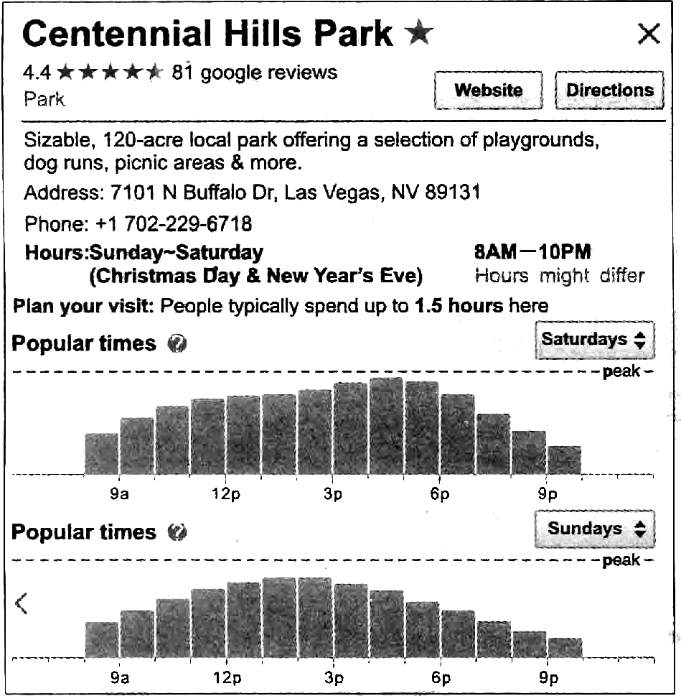

（ ）56. We may read the material above .
 | A. in a survey |  | B. on the Internet
 | C. in a newspaper |  | D. in a geography textbook
（ ）57. People can probably do the following things EXCEPT in the park.
 | A. going skiing | B. taking a picnic | C. doing exercise | D. walking the dog
（ ）58. The word “peak” probably means “ ”.
 | A. the shortest time |  | B. the longest time
 | C. the highest point |  | D. the lowest point
（ ）59. You can get the following information EXCEPT .
 | A. where the park is |  | B. how much the ticket is
 | C. when there will be the most people
 | D. what time the park is open on most days
（ ）60. What can we learn from the material?
 | A. 81 people have already bought the tickets online.
 | B. The park will not be open on Christmas Day.
 | C. There will be the most people at 5:00 pm on weekdays.
 | D. People usually stay here for about one and a half hours.
B
Chinese paper cutting or “jianzhi” is the art of cutting paper designs, and the cut-outs are also used to decorate doors and windows, so they are sometimes called “chuang hua”. Paper cutting has long been a symbol of Eastern charm.
There are symmetrical(对称的) designs that are usually created by some folding and cutting. When unfolded, it forms a symmetrical design. Chinese cut-outs are normally symmetrical and are usually in an even number series of 2, 4, 24, etc.
The oldest living paper cut-out is a symmetrical circle from the early 6th century found in Xinjiang, China. From the 7th to 13th century, paper cutting became popular especially during Chinese festivals. The art spread to the rest of the world in the 14th century. Throughout the Qing Dynasty many paper cutting skills were developed. By the end of the Qing ruling, however, paper cutting was once becoming weaker because new art forms were being introduced. The People’s Republic of China later tried to revive the art in the 1980s.
Today, paper cut-outs are mainly decorative. They decorate walls, windows, doors, mirrors, lamps and lanterns in homes and are also used on presents or are given as gifts themselves. Entrances decorated with paper cut-outs are supposed to bring good luck. Paper cut-outs used to be used as patterns, especially for embroidery (刺绣).
There are two methods of manufacture(加工): one uses scissors, the other uses knives. In the scissor method, several pieces of paper—up to eight—are tied together. The picture is then cut with sharp, pointed scissors. Knife cuttings are fashioned by putting several paper on a soft foundation(地基) made up of a mixtureof oil and ashes. Skilled crafters can even cut out different drawings freely without stopping.
（ ）61. When can the existing oldest paper cutting date back to?
 | A. About 1 500 years ago.  C. About 1 400 years ago. |  | B. About 1 600 years ago.  D. About 600 years ago.
（ ）62. The underlined word “revive” in Paragraph 3 can be replaced by “______”.
 | A. live longer | B. bring it back | C. copy it | D. fix it
（ ）63. What does the last paragraph talk about?
 | A. History | B. Tools | C. Uses | D. Process
（ ）64. Which is true according to the passage?
A. The oldest paper cut-out in history was found in Xinjiang, China.
B. People believe entrances with paper cut-outs can bring good luck.
C. Paper cut-outs used to be only used for embroidery (刺绣).
D. In the scissor method, more than eight pieces of paper are tied together.
（ ）65. What may be the best title of the text?
A. Paper Cutting— the Eastern Charm
B. The History of Paper Cutting
C. An Introduction to Paper Cutting
D. Paper Cutting — Unbelievable Skilled Crafters

C
Natalie Doan, 14, has always felt lucky to live in Rockaway, New York. Living just a few blocks from the beach, Natalie can see the ocean and hear the waves from her house. “It’s the ocean that makes Rockaway so special,” she says.
On October 29, 2012, that ocean turned fierce. That night, Hurricane Sandy attacked the East Coast, and Rockaway was hit especially hard. Fortunately, Natalie’s family escaped to Brooklyn shortly before the city’s bridge closed.
When they returned to Rockaway the next day, they found their neighborhood in ruins. Many of Natalie’s friends had lost their homes and were living far away. All around her, people were suffering, especially the elderly. Natalie’s school was so damaged that she had to attend a school in Brooklyn.
In the following few days, the men and women helping Rockaway recover inspired Natalie. Volunteers came with carloads of donated clothing and toys. Neighbors devoted their spare time to helping others rebuild. Teenagers climbed dozens of flights of stairs to deliver water and food to elderly people trapped in powerless high-rise buildings.
“My mom tells me that I can’t control what happens to me,” Natalie says. “but I can always choose how I deal with it.”
Natalie’s choice was to help.
She created a website page matching people in need with donors who wanted to help. Natalie posted information about a boy named Patrick, who lost his baseball card collection when his house burned down. Within days, Patrick’s collection was replaced.
In the coming months, her website page helped lots of kids: Christopher, who received a new basketball; Charlie, who got a new keyboard. Natalie also worked with other organizations to bring much-needed supplies to Rockaway. Her efforts made her a famous person. Last April, she was invited to the White House and honored as a Hurricane Sandy Champion of Change.
Today, damages are still seen in Rockaway, but hope is in the air. The streets are clear, and many homes have been rebuilt. “I can’t imagine living anywhere but Rockaway,” Natalie declares. “My neighborhood will be back, even stronger than before.”
（ ）66. When Natalie returned to Rockaway after the hurricane, she found .
 | A. some friends had lost their lives |  | B. her neighborhood was destroyed
 | C. her school had moved to Brooklyn |  | D. the elderly were free from suffering
（ ）67. According to Paragraph 4, who inspired Natalie most?
 | A. The people helping Rockaway rebuild.
 | B. The people trapped in high-rise buildings.
 | C. The volunteers donating money to survivors.
 | D. Local teenagers bringing clothing to elderly people.
（ ）68. How did Natalie help the survivors?
A. She gave her toys to other kids.
B. She took care of younger children.
 | C. She called on the White House to help.
 | D. She built an information sharing platform.
（ ）69. What’s the possible meaning of the underlined word?
 | A. help out | B. give out | C. take out |  | D. put out
（ ）70. What does the story plan to tell us?
 | A. Little people can make a big difference. |  |  | B. A friend in need is a friend indeed.
 | C. East or west, home is best. |  |  | D. Technology is power.
五、词与短语选择填空（每小题2分，共10分）
take out/everyday/achieve/changes/sweet/bring out
71. We value the time we spend with our family and friends in our lives.
72. My best friend helps to the best in me.
73. The spirit of the climbers shows us that we should never give up trying to our dreams.
74. Everything that you learn becomes a part of you and you.
75. Amy wants to keep her old things because they bring back memories.
六、阅读理解填词（每小题1分，共10分） www.wh111.com
A famous writer was in his study room.
He picked up his pen and started writing, “Last year, I had an operation. I had to s 76 stuck (不能动的) to the bed for a long time. The same year I r 77 the age of 60 and had to give up my favorite job. I had spent 30 years of my life in this publishing company. The same year I experienced the pain of the d 78 of my father. And in the same year my son failed his medical exam because of a car accident. The broken car was another loss.”
When the writer’s wife read what was w 79 on the paper, she left the room silently and came back with a 80 piece of paper and placed it on the side of her husband’s writing.
When the writer saw this paper, he found this written on it, “Last year I finally got rid of my p 81 in which I had spent years. I turned 60 and got retired from my job. Now I can spend my time writing something better with more attention and peace. The same year my father, at the age of 95, p 82 away in peace. The same year, god blessed my son with a new life. My car was broken but my son stayed a 83 without getting any disability.” At the end she wrote, “This year was a great blessing of God and it passed well.”
See! The same event but d 84 views. In our daily lives, we must see that it’s not h 85 that makes us thankful but thankfulness that makes us happy.
76. s | 77. r | 78. d | 79. w | 80. a
81. p | 82. p | 83. a | 84. d | 85. h
七、书面表达（15分）
假如你是李明，你们学校将举行“弘扬中华传统文化——戏曲进校园”展演活动，你打算邀请你的美国朋友Mike参加。请根据以下提示，用英语给他写一封电子邮件。
内容要点如下：
1．有好消息分享；2．展演时间：7月1日下午2点；3．展演地点：学校操场；
4．展演内容：文化展览、节目表演等；5．展演意义：……
注意：1．文章的开头和结尾已给出，不计入总词数；2．词数：60-80；
3．内容要连贯得体。
参考词汇：opera n. 戏曲 performance n. 表演 culture show 文化展览
Dear Mike,
I know you are interested in Chinese traditional culture.

I’m looking forward to your early reply.
Yours,
Li Ming

