云南省昆明市2017年中考英语真题试题
（全卷四个部分，共8页。满分120分，考试用时120分钟)
注意事项：
1.本卷为试题卷。考生必须在答题卡上解题作答。答案应书写在答题卡的相应位置上，在试题卷、草稿纸上作答无效。
2.考试结束后，请将试题卷和答题卡一并交回。
第一部分 听力（共四节，满分30分）
第一节听句子，选出与所听句子内容相符的图画。听音前你有10秒钟的读题时间，注意 听两遍（共5小题，每小题1分，满分5分）
（略）
第二部分英语知识运用（共二节，满分25分）
第一节单项填空
从A、B、C、D四个选项中选出能填入空白处或替换划线部分的最佳答案。（共15小 题，每小题1分，满分15分）
21. — Hello, may I speak ____ Mike?
—This is Mike speaking.
A. at B. to C. in D. on
【答案】B
【解析】
考点：考查介词。
22 — Could you please clean your room?
一_____!
A. Me, too B. What a pity
C. See you D. No problem
【答案】D
【解析】
试题分析：句意：--请你打扫一下你的房间好吗？--没问题。A. Me, too我也一样； B. What a pity真可惜；’
C. See you再见； D. No problem没问题。当听到对方的请求时，如果同意对方的请求，可以说No problem没问题。故选D。
考点：考查交际用语。
23.一 Excuse me, what’s your name?
一___name is Betty.
A.My B. His C. Her D. Your
【答案】A
【解析】
考点：考查代词。
24.— Did you do anything interesting last Sunday?
—Not really. I just __ at home.
- stay B. stayed C. will stay D. am staying
【答案】B
【解析】
试题分析：句意：--上周日你做了有趣的事情了吗？--没有，我就呆在家里了。根据问句的时间状语 last Sunday可知，这里问的是过去的事情，所以句子应该用一般过去时。故选B。
考点：考查动词时态。
25.Nowadays, it’s convenient and cheap for us ___a shared-bicycle.
A. ride B. to ride C. flying D. to fly
【答案】B
【解析】
试题分析：句意：现在对于我们来说骑共享自行车是又方便又便宜。这里是句式：it is+形容词+for+sb to do sth对于某人来说做某事是怎样的。 ride a shared-bicycle骑共享自行车.故选B。
考点：考查动词不定式。
26.Many ___are playing an active part in making Kunming a civilized city (文明城市).
A. man B. woman C. volunteer D. volunteers
【答案】D
【解析】
试题分析：句意：许多志愿者积极参加昆明建成文明城市的活动中。因为谓语动词用的是are，是复数形式，所以句子的主语也用复数形式。A. man男士，是单数；B. woman妇女，是单数； C. volunteer志愿者，是单数；D. volunteers志愿者，是复数。根据题意这里应该用复数形式。故选D。
考点：考查名词的单复数。
27.—Alan,_____?
—I’m sorry, I’m not available.
.A. did you like my housewarming party B. when is your housewarming party
C. can you come to my party tomorrow D. who will go to the party with you
【答案】C
【解析】
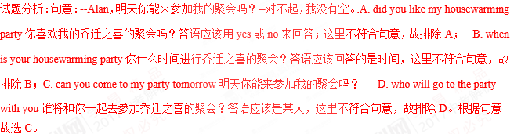
考点：考查宾语从句。
28.-Have you watched the TV program named Chinese Poetry Competition?
—Yes. It’s meaningful and ___.
A. I love it very much B. I don’t like it
C. she can’t stand it D. he doesn’t mind it
【答案】A
【解析】
试题分析：句意：--你看过电视节目《诗歌朗诵比赛》吗？--看过，它是很有意义，我真的很喜欢。A. I love it very much 我非常喜欢； B. I don’t like it我不喜欢；C. she can’t stand it她不能忍受；D. he doesn’t mind it他不介意。根据 meaningful有意义，可知，这里应该指喜欢的。故选A。
考点：考查陈述句。
29. --_____?
—Twice a week.
A. How old are you B. How far is it from your home to school
C. How do you get to school D. How often do you exercise
【答案】D
【解析】
试题分析：句意：--你多久锻炼一次？--一周两次。A. How old are you你好吗？ B. How far is it from your home to school从你的家到学校有多远？ C. How do you get to school你怎样到达学校？D. How often do you exercise你多久锻炼一次？根据答语Twice a week可知，问句问的是频率。故选D。
考点：考查特殊疑问句。
30.As we ___on our new journey, we shouldn't forget where we came from.
A. take out B. set out C. cut out D. blow out
【答案】B
【解析】
考点：考查动词短语辨析。
31.All the students in our class are over fifteen except Nick. He is____in our class.
A. younger B. older C. the youngest D. the oldest
【答案】C
【解析】
试题分析：句意：我们班里所有的学生除了Nick之外，都超过15岁，他是我们班最小的一个。根据in our class可知，比较的对象是三者以上，所以应该用最高级的形式，根据第一句可知，班里只有Nick不到15岁，所以他是班里最小的。故选C。
考点：考查形容词的最高级。
32.The Belt and Road initiative (一带一路）is ___a good chance to let more and more foreign students study in our country.
A. unluckily B. never C. really D. hardly
【答案】C
【解析】
试题分析：句意：一带一路真的是一个好机会让越来越多的外国学生在我们国家学习。A. unluckily不幸的是；B. never从不；C. really真的；D. hardly几乎不。根据句意故选C。
考点：考查副词词义辨析。
33. — Could you please tell me____?
一 The people and the food.
A. How does Tom like China B. if Tom likes China
C. what does Tom like about China D. what Tom likes about China
【答案】D
【解析】
试题分析：句意：--请你告诉我汤姆喜欢中国的什么？--人和食物。这里考查宾语从句，其语序是陈述语序，故排除AC；根据答语The people and the food.可知，上句问的是喜欢什么。故选D。
考点：考查宾语从句。
34.He was down in the mouth because he missed his plane.
A. unhappy B. happy C. glad D. relaxed
【答案】A
【解析】
试题分析：句意：因为错过了飞机他不高兴了。A. unhappy不高兴； B. happy高兴； C. glad高兴；D. relaxed放松的。 根据he missed his plane可知，错过了飞机肯定不高兴了。故选A。
考点：考查形容词。
35. Tell me your story, please. I’m all ears.
A. I have many ears. B. I like all kinds of ears.
C. I’m listening to you carefully. D, I don’t want to listen to you
【答案】C
【解析】
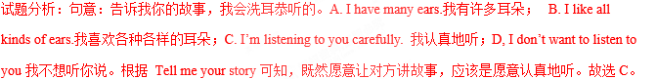
考点：考查同义句。
第二节完形填空
从A、B、C三个选项中选出能填入空白处的最佳答案。（共10小题，每小题1分，满 分10分）
A teacher decided to let her class play a game. She told each child in the class to bring along a bag with 36__ tomatoes. Each tomato would 37 a name of a person that the child hated. So the number of tomatoes in his or her bag would depend on the number of people the child hated.
When the day came, every child brought some tomatoes with the names of the people he or she hated. Some had two tomatoes. 38 had three tomatoes. Some even had five tomatoes. The teacher then told the children to carry the tomatoes with them wherever they went for a week. Days passed and the children started to complain (抱怨）39 the rotten (腐烂的）tomatoes let out terrible smell. Besides, those having five tomatoes, also had to carry 40 bags. After one week, the children were very happy because the game had 41 ended.
The teacher asked, “How did you feel?” The children started complaining of the trouble that they had to go through when carrying the heavy and smelly tomatoes.
Then the teacher told them the 42 behind the game.
The teacher said“This is the same situation when you carry your hatred (憎恨）for somebody 43 your heart. The terrible smell of hatred will 44 your heart, and you will carry it with you wherever you go. If you cannot stand the smell of the rotten tomatoes for just 45 week, can you imagine what it is like to have the smell of hatred in your heart for your lifetime?”.
36. A. much B. a little C. a few
37. A. call B. be given C. have written
38. A. Any B. Some C. Every
39. A. because B. but C. so
40. A. lower B. lighter C. heavier
41. A. often B. finally C. always
42. A. meaning B. time C. way
43. A. outside B. inside C. beside
44. A. clean B. wash C. pollute
45. A. one . B. two C. five
【答案】
36. C
37. B
38. B
39. A
40. C
41. B
42. A
43. B
44. C
45. A
【解析】
试题分析：本文中老师是想通过这个事情告诉学生一个道理，不要在心里去讨厌或者憎恨一个人，那样太累了，还不如原谅别人。
36. 考查短语及语境的理解。A. much多，后跟不可数名词；B. a little 一点，后跟不可数名词； 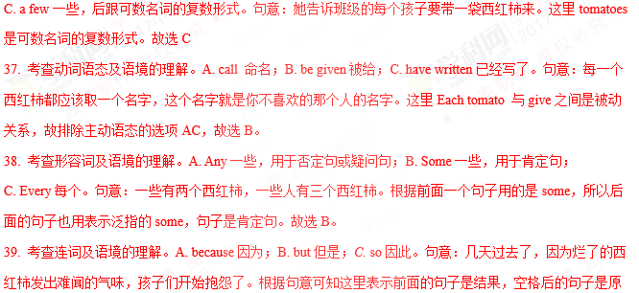因。 故选A。
40. 考查形容词的比较级及语境的理解。A. lower更低； B. lighter 更轻；C. heavier更重。句意：并且那些有5个西红柿的也不得不带着更重的袋子。与那些带着一个或两个西红柿的人来说，带着5个西红柿的人感觉是更重的。故选C。
41. 考查副词及语境的理解。A. often经常；B. finally最后；C. always总是。句意：一周过后，因为游戏终于结束了，孩子们很高兴。根据上文可知，孩子们开始抱怨了，最后游戏结束了孩子们感到很高兴。故选B。
42. 考查名词及语境的理解。A. meaning意义，意思；B. time时间；C. way方法。句意：之后老师告诉他们游戏背后的意义。根据can you imagine what it is like to have the smell of hatred in your heart for your lifetime?可知，后面老师解释这样做的意义。故选A。
43. 考查介词及语境的理解。A. outside在外面；B. inside 在里面；C. beside在旁边。句意：老师说：这种情况和你在心里装着对某个人的憎恨是一样的。根据your heart. 可知，对某人的憎恨当然装在心里。故选B。
44. 考查动词及语境的理解。A. clean使干净；B. wash洗；C. pollute污染。句意：憎恨的可怕的味道污染了你的心。根据If you cannot stand the smell of the rotten tomatoes 可知，是难闻的气味污染了人的心。,故选C。
45. 考查数词及语境的理解。A. one 一个；.B. two 2个； C. five5个。句意：如果你不能忍受腐烂的西红柿的气味仅仅一星期，你能想象你的一生心中有仇恨的味道会是什么样子？根据The teacher then told the children to carry the tomatoes with them wherever they went for a week.可知，这个活动持续一周的时间。故选A。
考点：故事类短文阅读。
第三部分阅读理解（共20小题，满分35分）
Are you still doing the “V” for victory sign? It’s out .The latest popular hand gesture (手势) is putting both your hands together to make a heart shape. It is called a “hand heart”.
Many young pop stars in the USA do this in their photos. “The ‘hand heart gesture means something between “I love you”and ‘thank you’ said Taylor Swift, the country singer. “You can send a sweet and simple message without saving a word.Taylor Swift often does it at her concerts. And some people think she makes this gesture popular.
Justin Bieber and his superstar friends did the “hand heart” and put the photos online. They did it to help out three children, whose parents died from a car accident.
In some Asian countries, the “hand heart”is popular too. but in a different way .People there put their hands above their heads and make a bigger heart shape with their arms. It means“I love you”。
根据短文内容，判断句子正（T)误（F)。（共5小题,每小题1.5分，满分7.5分)
46.It’s out to do the ‘V’ for victory sign.
47.The “hand heart” gesture means “I don’t love you”.
48.No one can express one’s love without saying a word.
49.In this passage, some superstars did the “hand heart ‘’to help out three children.
50.“Hand heart” is popular not only in the USA but also in some Asian countries.
【答案】
46.T
47.F
48.F
49.T
50.T
【解析】
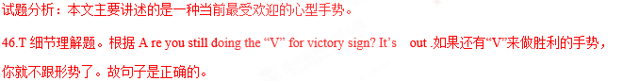
47.F细节理解题。根据 “The ‘hand heart gesture means something between “I love you”and ‘thank you’ 可知，现在说心的手势是我爱你。故句子是错误的。
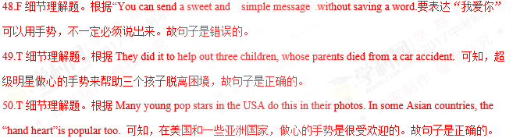
考点：考查社会类短文阅读。
B
A 12-year-old boy named Tim Brown got lost in the mountains. However, he survived at last thanks to his amazing survival (生存，幸存）skills.
One day in October 2016, Tim went hiking with his group in the Magaliesberg Mountains, South Africa. At first, everything went well. But at about one o'clock in the afternoon, he lost his way and couldn't find any other people. He got scared at first, but then he tried to calm down. He knew what to do in such a situation. “I should follow the river, follow the light, follow the sun and finally there will be buildings, roads and people and I could call home,” he told himself.
Tim kept walking. Suddenly he heard some sounds and ran towards them. But to his surprise, he saw some baboons (狒狒)。Unluckily, one baboon scratched (抓伤）his arm. He found some water to wash the blood off the scratches and continued to walk. Tim just wore a pair of swimming minks (游泳裤)，so he felt very cold. He tried to keep warm by covering his body with leaves. About 22 hours later, he finally met a farmer and was able to call his mom.
After he came back, his mom asked why he carried on walking when it got dark. The little boy said if he did that, he would see her again. Nothing could beat his love for his mom!
根据短文内#,选择最佳答案。（共5小题，每小题2分，满分10分）
51.Where did Tim get lost?
A. In a zoo. B. In the swimming pool.C. In a building. D. In the mountains.
52.How long was Tim lost?
A. About 22 hours, B, About 22 days. C. About 12 hours. D. About 12 days.
53.When he found he was lost, Tim felt scared at first and then___.
A. he cried over and over again
B. he shouted for help
C .he stayed and waited.
D. he tried to clam down
54.What did Tim do first when he heard some sounds?
A. He saw some baboons.
B. He scratched a baboon.
C. He ran towards the sounds.
D .He washed the blood off.
55.Which is NOT the reason for Tim’s survival?
A. He met a farmer.
B. He was too scared to carry on walking.
C. The love for his mom encouraged him
D. His abilities to solve problems helped him.
【答案】
51.D
52.A
53.D
54.C
55.B
【解析】
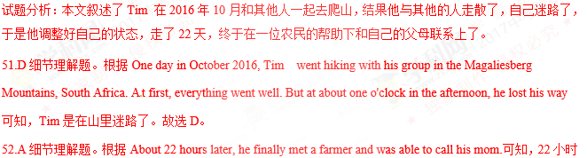后，他借用一位农民的手机给家里打了电话。故选A。
53.D细节理解题。根据He got scared at first, but then he tried to calm down. 可知，开始时，他很害怕，但是后来他镇定了下来。故选D。
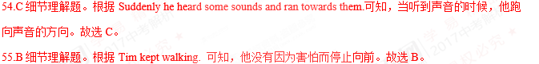
考点：考查故事类短文阅读。
C
In the 19th century, trains were the best way to travel long distances(距离) over land.Trains were fast and convenient. In the 20th century, airplanes replaced trains for long-distance travel. Today, however, high-speed trains are attracting (吸引）passengers again.
France has a train called the TGV. TGV is “Train a Grande Vitesse” in French, which means “high-speed train”. A TGV train operates at speed up to 300 km/h. The passengers can travel from Paris to Marseilles in only four hours.
The first country to have a high-speed train is Japan. The Bullet train offers a fast ,smooth ride between Tokyo and other major cities in Japan. This train operates at speed up to 210 km/h and can travel between Tokyo and Osaka in just three hours.
China has the world’s longest high-speed rail network with over 19,369.8 km of track (轨道) in service from December 2014. China’s high-speed rail system also includes the world’s longest line, the 2.298 km Beijing-Guangzhou high-speed railway. China’s high-speed trains are marked with“CRH”(China’s railway high-speed)。They are also called Hexie Hao. The fastest trainsets,CRH380BL, reached the highest test speed of 487.3km/h.
根据短文内容,选择最佳答案。(共5小题，每小题2分，满分10分)
56. What does the underlined phrase “at speed” in the second paragraph mean?
A. fast B. late C. slowly D. deeply
57. The first country to have a high-speed train is____.
A. China B. Japan C. France D. America
58.Which is the world's longest high-speed railway line?
A. The line from Beijing to Shanghai. B. The line from Paris to Marseilles.
C. The line from Beijing to Guangzhou. D. The line from Tokyo to Osaka.
59. The highest test speed of GRH380BL was___.
A. 210km/h B. over double the speed of the Japanese Bullet train.
C. 300km/h D. more than double the speed of the French TOV train.
60. What’s the main idea of this passage?
A. The development of the French TGV train.
B. The history of the Japanese Bullet train.
C. The tests of the Chinese CRH380BL trainsets.
D. The introduction of high-speed trains.
【答案】
56. A
57. B
58. C
59. B
60. D
【解析】
试题分析：短文介绍了世界上列车的历史，它的速度，最早的列车是在日本，现在有最长列车线的国家是中国，并且列车的速度是以前的两倍了。
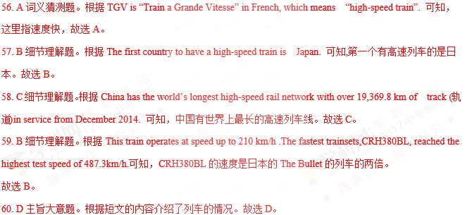
考点：考查历史类短文阅读。
D
Many people are trying to save the earth with special days like “Meatout Day”， “Earth day ”and “Buy Nothing Day”.
Meatout Day
“Meatout Day” is on March 20th. 61 Join this day, and you’ll get healthier. Also, you can reduce greenhouse gases (减少温室气体）and save the earth.
Earth Day
62 Many people all over the world try to do something green on this day. In Italy, people don’t use plastic bags. In Canada and Norway, people ride bicycles and don’t use their cars. In the USA, people dress up like plants and animals and dance in Times Square, New York.
Buy Nothing Day
“Buy Nothing Day” is usually on the fourth Friday in November. 63 “Buy nothing” means “make no rubbish”. 64 .
Do you want to join them? 65 .

根据短女内容，从短文后的选项中选出能_入空白处的最佳选项。选项中有两项为多余 选项。（共5小题，每小题1.5 分，满分7.5分）
A. This is Children’s Day.
B. When you make less rubbish, you can make a cleaner earth.
C. Many people around the world don’t eat any meat for one day.
D. Then you can remember these special days and do something green.
E. We have a national holiday.
F.“Earth Day” is on April 22nd.
G.on this day, many people don't buy anything.
【答案】
61. C
62. F
63. G
64. B
65. D
【解析】
试题分析：本文叙述了人们为了拯救地球，创造一个绿色的环境，人们设定了一些节日，来唤醒人们的环保意识。
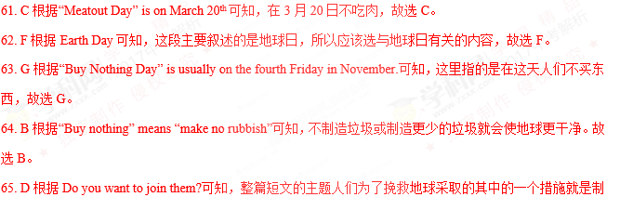定一个日期，唤醒人们的环保意识。故选D。
考点：文化类短文阅读。
第四部分写作（共三节，满分30分）
第一节单词填空
用括号中所给词的适当形式填空，使语篇意思完整，必要时请用否定式。（共10小题， 每小题1分，满分10分）
In November 1979, pupils in England 66 (be)able to watch a new TV program called Monkey. Most of them were hearing this story for the 67 (one) time. However, this story is not new to Chinese children. The Monkey King or Sun Wukong is the main character in the traditional Chinese book Journey to the West.
The Monkey King is not just any 68 (normally) monkey. In fact ,he sometimes does not even look like a monkey! This is because he can make seventy-two 69 (change) to his shape and size, turning himself into different animals and objects. But unless he can hide his tail, he 70 (can) turn himself into a man. To 71 (fight) bad people, the Monkey King uses a magic stick. Sometimes _72__(him) can make the stick so small that he can keep it in his ear. 73 (at)other times, he is able to make it big and long.
The Monkey King 74 (excite) children of China for many years. And as soon as the TV program came out more than 30 years ago, Western children became interested in 75 (read) this story because the clever Monkey King keeps fighting to help the weak and never gives up.
【答案】
66. were
67. first
68. normal
69. changes
70. can’t
71. fight
72. he
73. At
74. has excited
75. reading
【解析】
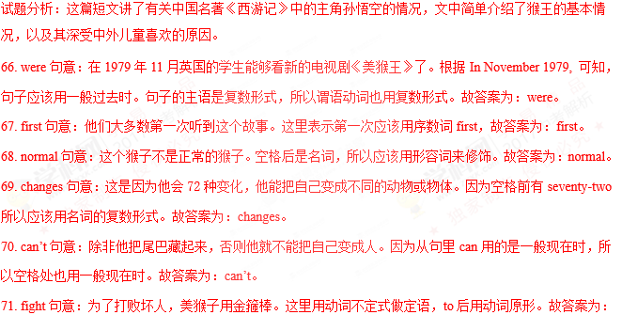 fight。
72. he 句意：有时他能把金箍棒变得很小，能藏进耳朵里。这里缺少句子的主语，所以应该用主格的形式。故答案为：he 。
73. At句意：在其他的时候，他能够把金箍棒变大变长。短语at other times在其他时候。故答案为：At。
74. has excited句意：猴王已经使中国的孩子们兴奋了很多年。根据 for many years可知，从过去开始，一直持续到现在的动作，用现在完成时。故答案为：has excited。
75. reading句意：西方的孩子们开始变得对这个故事感兴趣。因为in是介词，所以应该用动名词的形式。故答案为：reading。
考点：考查文化类短文。
第二节补全对话
根据对话内容，在空白处写出恰当的句子，使对话意思连贯完整。所写句子应与所给的 标点符号一致。（共5小题，每小题1分，满分5分）
A: Sarah, you don’t look well. 76 ?
B: I have a headache and my head feels very hot.
A: Maybe 77 .
B: Oh, maybe. 78 ?
A: You should take your temperature, lie down and rest.
B: That sounds like a good idea.
A: If you still have a fever tomorrow， you’d better go to a doctor.79____ .
B: I hope so. 80 .Kelly.
A: You are welcome.
【答案】
76.what’s the matter？
77. you have a fever.
78. what should I do ?
79. I hope you will be better soon .
80. Thank you.
【解析】
试题分析：
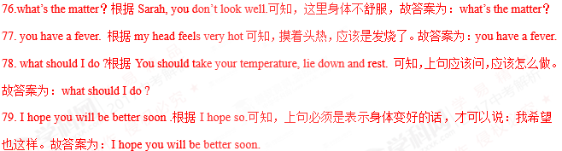
80. Thank you. 根据You are welcome.可知，上句应该是表示感谢的句子。故答案为：Thank you.
考点：补全对话。
第三节书面表达（满分15分）
A. One day in my childhood
B. My_______
要求:
1. 请从所给的A、B两个题目中任选其一作答，分值相同。如选B，请把题目补充完整再作答，例如： “ ” “My hometown”“ My pet dog”等。
2.注意紧扣主题，意思连贯，语言通顺，书写规范。
3.文中不得使用真实姓名和校名，如需使用名字，请用Mike,Gina等英文名字，校名统一用Guangming Middle school.
4.词数不少于60字。
【答案】
My home town is a beautiful place. It stands beside a wide river and is rich in fish and rice. But in the old days it was a poor and backward little town.Many people had no work. They lived a hard life. In 1949 my hometown was liberated. Since then great changes have taken place there.The streets have
been widened .Factories, schools, hospitals, cinemas and theaters have been set up one after another.The life of the
people is greatly improved. I love my hometown and all the people there. They are working hard so as to make it
still richer and more beautiful.
【解析】
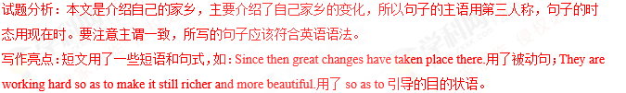
考点：话题作文。

