金山区2016-2017学年第一学期期中考试
九年级英语试卷 2016.11

（考试时间100分钟，满分150分）

Part 1 Listening (第一部分 听力)

I. Listening Comprehension（听力理解）：（共30分）
- Listen and choose the right picture (根据你听到的内容，选出相应的图片): (共6分)
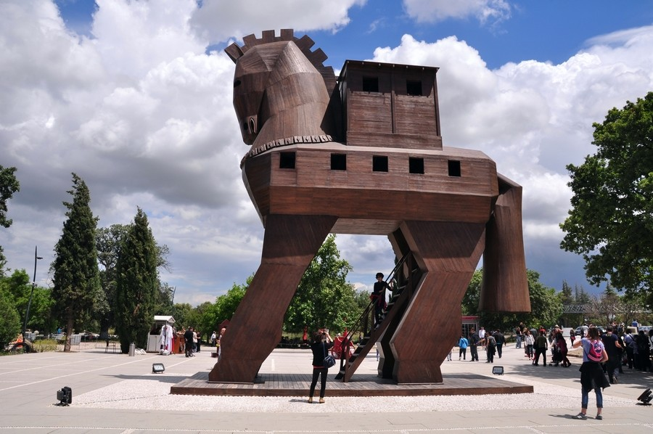
A B C D

E F G H
1.__________ 2. __________ 3. __________ 4. __________ 5. __________ 6. __________
B. Listen to the dialogue and choose the best answer to the question you hear（根据你听到的对话和问题，选出最恰当的答案）：（共8分）
7. A)Volleyball. B) Football. C) Basketball. D)Tennis.
8. A) Meat and Potatoes. B) Chicken and chips.
C) Potatoes and chips. D) Meat and chicken.
9. A) Blue. B) Yellow. C) Green. D) Grey.
10. A) By car. B) By underground. C) By bus. D) On foot.
11. A) In a library. B) In a zoo.
C) At school. D) In a bookstore.
12. A) Five yuan. B) Six yuan. C) Twenty yuan. D) Thirty yuan.
13. A) Mother and son. B) Shop-assistant and customer.
C) Teacher and student. D) Boss and secretary.
14. A) The exam had only one page. B) The exam was difficult for the girl.
C) The girl completed the exam in one hour. D) The girl found the exam easy.

C. Listen to the passage and tell whether the following statements are true or false (判断下列句子是否符合你听到的内容, 符合的用“T”表示，不符合的用“F”表示) (6分)
15. Sally told Jina how to get to her house from Heathrow Airport.
16. Jina can download an underground map from the London Underground’s website.
17. Jina has to get off at Oxford Street and change to Line 2.
18. In Sally’s letter, Jina has to take three underground lines.
19. Sally wrote to Jina to tell her the shortest route to her house.
20. Jina can ask the other passengers and the underground staff for help.
D. Listen to the passage and complete the following sentences (听短文，完成下列内容，每空格限填一词) (10分)
21. Living in caves is a __________ __________ of many European people.
22. Nowadays thousands of people __________ __________ in cave homes.
23. In the Loire valley of France, you can find the __________ __________ cave.
24. The cave areas have been used to __________ __________and grow mushrooms.
25. You can spend about US$200 staying in a cave house for __________ __________.

Part 2 Phonetics , Vocabulary and Grammar

(第二部分 语音、词汇和语法)

II. Choose the best answer (选择最恰当的答案) (共20分)
26. You shouldn’t refuse to help an old friend. Which of the following is correct for the
underlined word in the sentence?

A) / ri'fju:s / B) /' rifju:s / C) / ri'fju:z / D) /' rifju:z /
27. Which of the following underlined parts is different in pronunciation from others?
A) We dragged the box out of the room
B) There was a lantern hanging over the door.
C) He told us about his unhappy experience.
D) They successfully landed on the moon by spaceship.
28. Peter is ______ elderly man who lives alone and enjoys going travelling.
A) a B) an C) the D) /
29. --- Lucy’s skirt is black. What about yours?
--- ______ is white.
A) I B) me C) Mine D) myself
30. Can you tell me the answer ______ the question? It's difficult for me.
A) by B) on C) to D) among
31. Don’t worry, Linda. There is ______ wrong with your computer.
A) something B) anything C) nothing D) everything
32. The whole class went to the beach ______ Li Wei because he was ill.
A) except B) with C) besides D) including
33. The little girl looked ______ at her mother because she got a few sweets.
A) lovely B) happily C) friendly D) tidily
34. Jane ______ be in the office. She has gone to the meeting room.
A) mustn’t B) needn’t C) can’t D) shouldn’t
35. Once you make a decision, you’d better ______ your mind.
A) don’t change B) not change C) not to change D) not changing
36. Gong Yangling from Harbin has remembered over 15 ______ telephone numbers.
A) thousand B) thousands C) thousand of D) thousands of
37. All the restaurants are listed on the paper _______ you can choose one to have lunch easily.
A) although B) so that C) because D) if
38.Mary ______ in that housing estate since she came back to Shanghai.
A) is living B) had lived C) would live D) has lived
39. ______ useful advice she offered us! We all thank her.
A) What B) What a C) How D) How a
40. My son knows nothing about his hometown. He _____ there.
A) has ever been B) has never been
C) has ever gone D) has never gone
41. Can you guess who is doing his work ______, Mike or Jack?
A) more carefully B) more careful C) most carefully D) most careful
42. More trees ______ on both sides of the road in our city this coming winter holidays.
A) are planted B) were planted
C) have been planted D) will be planted
43. We should say sorry to the teachers when we are late for school. The underlined part means ______.
A) greet B) apologize C) describe D) answer
44. – Jill, you look busy. ______.
– Thank you, Peter, but I can manage it myself.
A) I’m sorry to hear that. B) Anything I can do to help?
C) That’s all right. D) How could you do that?
45. –Sorry, I’m late, Miss Wang. The minibus broke down, and there were no taxis.
–______
A) You’re welcome. B) That’s all right.
C) That’s right. D) It’s a pleasure.
III. Complete the following passage with the words or phrases in the box. Each can only be used once (将下列单词或词组填入空格。每空格限填一词，每词只能填一次) (共8分)
(A) A. if B. protect C. before D. afer E. later
There are many things that you should be careful with when you are alone at home. Read the following tips to protect yourself.
First, Keep the door locked when you are alone at home. Many people think it’s the best way to 46 themselves. Second, Keep a list of phone numbers to call for help, such as 110, the police station or a neighbour’s number. Third, be careful with the electrical appliances. If you don’t know how to use them, ask your parents. Make a safety check 47 going to sleep. Finally, Look through the keyhole when you hear the doorbell. If there are strangers, ask “Who’s that?” with the door locked and say “Come back 48 ” Don’t tell them that your parents are away. Say “Mum’s having a shower.” Or “Dad’s having a sleep.” To ignore the doorbell is not a good idea because sometimes bad people ring doorbells to see 49 anyone’s at home.

(B) A. begin B. program C. end D. pleased E. call
This is a message for Marco Daniel. My name’s David Dolby. I’m sorry I missed your 50 . I understand that you want some information about the volleyball club. The club meets once a week, on Wednesday evening. There are sometimes matches on Sunday morning, but those are just for our team players. Our meetings 51 at eight, and are about two hours long, so we finish at ten. People like to get home in time for the 10:15 sports 52 on television. We meet in the Jubilee Hall in Park Lane, behind the High Street. The hall doesn’t have very good heating, so you’ll need to bring a coat to put on afterwards. It’s also quite expensive to rent, so our players pay ￡2.75 each week. I hope this answers all your questions and we’ll be very 53 to see you at our next meeting.
IV. Complete the sentences with the given words in their proper forms (用括号中所给单词的适当形式完成下列句子。每空格限填一词) (共8分)
54. On the ________ day, the sick boy came back to life. (four)
55. Make sure that every English word you can spell . (accurate)
56. All the _________ in Rio de Janeiro celebrated the coming Olympic Games. (city)
57. Although the old man lost his way in the park, he managed to go home by______. (he)
58. The _________ of Michael Jackson, the King of Pop, made his fans very sad. (die)
59. We hope that more university students will _________ in finding good jobs soon. (success)
60. It’s __________ for Jack to climb such a high mountain. He decided to give it up. (possible)
61. He felt that the reporter should be __________ for what he had reported. (responsibility)
V. Complete the following sentences as required (根据所给要求，完成下列句子。每空格限填一词) (共14分)
62. We have already saved enough money to buy a camera. (改为否定句)
We _________ saved enough money to buy a camera _________.
63. It rarely snows in Shanghai in winter. (改为反意疑问句)
It rarely snows in Shanghai in winter, ?
64. The nearest hospital is about fifteen minutes’ ride from our school. (对划线部分提问)
________ ________ is the nearest hospital from our school?
65. You should write all the answers on the answer sheet. (改成被动语态)
All the answers should ______ ______ on the answer sheet.
66. “Can you help me repair the bike? ” Mary asked Jack. (保持句意不变)
Mary asked Jack _______he _______ help her repair the bike.
67. Betty is warm-hearted. Everyone wants to make friends with her. (合并为一句)
Betty is ________ warm-hearted ________ everyone wants to make friends with her.
68. spent, the homework, an hour, more than, I, yesterday, on (连词成句)
___________________________________________________

Part 3 Reading and Writing (第三部分 读写)
VI. Reading comprehension (阅读理解) (共50分)
- Choose the best answer (根据短文内容，选择最恰当的答案) (12分)

On a freezing January morning, Myron opened the library in Iowa. She heard a cat cry and finally found a yellow kitten in a pile of books.
“His little feet were frozen,” Myron recalls. “We gave him a bath to warm him up and he purred the whole time so that we know he liked us very much.”
That was 1988 and it was a story for Dewey, the cat who has lived happily among the books ever since. “His story has a life of its own, we have people drive hundreds of miles out of their way just to see Dewey. We even had a Japanese public television crew come here to make a short film of him. ”Shortly after the kitten’s rescue, a photo of the library’s “new employee” appeared in local newspapers. Local people were invited to vote for the name of the kitten. “We have never had such a big crowd for a contest and there wasn’t even a prize,” Myron says with a laugh.
Dewey grew from a popular local “library employee” to a national star with his pictures on calendars. However, he is not the only cat who lives among books. Library cats greet people in about 125 libraries across America. Most live and “work” in comfortable, small town libraries where they don’t get lost in the books. Library cats used to make a living by catching rats, but library cats have more duties: to a make the library a pleasant place.
“Library cats just create a nice, warm atmosphere (气氛),” says Gary Roma, producer of Puss in Books, the film about library cats. “The cats attract children to the library and the elderly who maybe can’t have pets in their apartments,” Roma says. “Books, libraries, and cats just go together.”
69. The cat Dewey was found by Myron in the ______ of 1988.
A) spring B) summer C) autumn D) winter
70. The underlined word “purr” in the second paragraph means “____”.
A) feel angry B) feel happy C)feel hungry D) feel sleepy
71. A contest was held after the kitten’s rescue to ______ the cat.
A) win B) name C) film D) feed
72. Library cats can do many things including ______.
A) acting for a film B) catching rats
C) making people pleased D) All of the above
73. Puss in books was ______.
A) a book about cats B) a film about Dewey
C) a film about library cats D) a film about popular libraries
74. From the passage we can infer (推断) that ______.
A) Library cats only attract children and old people
B) Dewey is one of the cats who live among books.
C) Library cats are not as popular as they used to be
D) Every library in America has at least one cat

B. Choose the best words and complete the passage (选择最恰当的单词完成短文) (12分)


Doing experiments is one of the most interesting things about studying chemistry. In China, it’s often teachers who do the experiment in the front of the class with students ______. But in the US, students take action by themselves.
The first time I took a class in my school’s chemistry lab, I was surprised to find that students were wearing special glasses, plastic gloves, as if there had been a bio-chemical attack! ______ is always the most important for science lab classes in America. The outfit (装备) prevents us from harmful chemical materials.
My chemistry teacher usually gives us the instruction sheet the night before the lab class to let us know a lot about the experiments. During the class, she first ______ the steps of the experiments and then puts us into groups to do the experiments. What’s special is that for every lab class, she changes everyone’s partner to let us work with ______ classmates.
The class is often filled with laughs. Once we tried to burn chemicals. The chemicals produced many colors of flames(火焰), ______ bright orange and dark green. Many students in my class were amazed. “Wow! That’s so beautiful!” they screamed.
After finishing an experiment, we need to write a detailed report. It consists of the steps, our feelings and the final results. If there has been a mistake in the experiment, we need to analyze (分析) why it happened and ______ we should do to correct it. The reports are important. They make up around 25 percent of our term grade.
( )75. A. playing B. watching C. singing D. sleeping
( )76. A. Fun B. Time C. Money D. Safety
( )77. A. wait for B. care for C. go over D. clean out
( )78. A. different B. same C. tall D. clever
( )79. A. during B. from C. through D. including
( )80. A. how B. what C. where D. when
C. Read the passage and fill in the blanks with proper words (在短文的空格内填入适当的词，使其内容通顺。每空格限填一词，首字母已给) (14分)
He was just an ordinary p___________. Day after day, he went regularly across the village. For him, life was without waves.
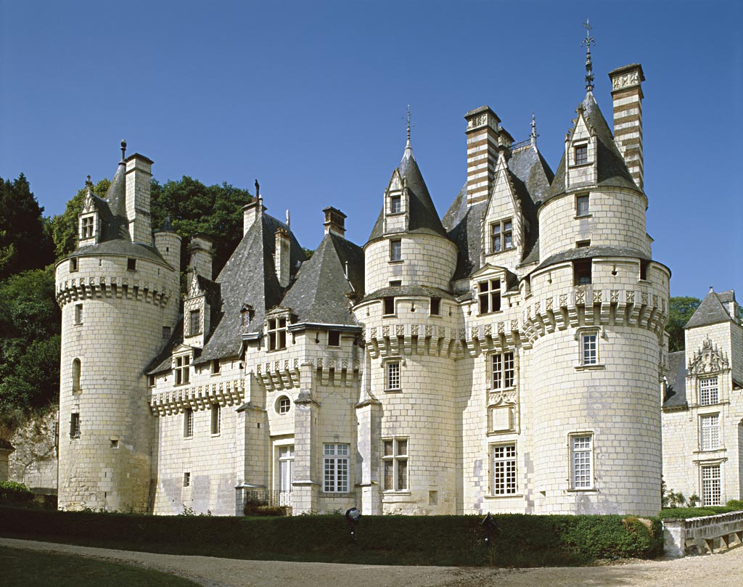
One day, he was delivering mails as usual. When he looked up in the sky, he s____________ lost his balance（平衡）. It was a little stone that caught his feet. He found it strange but beautiful. He then placed the stone in his bag carefully. Because of this stone’s arrival, his day was lightened. He had a thought—I can b____________ a castle with such beautiful stones. How wonderful it will be!
His ordinary life started to be different since then. He still delivered mails, but he collected every stone he could find along the way. All those dusty stones, in his eyes, shone like diamonds. After collecting e____________ stones, he started. During the daytime, he passed along the dreams of others; and during the night time, he had his own dream. No one was willing to join in. But he was still happy ___________ he knew, the dream and the castle only belonged to him.
After 20 years of working day and night, his dream castle was finally completed. It was a wonderful castle just as he i____________.
This is a real story. His name is Xue Waller. The stone castle has become one of the most famous tourist a____________ in France. At the entrance of the stone castle, there is a sentence—“I want to know how far a dream stone can go.”
81. p____________ 82. s____________ 83. b____________ 84.e____________
85. b____________ 86. i____________ 87. a____________
D. Read the passage and answer the following questions. (根据短文内容回答下列问题)(12分)
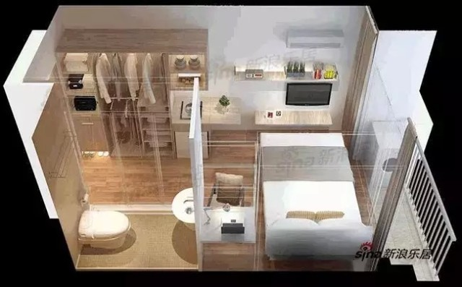
What will the home of the future look like? A team of architects in Hong Kong say that city homes will be tiny, as populations continue to grow and space becomes more expensive.
They have designed “spaceflats” that are only 30 square metres in size. These flats have small rooms: a living room, a bathroom and a bedroom, as well as a balcony (阳台), but everything is carefully planned to make good use of the limited space.
The living room is the main room of the flat. It can be used as an office, a kitchen even a second bedroom. There is a sofa that can be changed into a bed. The dining table can be changed into a computer desk. And, if not needed, both the sofa-bed and the table can be folded away (折叠收拢). There is a flat-screen TV, which can also serve as a computer monitor. You can’t see the cooker, the microwave and the small refrigerator because they are all hidden out of sight.
The other rooms are small but practical (实用的). The bathroom contains a toilet and a shower. The double bed in the bedroom can also be a sofa, if necessary. The balcony has enough space for two people to sit and you may see an amazing fountain on it . All the rooms have high ceiling to provide as much storage (存储) space as possible, while the flat has large windows to let in plenty of sunlight.
“Spaceflats” are now being tested in a building in Hong Kong. It’s wonderful, said one citizen. “The flat is so well designed that you feel that here is plenty of space.”

88.How big are the “spaceflats”?
89.What can the living room be used as?
90.How many things are hidden out of sight?
91.Where can the owner enjoy the nice view ?
92.There is plenty of sunlight in the flats, isn’t there?
93.Would you like to live in the “spaceflats”?Why?

VII. Writing (作文) (共20分)
94. Write at least 60 words about the topic "My opinion on playing computer games"( 以“ 我对玩电脑游戏的看法”为题 ,写一段不少于60个字的短文，标点符号不占格。)
（注意：短文中不得出现任何人名、校名及其它相关信息，否则不予评分。）
Suggested questions: (以下内容仅供参考)
1. What is your opinion about playing computer games ?
2. Why do you think so? (Give at least two reasons)
3. What suggestions will you give about playing computer games?

_______________________________________________________
________ ________ ________ ________ ________ ________ ________ ________ _________
________ ________ ________ ________ ________ ________ ________ ________ ________
________ ________ ________ ________ ________ ________ ________ ________ ________
________ ________ ________ ________ ________ ________ ________ ________ ________
________ ________ ________ ________ ________ ________ ________ ________ ________
________ ________ ________ ________ ________ ________ ________ ________ ________
________ ________ ________ ________ ________ ________(60) ________ ________ ______
________ ________ ________ ________ ________ ________ ________ ________ ________
________ ________ ________ ________ ________ ________ ________ ________ ________

2016-2017学年第一学期期中考试
九年级英语
听力文字稿及参考答案
Part 1 Listening
Ⅰ. Listening comprehension（听力理解）

A. Listen and choose the right picture (根据你听到的内容，选出相应的图片): (共6分)
1. I like the story of The Night of the horse. （C）
2. The old man is good at cormorants fishing. (F)
3. Kathy is no longer a baby. She’s a pretty girl now. (A)
4. Computers bring us a lot of information every day. (E)
5. After school, Mary loves playing with her little puppy at home. (D)
6. Sun Yang won the gold medal on the third day of Rio Olympics. (B)
B. Listen to the dialogue and choose the best answer to the question you hear.(根据你所听到的对话和问题，选择最恰当的答案): (共8分)
7. M: I don’t like such sports as football or volleyball.
W: Oh. I do. And I like tennis even better. I play it every day.
Q: What sport does the woman play every day? (D)
8. W: What do you usually have for supper, Mike?
M: Meat and potatoes. But my brother likes chicken and chips.
Q: What does Mike’s brother usually have for supper? (B)
9. M: What a lovely dress! Where did you buy it?
W: I bought it in Huaihai Road last week. It’s green. I like this colour best.
M: Yeah. It’s nice, but I prefer blue and yellow.
Q: What colour does the woman like best? (C)
10. W: Do you always drive to work?
M: Yes, I usually do. But when it rains heavily, I don’t drive.
W: How do you go then?
M: I go by underground.
Q: How does the man usually go to work? (A)
11. M: The children want to stay longer to see more animals.
W: OK. Let’s move to the Monkey section. There must be more fun over there.
Q: Where does this dialogue probably take place? （B）
12. M: How much is the cup?
W: Six yuan.
M: Ok, I’ll take five.
Q: How much should the man pay? (D)
13. W: Tim, you are late. You never come to school late. What’s the matter?
M: I went over my lessons late last night. I was too tired this morning.
W: Ok. Don’t be late again next time.
Q: What is the relationship between the two speakers? (C)
14. M: What did you think of the Math exam?
W: I was expecting it to be easy, but after the first hour, I was still on the first page. I hardly had time to finish it.
Q: What can we know from the dialogue? (B)
III. Listen to the passage and tell whether the following statements are true or false (判断下列句子是否符合你听到的短文内容，符合的用“T”表示，不符合的用“F”表示):
Hey, Jina!
I’m so glad you’re coming to stay! Let me give you some directions from the airport. You can also download an underground map from the London Underground’s website. Anyway, I hope you will understand my instructions!
From Heathrow, get on the underground Line 1. You’ll pass a lot of stations, but you need to get off at London Library. From there, you should take the Line 2 to Oxford Street. It’s only one stop, so don’t miss it! At Oxford Street, you have to change again. You need get on the red Central Line. Make sure you get the right platform. My house is really close to Mail Station – it’s really convenient. Just give me a call when you arrive and I’ll come to meet you! It’s not the shortest route here, but I think it’s the simplest. If you have any problems, just ask the other passengers. The underground staff will always help you, too.
Looking forward to seeing you soon!
Love,
Sally

15-20 TTFTFT
D. Listen to the passage and complete the following sentences (听短文，完成下列内容，每空格限填一词) (10分)
We all know that people lived in caves long ago. It is a traditional way of many European people. Living in these homes is more comfortable than you might think. Nowadays thousands of people in southern Spain and central Turkey still live in cave homes.
They are naturally cool in summer and warm in winter. There are windows and doors. Many cave homes have telephones, and some even have fax and Internet connections. In Spain, there is also a desktop computer in each room. Perhaps the most modern cave in the world can be found in the Loire valley of France. For hundreds of years, the cave areas have been used to store wine and grow mushrooms. In recent years, all the caves have been fitted with nice conveniences like running water and electricity. There’s even a restaurant that serves 5-course meals.
If you travel to some of these places, you can even find hotels that are in caves. In a village in Turkey, for example, staying in a cave house may cost you around US$200 for 3 days.

21 traditional way 22 still live 23 most modern 24 store wine 25 3 days
Part2 Vocabulary and Grammar

II. Choose the best answer (选择最恰当的答案) (共20分)
26.C 27.D 28. B 29.C 30.C 31.C 32. B 33. A 34.C 35. B
36. A 37.B 38. D 39. A 40.B 41.A 42.D 43. B 44.B 45.B

III. Complete the following passage with the words or phrases in the box. Each can only be used once (将下列单词或词组填入空格。每空格限填一词，每词只能填一次) (共8分)
46. B 47. C 48. E 49. A 50. E 51.A 52. B 53. D

IV. Complete the sentences with the given words in their proper forms (用括号中所给单词的适当形式完成下列句子。每空格限填一词) (共8分)
54.fourth 55.accurately 56. citizens 57.himself
58. death 59. succeed 60. impossible 61. responsible

V. Complete the following sentences as required (根据所给要求，完成下列句子。每空格限填一词) (共14分)
62. haven’t yet 63. does it 64. How far 65. be written 66. if could 67. so that
68. I spent more than an hour on the homework yesterday .
Part 3 Reading and Writing (第三部分读写)

VI. Reading comprehension (阅读理解) (共50分)

A. Choose the best answer (根据短文内容，选择最恰当的答案) (12分)
69. D 70. B 71.B 72.D 73.C 74. B

B. Choose the best words and complete the passage (选择最恰当的单词完成短文) (12分)
75. B 76. D 77.C 78.A 79.D 80. B

C. Read the passage and fill in the blanks with proper words (在短文的空格内填入适当的词，使其内容通顺。每空格限填一词，首字母已给) (14分)
81. postman 82. suddenly 83. build 84.enough 85. because 86. imagined 87. attractions

D. Read the passage and answer the following questions. (根据短文内容回答下列问题12分)
88. 30 square metres.
89. It can be used as an office, a kitchen even a second bedroom..
90. 3.
91. On the balcony.
92. Yes, there is.
93. Any reasonable answer can be accepted.

VII. Writing (作文) (共20分)

94. Write at least 60 words about the topic "My opinion on playing computer games"( 以“ 我对学习玩电脑的看法”为题 ,写一段不少于60个字的短文，标点符号不占格。)

（注意：短文中不得出现任何人名、校名及其它相关信息，否则不予评分。）
写话评分标准：
作文共20分，其中内容8分，语言8分，组织结构4分。
- 内容：
7-8分内容切题，意思连贯，表达清楚、完整。
5-6分内容基本切题，意思大致连贯，表达基本清楚，但不够完整。
3-4分内容不够切题，意思不够连贯，表达不够清楚，离题目要求较远。
0-2分文不对题，表达不清。
（二）语言：
①拼写：每错扣0.5分，同一错误不重复计数。
②语法：同①
③标点符号、大小写：每两处错误扣0.5分，但标点符号和大小写的扣分总和均不得超过1分。
④语言分最多扣8分。
（三）组织结构：
①内容充实，不写废话；上下文连贯、用语规范、表达正确、无或少见语法错误；词汇和句型句式运用恰当，多见好句型和习惯表达用语者，可给4分。
②一般情况下，要得到4分组织结构分，内容和语言积累得分在14分以上者（含）。
③内容和语言累积不足14分者，如文中有值得肯定的好的句型和表达，可酌情考虑给1-2分组织结构分。
④通篇句型、句式单一。词汇贫乏者，即使无语法错误，一般亦不给组织结构分。

（四）词数：
①词数不足30词者，得分最多不得超过9分；
②词数不足40词者，得分最多不得超过14分；
③词数不足50词者，得分最多不得超过15分；
④词数在50-59词之间者，每少5个词扣0.5分；
⑤只写出个别单词、词不成句不给分。

