普陀区2016-2017学年度第一学期初三质量调研
英语试卷
（满分150分，考试时间100分钟）
Part I Listening (第一部分 听力)
I. Listening Comprehension(听力理解)（共30分）
A. Listen and choose the right picture.(根据你听到的内容，选出相应的图片)（6分）
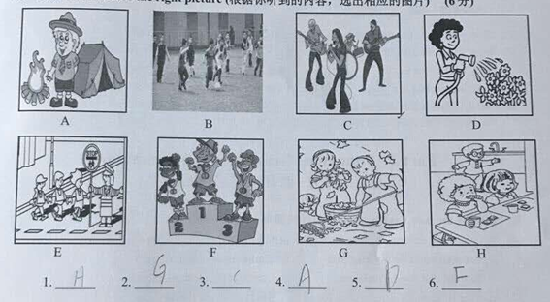
B. Listen to the dialogue and choose the best answer to the question you hear.(根据你听到的对话和问题，选出最恰当的答案)（8分）
7.A）On Sunday B)On Tuesday C)On Thursday D)On Friday
8.A)He has a stomachache B)He has a cold
C)He has to stay at home D)How to speak English
9.A)How to read a poem B)How to teach Chinese
C)How to write a love story D)How to speak English
10.A)The salad B)The juice C)The steak D)The dessert
11.A)By underground B)By bus C)By taxi D)By car
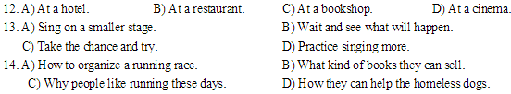
C. Listen to the passage and tell whether the following statements are true or false(判断下列句子是否符合你听到的短文内容，符合的用T表示，不符合的用F表示)
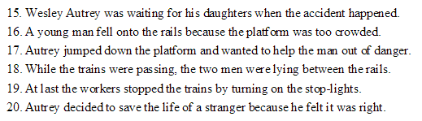
D. Listen to the passage and complete the following sentence( 听短文，完成下列内容，每空格限填一词)
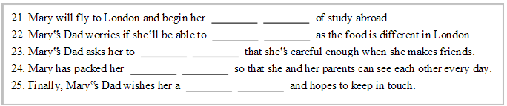

Part 2 Phonetics, Grammar and Vocabulary

II. Choose the best answer(选择最恰当的答案) 20分
26. Which of the following underlined parts is different in pronunciation from others?
A.Put your hand on my shoulder B.Mother is so proud of me
C.Tom drew a mouse just now D.Can the kid count numbers
27. In order to keep fit ,Simon goes for_____swim after work every day.
A./ B.a C.an D.the
- _____ the toy attracted many people’s attention, it didn’t have many buyers.
A.If B.Though C.As D.Because
29. Stephen learned skating _____several months when he lived in German.
A.on B.in C.at D.for
- At last I saw the wild lions and elephants in Africa with_____own eyes!
A.I B.me C.my D.mine
- All the seats in the library are empty now. You may take _____of them.
A.either B.neither C.any D.both
- The parents haven’t heard _____their kid in Europe for a long time.
A.at B.to C.with D.from
- The brave fire fighters saved the people in the building one after _____.
A.another B.the other C.others D.the others
- Jane’s twin brothers are making much _____progress this term than last term.
A.great B.greater C.greatest D.the greatest
- The search for the missing old man continued______he was found.
A.until B.while C.after D.since
- We saw a huge rainbow on our way home._____, I had my camera with me.
A.Luck B.Lucky C.Luckier D.Luckily
- Look! Someone _____up the hall already and we can just relax!
A.cleans B.will clean C.cleaned D.has cleaned
- Mr,Drake called 5 minutes ago. He’d like your nephew _____his fence.
A.fix B.fixes C.to fix D.fixed
- Yesterday the funny short play made every audience in the theater_____.
A.laugh B.to laugh C.would laugh D.laughed
- When he retired at 65,he_____painting in over 20 cities in Europe and Asia.
A.teaches B.has taught C.had taught D.would teach
- Don’t worry!Our boss is coming and_____you there in five minutes.
A.will meet B.meet C.met D.has met
42. --_____did the winner of the bicycle race ride?
--At the speed of 40km/h.
A.How long B.How fast C.How much D.How far
- Dustin has been warned that he _____lose at least 10 pounds if he wants to stay healthy.
A.may B.can C.would D.should
- --It’s so kind of you to hold the door for me.
--_____.
A.Thank you B.I’m afraid not C.My pleasure D.That’s right
- --Would you mind if I put my umbrella here,too?
--_____.There’s enough space.
A.Of course B.Not at all C.Take care D.You’re welcome
III. Complete the following passage with the words or phrases in the box. Each can only be used once(将下列单词或词组填入空格。每空限填一词，每词只能填一次)（共8分）
- investigate | - escape | - recently | D)conversations | E) confident

Look at the people around you in class. Think back to what they ___46____ said, and study it. Did the boys use words and sentences different from those the girls used? Did the boy seem more ___47____ than the girls did? Some people would probably answer yes to both questions. They believe that males and females have different ways of speaking. They also think that the differences can make it hard for boys and girls to understand one another. To check these ideas, language scientists have worked to ___48_____ the ways that males and females speak. After studying many __49_____, some scientists say they hear some difference.
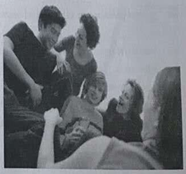
- conclusion | - on the other hand | - basic | D)equal | E)chat

One difference is about the topic. Some language scientists believe that boys talk most often about things, while girls talk most about feelings. For example, boys might ___50____ about cars, sports, and games. Girls, ___51____, might talk about what is happening in their friends’ lives. They want to make people feel ___52____ and comfortable. Language scientist Deborah Tannen draw a ___53____ , “Boys learn to use talking as a way to get and keep attention. From childhood, girls don’t get along with those who try to perform better than others.”
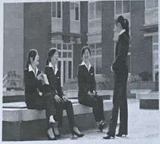
IV. Complete the sentences with the given words in their proper forms(用括号中所给单词的适当形式完成下列句子。每空格限填一词)（共8分）
54. David plans to travel around the world with his family in his _______. (sixty)
55. I usually ask _______ some questions before I make a big decision. (I)
56. We all know that Detective Ken is good at dealing with such _______. (case)
57. Our success in the local market _______ depends on your support. (main)
58. The students learnt to cook some _______ English dishes in the host family. (tradition)
59. Looking at your phone in the darkness will do _______ to your eyes. (harmful)
60. I got interested in _______ because of a movie about science. (physical)
61. The bicycle-sharing system may help reduce air _______ in big cities. (pollute)

V. Complete the following sentences as required. (根据所给要求完成句子。62-67小题每空格限填一词)（共14分）
62. Linda’s laptop often goes wrong when she’s doing something important.(改为一般疑问句)
_______ Linda’s laptop often _______ wrong when she’s doing something important?
63. The sea wave reached 10 meters in the storm. (对划线部分提问)
_______ _______ was the sea wave in the storm?
64. It’s so pleasant to visit an old friend from time to time. （改为感叹句）
_______ _______ it is to visit an old friend from time to time!
65. Martin doesn’t play for the school football team any longer. (保持句意不变)
Martin is _______ _______ a member of the school football team.

66. The fisherman tied a piece of grass around the bird’s neck. (改为被动语态)
A piece of grass _______ _______ around the bird’s neck.
67. “Do you take your pet to work every day?” the reporter asked the actress. (改为宾语从句)
The reporter wondered _______ the actress _______ her pet to work every day.
68. doing, Jim, interesting, in, experiments, cares for, the chemistry lab (连词成句)
_____________________________________________________________________________

VI. Reading Comprehension
A. Choose the best answer（根据以下内容，选择最恰当的答案）（12分）
If you are going to apply for a job ,be prepared for the kinds of interviews you can expect .One type of interviews is the telephone interview. Here are some tips for telephone interviews:______________. Before the interview ,guess and write down the questions you might be asked. Practise the answers orally until you are satisfied with yourself. The questions scan be about your working experiences, skills and achievements.
Keep your notes handy. Have any key information next to the phone, including your notes about the company and the questions you have prepared for. Then you can easily get the information you need. In this way, you will sound more prepared.
Avoid salary topics. When you are asked how much money you would expect, it’s not wise if you give no response. But it’s not right to give an exact number at once. Try to be open to discussion, so you’d better say something like, “If this is the right job for me, I believe we can come to an agreement on salary ”
Push for a face-to-face meeting. At the end of the interview, don’t forget to sell yourself. You cab say something like, “I am very interested in your company. If possible I’d be really happy to see some of your managers. I am free either Tuesday afternoon or Wednesday morning. Which would be better for you?”
Try to rearrange surprise interviews. If you receive an interview call without any expectation, you can politely ask them to arrange another time for the interview, so you can be better prepared. Try something like, “I am sorry but I can’t do it right now. Can I call you back tomorrow after work, at 6p.m.?”
After the telephone interview, only a few are left for face-to-face interview, so get prepared and good luck!

- The article is about________.
A. how to apply for a job B. how to make telephone call
C. how to deal with a telephone interview D. how to take telephone messages
- Which one best suits the “________” in paragraph 2?
A. Make a self-introduction B. Practice working skills
C. Write down the answers D. Predict the questions
- The underlined word “handy” in paragraph 3 is closest in meaning to ________.
A. easy to get B. easy to recognize
C. easy to hold D. easy to understand
- Which might be the best response to the questions about salary?
A. I am expecting a salary of $5000 month.
B. My salary requirements can be discussed.
C. May I not answer your question?
D. I don’t mind at all.
- At the end of the interview, you should ________.
A. talk to some of the managers B. try to ask for a meeting
C. tell them where you live D. let them introduce themselves
- You’d better________ if you receive a surprise call from the interview.
A. not answer the call B. ask someone else to answer it
C. ask for another interview D. Start you interview at once

B. Choose the best answer and complete the passage (选择最恰当的选项完成短文)（12分）
Have you ever been in a meeting and suddenly found that your mind was a million miles away while someone was making a speech? You probably felt 75 and made up your mind to pay attention and never daydream again. Most of us, from the earliest school days, have been told that daydreaming is a waste of time.
“On the contrary,” says an expert in psychology, “daydreaming is quite 76 . Without it, the mind couldn’t do all the thinking it has to do in daily life. You can’t possibly do all your thinking with a conscious mind. 77 , your unconscious mind is working out problems all the time. The unconscious and conscious states of mind have a silent dialogue in the way of daydreaming.”
Early experts in psychology paid no attention to the 78 of daydreaming, and even considered it harmful. They did not have a better understanding of daydreams until the late 1980s. Eric Klinger, a professor of psychology, is the writer of the book Daydreaming. Klinger says, “Now we know that daydreaming is one of the main ways that we organize our lives, 79 our experiences and plan for future.” Daydreams really show the things we fear and the things we desire in life.
Daydreams are usually very simple and direct while sleep dreams may be hard to understand. It’s easier to gain a deep understanding of your life by paying close attention to your daydreams than by studying your sleep dreams 80 . Daydreams help one recognize the difficult situation in life and find out a possible way for dealing with them.
So next time you catch yourself daydreaming, don’t stop.
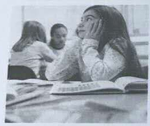
75. A. sorry B. lonely C. angry D. bored
76. A. easy B. interesting C. necessary D. clear
77. A. In addition B. For example C. What’s more D. In fact
78. A. importance B. time C. variety D. environment
79. A. write down B. learn from C. talk about D. depend on
80. A. happily B. early C. immediately D. carefully

C. Fill in the blanks with proper words (在短文的空格内填入适当的词， 使其内容通顺， 每空 格限填一词，首字母已给） （14 分）w
This is a true story of a teenager caught in a deadly storm. He m 81 to stay alive by using tips the survival TV shows taught.
One Sunday, Nicholas went skiing. In the early afternoon, a fierce snowstorm swept into the area. Unable to see far, he accidentally turned off the path. Before he r 82 this, Nicholas found he was lost! He didn’t have food, water, a phone, or other useful things.
Nicholas had no idea where he was. He told himself to be c 83 . He thought about all the survival shows he had watched. He decided to stop skiing. He needed to find shelter from the freezing wind and snow.
Nicholas built a snow c 84 . He gathered a huge amount of snow and dug out a hole in the middle with his skis. He got in. Then he put branches on himself, like a b 85 , to stay as warm as he could. He ate snow and drank water from a nearby streams so that his body wouldn’t lose too much water.
The next day, Nicholas went out to look for help, but he couldn’t find anyone. He didn’t dare to go too far,
o 86 he might not be able to find his way back. Without shelter, he could die that night. On Tuesday, Nicholas went out again. He had walked for about a mile when a volunteer searcher found him.
Nicholas had often watched Bear Grills’ survival show Man vs. Wild. That’s where he learned the tips that helped him survive. When Grills heard about Nicholas experience, he said it was really a 87 that the teenager had made it. He told the reporters that most people would likely make big mistakes if they were lost in a deadly storm.
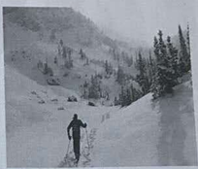
D. Answer the questions（根据短文内容回答下列问题）（12分）
One day Doctor Ken received a call and was told that a boy called Franco needed an immediate operation. He entered the hospital hurriedly. He changed his clothes and went directly to the operating room.
Franco’s father was walking up and down in the hall, waiting for the doctor. On seeing Doctor Ken, the father shouted, “Why did you take so long to come? Don’t you know my son’s life is in danger? Don’t you have any sense of responsibility?”
Doctor Ken smiled and said, “I am sorry. I wasn’t in the hospital and I came as fast as I could and now, I wish you’d sit down and be patient so that I can do my work.”
“Be patient?! What if your son was in this room right now? If your own son dies while waiting for the doctor, then what will you do?” said Franco’s father angrily.
Doctor Ken smiled again and replied, “We will do our best and you should also pray for your son’s healthy life.”
The operation lasted several hours. Then Doctor Ken went out of the operating room happily. “Thank goodness! Your son is saved!” And without waiting for the father’s reply he ran out of the hospital, saying, “If you have any question, ask the nurse.”
“Why?” complained Franco’s father, “He couldn’t even wait some minutes so that I can ask about my son’s state.”
The nurse answered, tears coming down her face, “Doctor Ken’s son died in a road accident. He was at the burial（葬礼）when we called him for your son’s operation. And now that he saved your son’s life, he left running to finish his son’s burial.”
Hearing this, Franco’s father felt so sorry. And at the same time he was really_________.
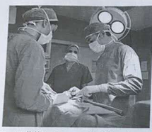
88. Franco needed to be operated on, didn’t he?
______________________________________________________________________________.
89. Where did Franco’s father wait for the doctor?
______________________________________________________________________________.
90. How did Doctor Ken speak to Franco’s father when he shouted at him?

Doctor Ken spoke to Franco’s father______________________________________________.
91. In what way did Doctor Ken leave the hospital after the operation?
______________________________________________________________________________.
92. According to the nurse, what had happened to Doctor Ken’s son?
______________________________________________________________________________.
93. Which word can be used to complete the last sentence? Why?

And at the same time Franco’s father was really ____________________________________
because_______________________________________________________________________.

VII. Writing (作文）（共 20 分）
- Write a short passage of at least 60 words on the topic “My favourite activity at the School ________ (Science/Art/English...) Festival ”(根据下面的信息，写一篇不少于60个词的短文，标点符号不占格。)
信息提示： 以学校__________科技/艺术/英语....节中我最喜欢的一项活动为题，写一篇不少于60词的作文。
为了给学生提供更多学习和展示平台，学校每年举行各种活动，例如，科技节，艺术节，英语节等等，请选取某个活动中你最喜欢的一项活动，可以结合你最近的一次经历，谈谈你在该项活动中做了什么，以及你最喜欢这项活动的理由。
（注意：短文中不得出现任何人名、校名及其他相关信息，否则不予评分。）

参考答案：
1、H 2、G 3、C 4、A 5、D 6、F
7、C 8、A 9、A 10、D 11、A 12、B 13、C 14、A
15、F 16、F 17、T 18、T 19、F 20、T
21、first year 22.eat well 23. come back 24.new computer 25.happy birthday
26-45 ABBDC CDABA DDCAC ABDCB
46--53 CEAD EBDA
54--61 sixties myself cases mainly traditional harm physics pollution
62--68 Does go How high How pleasant no longer was tied whether/if took
Jim cares for doing interesting experiments in the chemistry lab.
69--74 CDABBC
75--80 ACDABD
81--87 managed realized calm cave blanket otherwise amazing
88-93 88.Yes,he did
89.In the hall.
90.politely and patiently
91.He ran out of the operating room happily without waiting for the father’s reply.
92.His son died in a road accident.
93.参考 moved/ashamed
Because the doctor’s behavior is so selfless.
Because he shouted at the doctor impatiently....

