盐城市时杨中学2012/2013学年第二学期高一调研考试
英语试题
注: 1.本试卷共8页,五大部分,86小题,总分120分。
2.考试时间120分钟。
3.选择题答案用2B铅笔涂到答题卡上,非选择题答案一律写到答题纸上。

第I卷 选择题 （共85分）
第一部分：听力(共两节，满分20分)
第一节(共5小题；每小题1分，满分5分)
听下面5段对话。每段对话后有一个小题，从题中所给的A、B、C三个选项中选出最佳选项，并标在试卷的相应位置。听完每段对话后，你将有10秒钟的时间来回答有关小题和阅读下一小题。每段对话仅读一遍。
1. Where is Jimmy now?
A. At the hotel. B. At home. C. At the lab.
2. What does the man probably do?
A. A waiter. B. A taxi driver. C. A guide.
3. How does the woman feel?
A. Discouraged. B. Satisfied. C. Excited.
4. How many bank robbers were there altogether?
A. One. B. Three. C. Four.
5. How much will it cost the speakers to have the car repaired?
A. $900. B. $600. C. $300.
第二节 (共15小题；每小题1分，满分15分)
听下面5段对话或独白。每段对话或独白后有几个小题，从每题所给的A、B、C三个选项中选出最佳选项，并标在试卷的相应位置。听每段对话或独白前，你将有时间阅读各个小题，每小题5秒钟；听完后，各小题将给出5秒钟的作答时间。每段对话或独白读两遍。
听第6段材料，回答第6、7题。
6. What does the man’s father do?
A. A writer. B. A teacher. C. A photographer.
7. Who is not in the photograph?
A. The man’s father. B. The man’s mother. C. The man’s sister.
听第7段材料，回答第8至10题。
8. What is the woman going to do?
A. Attend a party. B. Take a holiday. C. Go on a business trip.
9. When does the woman plan to arrive?
A. Late Friday. B. Midday Saturday. C. Saturday night.
10. What will the man take with him?
A. A rain coat. B. An umbrella. C. A sweater.
听第8段材料，回答第11至13题。
11. How much money does the man want to borrow?
A. $10. B. $20. C. $30.
12. Why does the man need to borrow money?
A. To buy a present. B. To hold a party. C. To buy a shirt and tie.
13. When does the man say he will pay his mother back?
A. Next week. B. Next month. C. Next year.
听第9段材料，回答第14至16题。
14. Why does the woman feel unhappy?
A. The Molinas don’t treat her nicely.
B. The letter reminded her of her family.
C. She has nobody to talk to.
15. What will the woman probably do after the conversation?
A. Go to a restaurant. B. Go shopping. C. Visit her parents.
16. What can we know about the man?
A. He has bought a new walkman.
B. He lost the photograph of his family.
C. He doesn’t like his maths teacher.
听第10段材料，回答第17至20题。
17. Which of the following things does the speaker see in the village?
A. Electric lights. B. Candle lights. C. Truck lights.[来源:学§科18. How did the speaker go to Vientiane after lunch?
A. By bike. B. By truck. C. By bus.
19. How did the speaker greet the old man on the Mekong?
A. By putting his hands together.
B. By kissing him on the cheek.
C. By waving his arms.
20. What is the Mekong River rich in?
A. Gold. B. Sand. C. Fish.
第二部分：英语知识运用（共两节，满分35分）
第一节：单项填空（共15小题；每小题1分，满分15分）
从A、B、C、D四个选项中，选出可以填入空白处的最佳选项，并在答题卡上将该项涂黑。
21.Many people are still in ____ habit of writing silly things in ____ public places.
A. the, the B. /, / C. the ,/ D. /, the
22.This toy Mickey Mouse _______be Amy's because she is the only kid at the picnic.
A. must B. can C. need D. can't[中#国*教育
23.The ________point of the two is of great importance.
A．late B．lately C．later D．latter
24. An advertisement uses words and pictures to persuade people___a product or service ,or believe in an idea.
A. buying B. to buy C. bought D.buy
25.I hate______when people speak with their mouth full.
A.it B.that C.one D.so
26..It was only later that we realized the true________ of his advice.
A．significance B．attempt
C．approach D．target
27. Today, both male and female athletes from around the world can take part, no matter______nation they come from.
A. when B. which C.how D.what

28.On April 1st,they told me there would be a test and I was so foolish to _______it.
A. fall into B. fall asleep C.fall for D. fall off
29.My brother is really______.He often works in his office far into the night.
A.easy-going B.hard-working
C.self-confident D.warm-hearted
30. A number of paintings in the castle are believed ________in a fire last week.
A. being destroyed B. having been destroyed
C. to be destroyed D. to have been destroyed
31. The committee ______ over the problem among themselves for two hours.
A. has argued B. has been arguing
C. have argued D. have been arguing
32．Tom’ success lies in the fact ________ she is cooperative and eager to learn from others.
A．which B．that C．when D．why
33. Some insects ______ the colour of their surroundings to protect themselves.
A．take in B．take off
C．take on D．take out
34. When ________ what his name was，he just kept silent.
A．asking B．to ask C．to be asked D．asked
35. —I think you should phone Jenny and say sorry to her.
— _____ It was her fault.
A. No way B. So what C. No chance D. Not at all
第二节: 完形填空（共20小题；每小题1分，满分20分）
阅读下面短文，从短文后各题所给的A、B、C、D四个选项中，选出最佳选项，并在答题卡上将该项涂黑。
Billy，a hardworking student，is fourteen years old . He has a parttime job that __36_him up every morning at five o’clock，when most people are still __37_asleep. He is a newspaper boy.
Each morning，Billy leaves the house at 5∶15 to go to the __38__ where the newspapers always are. The newspapers were __39__ to the corner by truck at midnight. He always takes a wagon to __40__ them.
In the winter it is still dark __41__ he gets up every day，but during the rest of the year it is __42__. Billy must send the newspapers to the houses of people on his __43__ in all kinds of weather. He tries to put each paper on the porch(门廊) where it will be __44__ from wind，rain or snow. Sometimes his customers give him tips，__45__ him very excited.
Billy earns about $70 per month through hard __46__，and he is saving some of the money to go to __47__，where he has always been longing to go. Besides that，he __48__ the rest of the earnings on records and clothes. Once a month，he has to collect the __49__ at night since many of them work during the day. That is when he is __50__ so that he is full of excitement. Luckily，he gets __51__ supported by his family. Sometimes，when Billy is sick，his brother offers to deliver the newspapers for him. Once，his father was too __52__ to help.
Billy has seventy customers now，but he doesn’t feel __53__ about the number.
He dreams that he will get __54__ customers as possible some day. __55__，he might win a prize for being an outstanding newspaper boy. He wants to win a trip to Europe，but he will be happy if he wins a new bicycle.
36．A.wakes B．takes C．gets D．picks
37．A.sound B．falling C．fall D．soundly
38．A.corner B．street C．room D．department
39．A.given B．addressed C．handed D．delivered
40．A.carry B．bring C．send D．load
41．A.at which B．while C．that D．when
42．A.short B．black C．light D．long
43．A.road B．way C．route D．path
44．A.protected B．stopped C．kept D．prevented
45．A.making B．letting C．leading D．causing
46．A.attempt B．job C．work D．struggle
47．A.abroad B．school C．college D．hospital
48．A.costs B．spends C．pays D．uses
49．A.paper B．money C．newspapers D．records
50．A.depressed B．energetic C．fulfilled D．moved
51．A.very B．great C．greatly D．a lot of
52．A.likely B．reluctant C．tried D．willing
53．A.satisfied B．pleasant C．contented D．happy
54．A.many more B．as much C．as many D．much more
55．A.If that B．If so C．Besides D．What’s more
第三部分：阅读理解 (共15小题；每小题2分，满分30分)
阅读下列短文，从每题所给的四个选项A、B、C和D中，选出最佳选项，并在答题卡上将该项涂黑。

A
Welcome to Wonderful Museum. This month we are having a special display about old machines from different countries. You can find the ways machines were used to help people one hundred years ago. How did the Germans make their first cars?How did our grandfathers use their farming tools? When did the Americans try to make their planes ?And when did the Spanish make comfortable shoes in their factories？You will find the answers.
After this visit of the machine history, enjoy some coffee by our wonderful coffee-making machines in Yarn’s Café in the corner of this floor.
56. Henry is a car fan. When he knows about the display, he visits the museum to know more
about the history of car making. Which room will he surely visit？
A. Japanese Room. B. Chinese Room.
C. German Room. D. Spanish Room.
57. What is the best name for the special display in Wonderful Museum?
A. Traffic History. B. Old Machines.
C. The Business World. D. The Communication Age.
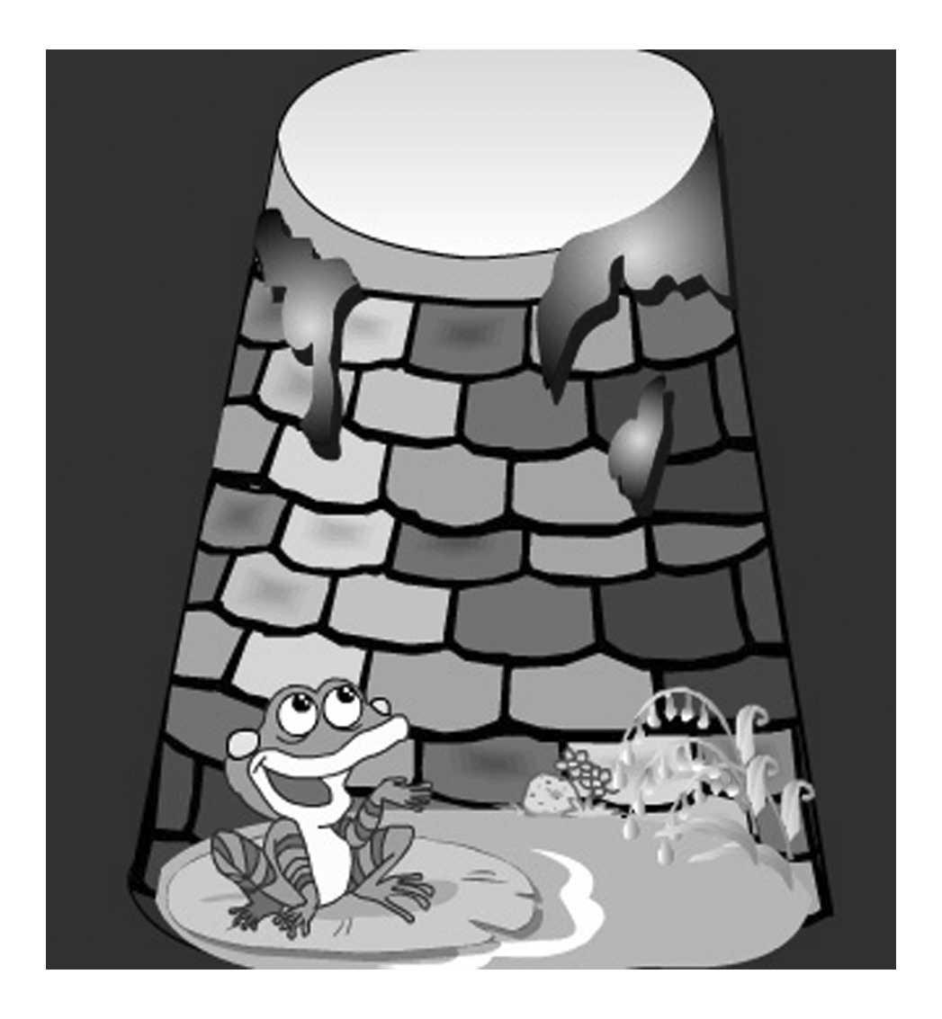
B
If you are a human, you can’t help but experience the time when everything seems to be going wrong and you feel as if your life is completely out of control. It is during the low time that words of encouragement from family, friends, coworkers or even strangers can boost your spirits. It is also during the low time that destructive words can be devastating(毁灭性的) and make you sink deeper and deeper into depression.
For example, consider this story about a group of frogs who were traveling through the woods when two of them fell into a deep pit(深坑). All of the other frogs gathered around the pit. When they saw how deep the pit was, they told the two unfortunate frogs they would never get out.
The two frogs ignored the comments and tried to jump out of the pit.The other frogs kept telling them to stop. Finally, one of the two frogs took notice of what the other frogs were saying and simply gave up. He died. The other frog continued to jump as hard as he could. Once again the crowd of frogs shouted at him to stop the pain. The more they shouted, the harder he jumped and finally he made it.
When he got out, the other frogs asked him why he continued to jump when they were all shouting at him to tell him to give up. The frog explained to them that he was a little bit deaf. He thought they were encouraging him the whole time.
Every time you have a chance to say either something positive or negative to another human being, do choose the chance to say something positive! Don’t let those opportunities get away from you. Your words have a large amount of power. Use them wisely. You really never know just how much they can mean to someone else.
58．Why did the frog that succeeded in jumping to safety neglect the other frogs’ comments?
A．Because he would like to jump out of the pit.
B．Because he could hardly hear what the other frogs said.
C．Because he didn’t want to give up his hope.
D．Because he had a positive attitude toward life.
59．We can infer from the frog succeeding finally that ________.
A．encouragement is not important in our lives
B．persistence is bound to victory
C．miracles sometimes happen by accident
D．success must belong to us if we keep on working
60．What can we infer from the first paragraph?
A．There is no way to go when we go wrong.
B．Life depends on encouragement.
C．Destructive words will lead to death.
D．Words are playing an important role around us.
61．The writer mainly wants to tell us ________ in the last paragraph.
A．the power of words B．positive words
C．negative words D．the opportunities to say something

C
Once there was a parrot(鹦鹉) on sale in a pet store. It was a beautiful red and blue bird. It sat on a perch in the middle of the store, so that everyone could see it when they came in. The owner was very proud of it and asked a high price for it.
One day a man went into the store. "That's a beautiful bird,"he said to the pet store owner, "But why is it so expensive? Is it unsual bird?"
"No, it's not very unusual. It's expensive because it can talk," the pet store owner said.
"I see. How can I make it talk?" the man asked.
The pet store owner asked him, "Do you see those string tied to each of the bird's legs?"
"Yes," the man answered.
"Well, you pull those strings," the pet store owner told him."That will make the parrot talk."
The man asked,"Do you mind if I try?"
"Not at all," the pet store owner said.
The man walked up to the parrot and pulled the string on its left leg. The parrot said, "Good morning."
The man pulled the string on the parrot's right leg. This time the parrot said, "How are you today?"
"That's not very interesting, " said the man. "Any parrot could do that." Then he laughed, "But what wold happen if I pulled both strings at the same time?"
"I'll fall off my perch, you fool!" the parrot said.
62.The parrot was expensive because________.
A.it was pretty beautiful B.it could talk with the people
C.it was a very unusual bird D.it was in the middle of the store
63.Which is the first sentences that the parrot said to the man?
A.Good morning. B. How are you?
C.That's wasn't interesting. D.I'll fall off my perch, you fool.
64.From the story we know the parrot was_______.
A.kind B.silly C.clever D.crazy
65.The best title for the passage should be _________.
A. Unusual Parrot B. Parrot Talk C. Silly man D. Clever Owner

D
“I sometimes get up at three or four in the morning and I surf the net.”
“I often check my e-mail forty times a day.”
“I often spend more than three hours during one time on the net.”
“I spend more time in chat rooms(聊天室) than with my ‘real-1ife’ friends.”
Do you know any people like these? They are part of a new addiction(瘾) called Internet addiction. Internet addicts spend at least thirty to forty hours online every week. The use of the Internet can be an addiction like drug use. People lose control of the time they spend on the Internet
For example, one college student was missing for several days. His friends were worried, and they called the police. The police found the student in the computer lab: he was surfing the net for several days straight.
Studies show that about 6 to 10% of Internet users become addicted. And people worry about the teens because the Internet is changing the playing field for some of them.They spend more time in cyberspace than in the real world of friends and family.
Is “surfing the net” a hobby or an addiction for you? You may have a problem if
you have these symptoms(症状):
●You do not go to important family activities or you do not do school work because you like to spend hours on the Internet.
●You can’t wait for your next online time.
●You plan to spend a short time online, but then you spend several hours.
●You go out with your friends less and less.
66．What does the beginning of the passage tell us?
A. How to become an Internet addict. B. What an Internet addict usually does.
C. Where to find an Internet addict. D. Why to write this passage.

67．How does the writer describe the addicts’ use of Internet?
A. It is something like keeping drugs.
B. It is a way of producing drugs.
C. It is like taking drugs.
D. It is terrible to imagine.
68．Why do people worry about the teens?
A. The teens are wasting too much money.
B. They used to work on the Internet.
C. The playing field of the teens will disappear.
D. More and more of the teens wil1 become addicted to the Internet.
69．The example in the passage shows that _______.
A. Internet problems are more serious among college students
B. Internet addicts usually stay in the computer lab without sleep
C. Some of the Internet users have already been seriously addicted
D. The police often help to find those Internet addicts.
70．What is the writer trying to tell us at the end of the passage?
A. Don’t be addicted to the Internet.
B. Go to family activities more often.
C. Do things as you have planned
D. Stay with your parents as often as possible.

第II卷 非选择题 （共35分）
第四部分：任务型阅读（共10小题，每小题１分，满分10分）
请认真阅读下列短文，并根据所读内容在文章后表格中的空格里填入最恰当的单词。注意：每空格只填一个单词。

Teenagers today live in a very competitive world. It is more important than ever to be successful at school if you hope to have a chance in the job market afterwards. It's no wonder that many young people worry about letting down(使失望) their parents, their classmates and themselves. In trying to please everyone, they take on too many tasks until it becomes harder and harder to balance homework, parties, sports activities and friends. The result is that young people suffer from stress.
There are different ways of dealing with stress. Everyone knows that caffeine, whether it is in the form of coffee or soft drinks, keeps you awake and active. But caffeine is a drug which can become addictive (上瘾). In the end, like other drugs, caffeine only leads to more stress. A better way to deal with stress is to exercise. Research has proved that physical exercise is a good release for stress, because it increases certain chemicals in the brain which calm you down. Making sure you get enough sleep is also an important way of avoiding stress and of staying healthy and full of energy. Another way to avoid stress is to manage your time effectively. It is better to do a few tasks really well than lots of tasks badly. Know your limits and try not to take on too much. Finally, if it all gets beyond your control, don't panic or get hysterical (歇斯底里).Find the time to sit down quietly and breathe deeply for ten to twenty minutes. Do this regularly, and it will help you calm down.

Title: Stressful teenagers
The 71. ____ of teenagers'  stress | Living in a very competitive world, teenagers have to 72. ____ in school hoping to find a good job afterwards.  They also worry about disappointing their 73. ____, their classmates and themselves. So they're occupied with a number of tasks.
74. ____ of dealing with stress | 75. ____ coffee or soft drinks | Caffeine keeps you 76. ____ and active. But it is addictive, thus causing more stress.
74. ____ of dealing with stress | Taking exercise | Physical exercise 77. ____ certain chemicals in the brain which calm you down.
74. ____ of dealing with stress | Getting enough sleep | Enough sleep is an important way to 78. ____ stress.
74. ____ of dealing with stress | Managing your time 79. ____ | It is better to do a few tasks really well than lots of tasks badly.
74. ____ of dealing with stress | Doing regular exercises of relaxation | Find the time to sit down quietly and have a deep 80. ____ for 10 to 20 minutes.

第五部分:书面表达（共1题，满分25分）
现在很多人喜欢在交流时使用网络语言，包括拼音或者英文字母的缩写、含有某种特定意义的数字以及形象生动的网络动画和图片。如：“886”代表再见；“)”表示微笑等。就此现象，你班最近举行了一场讨论会。请根据下面的提示写一篇120词左右的短文，介绍一下讨论的情况，并发表自己的看法。
赞成网络语言 | 不赞成网络语言
60%的同学认为：  1．网络语言简洁，可以节约时间，加快交流；  2．网络语言幽默、活泼，有助于表达思想。 | 40%的同学认为：  1．网络语言荒诞，有时难以理解；  2．有些表达方式违背语法规则。
你的看法……
注意：1.开头已经给出；
2．参考词汇：荒诞的ridiculous。
Nowadays，with the development of the Internet，a kind of language called Web Language has come into being.

英语试题参考答案
一.听力(每小题1分,共20分)
1-5 CBACC 6-10 ABBAC 11-15 BCBBA 16-20 CBCAC
二.单项填空(每小题1分,共15分)
21-25 CADBA 26-30 ADCBD 31-35 DBCDA
三.完型填空(每小题1分,共20分)
36-40 CAADA 41-45 DCCAA 46-50 CCBBC 51-55 CDDCB
四.阅读理解(每小题2分,共30分)
56-60 CBBCD 61-65 ABACB 66-70 BCDCA
五.任务型阅读(每小题1分,共10分)
71. causes 72. succeed 73. parents 74. Ways 75. Drinking/ Having
76. awake 77. increases 78. avoid 79. effectively 80. breath
六.书面表达(共25分)
参考范文
Nowadays，with the development of the Internet，a kind of language called Web Language has come into being. We have held a discussion about it in our class.
60% of the students like the special language. They think the language is simple，which makes communication easier. Besides，it is humorous and lively，which is of great help to express thoughts. For instance，“)” stands for a smile，which can convey the feelings in an effective way.
However,40% are against it.On the one hand，they think it is ridiculous and hard to understand sometimes. For example，when “886” is used，others may not know what it means.On the other hand，some expressions are against the grammar rules.
As far as I’m concerned，everything is changing，so is the language. We should recognize it and adapt to the new change.

