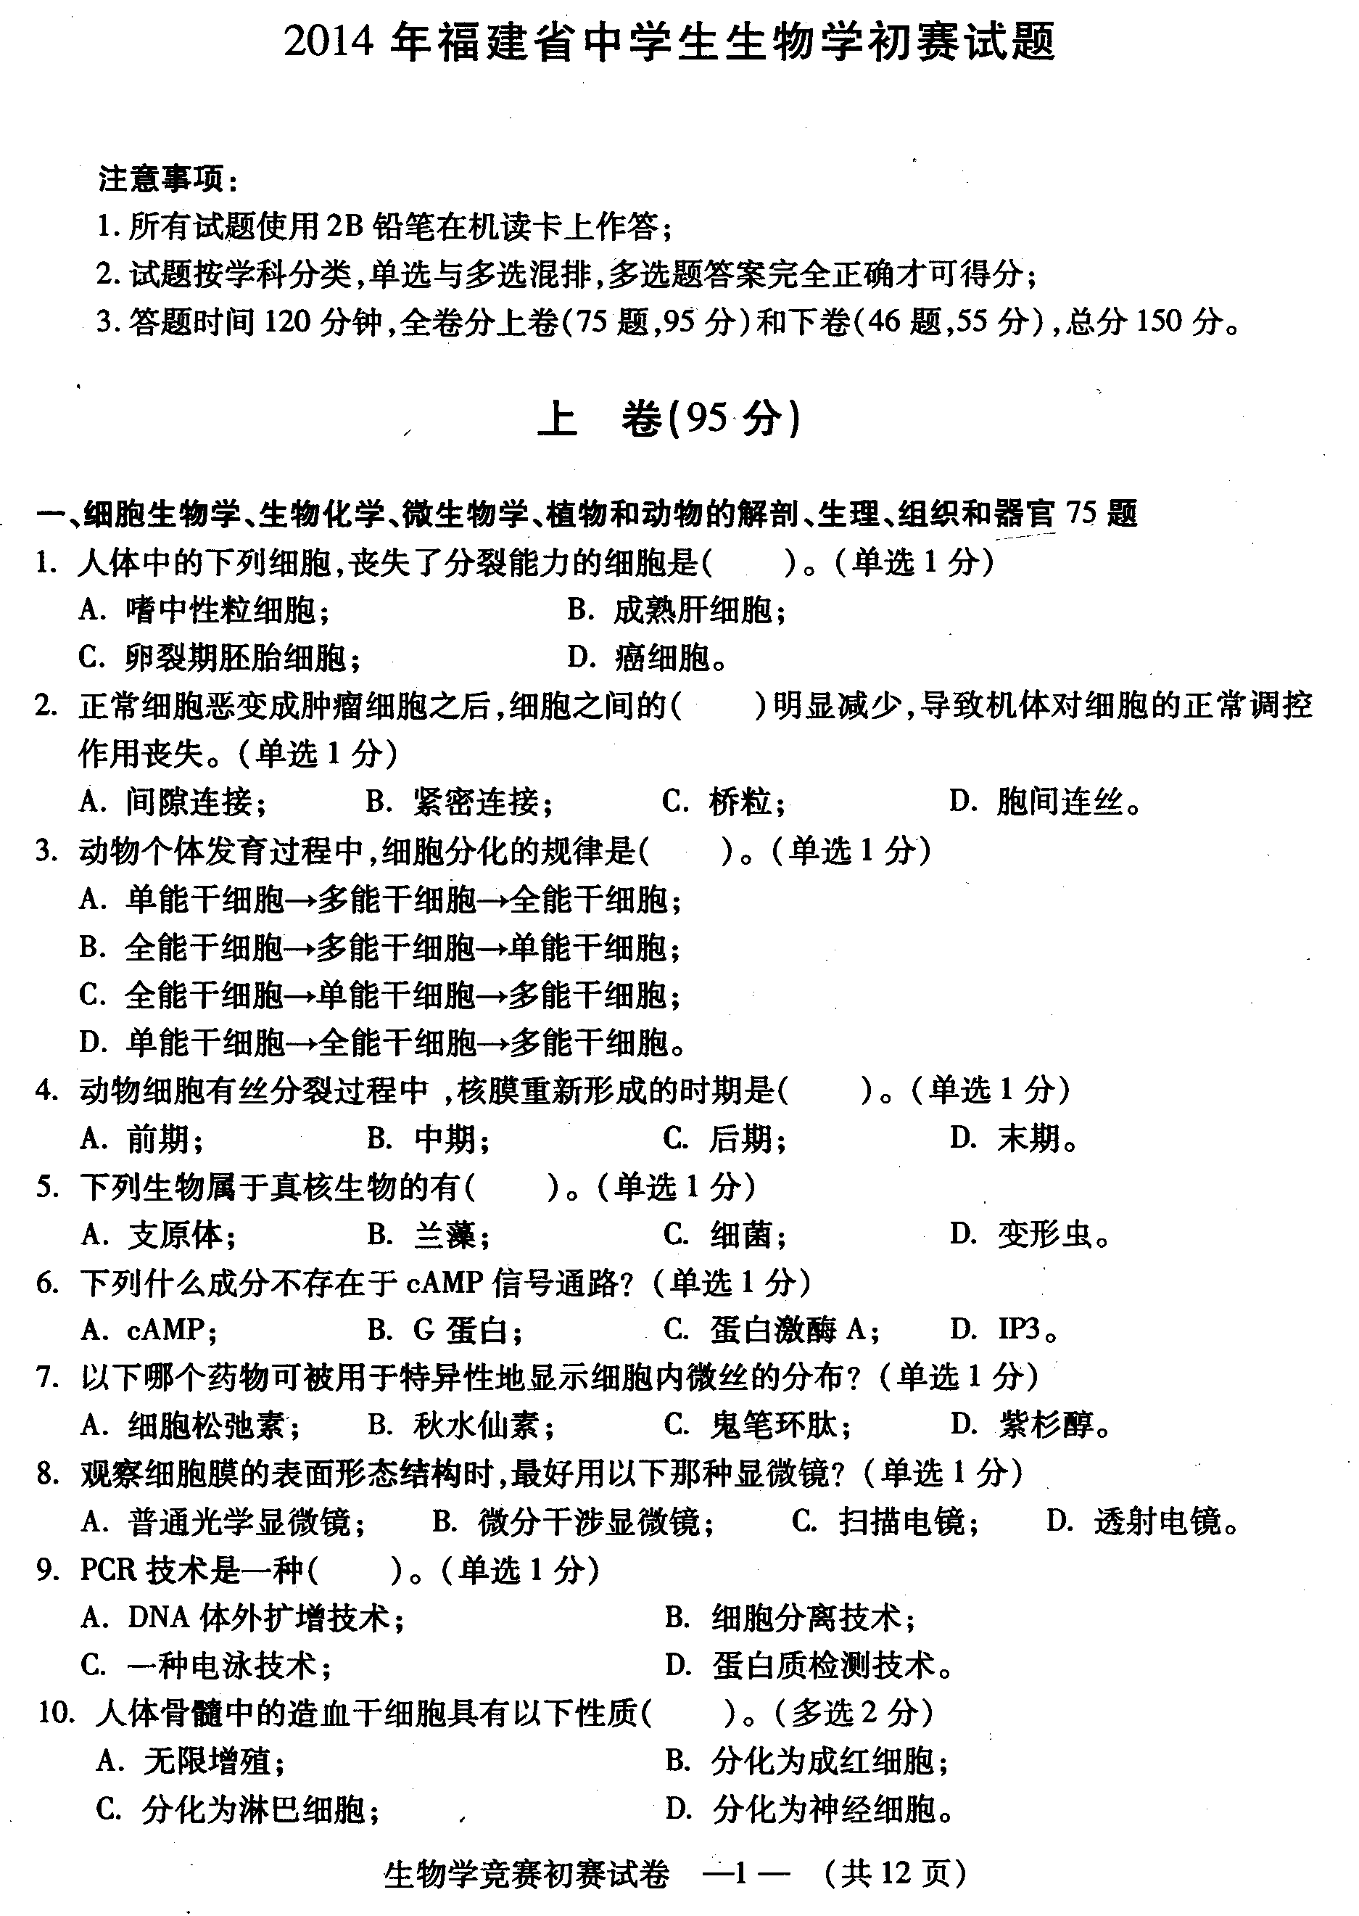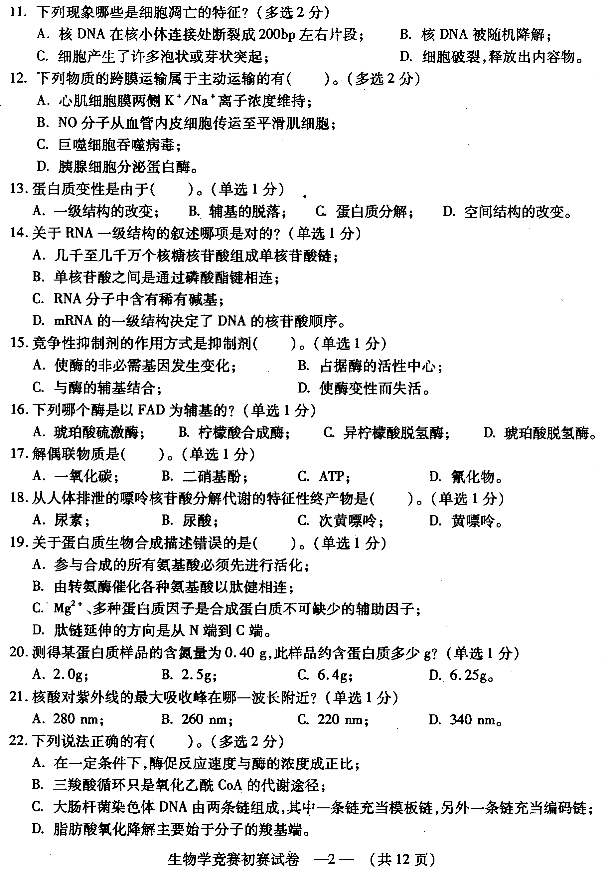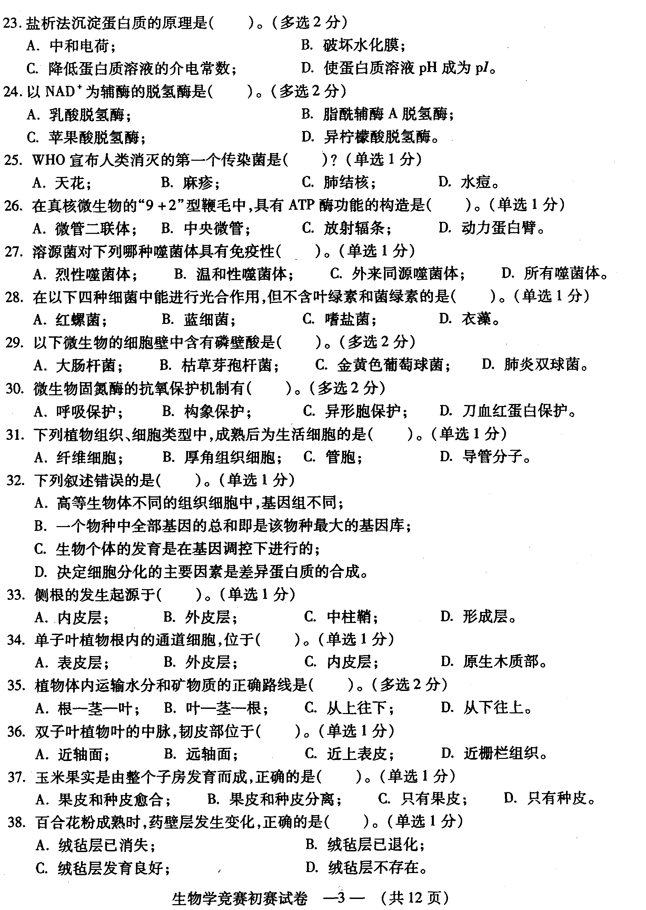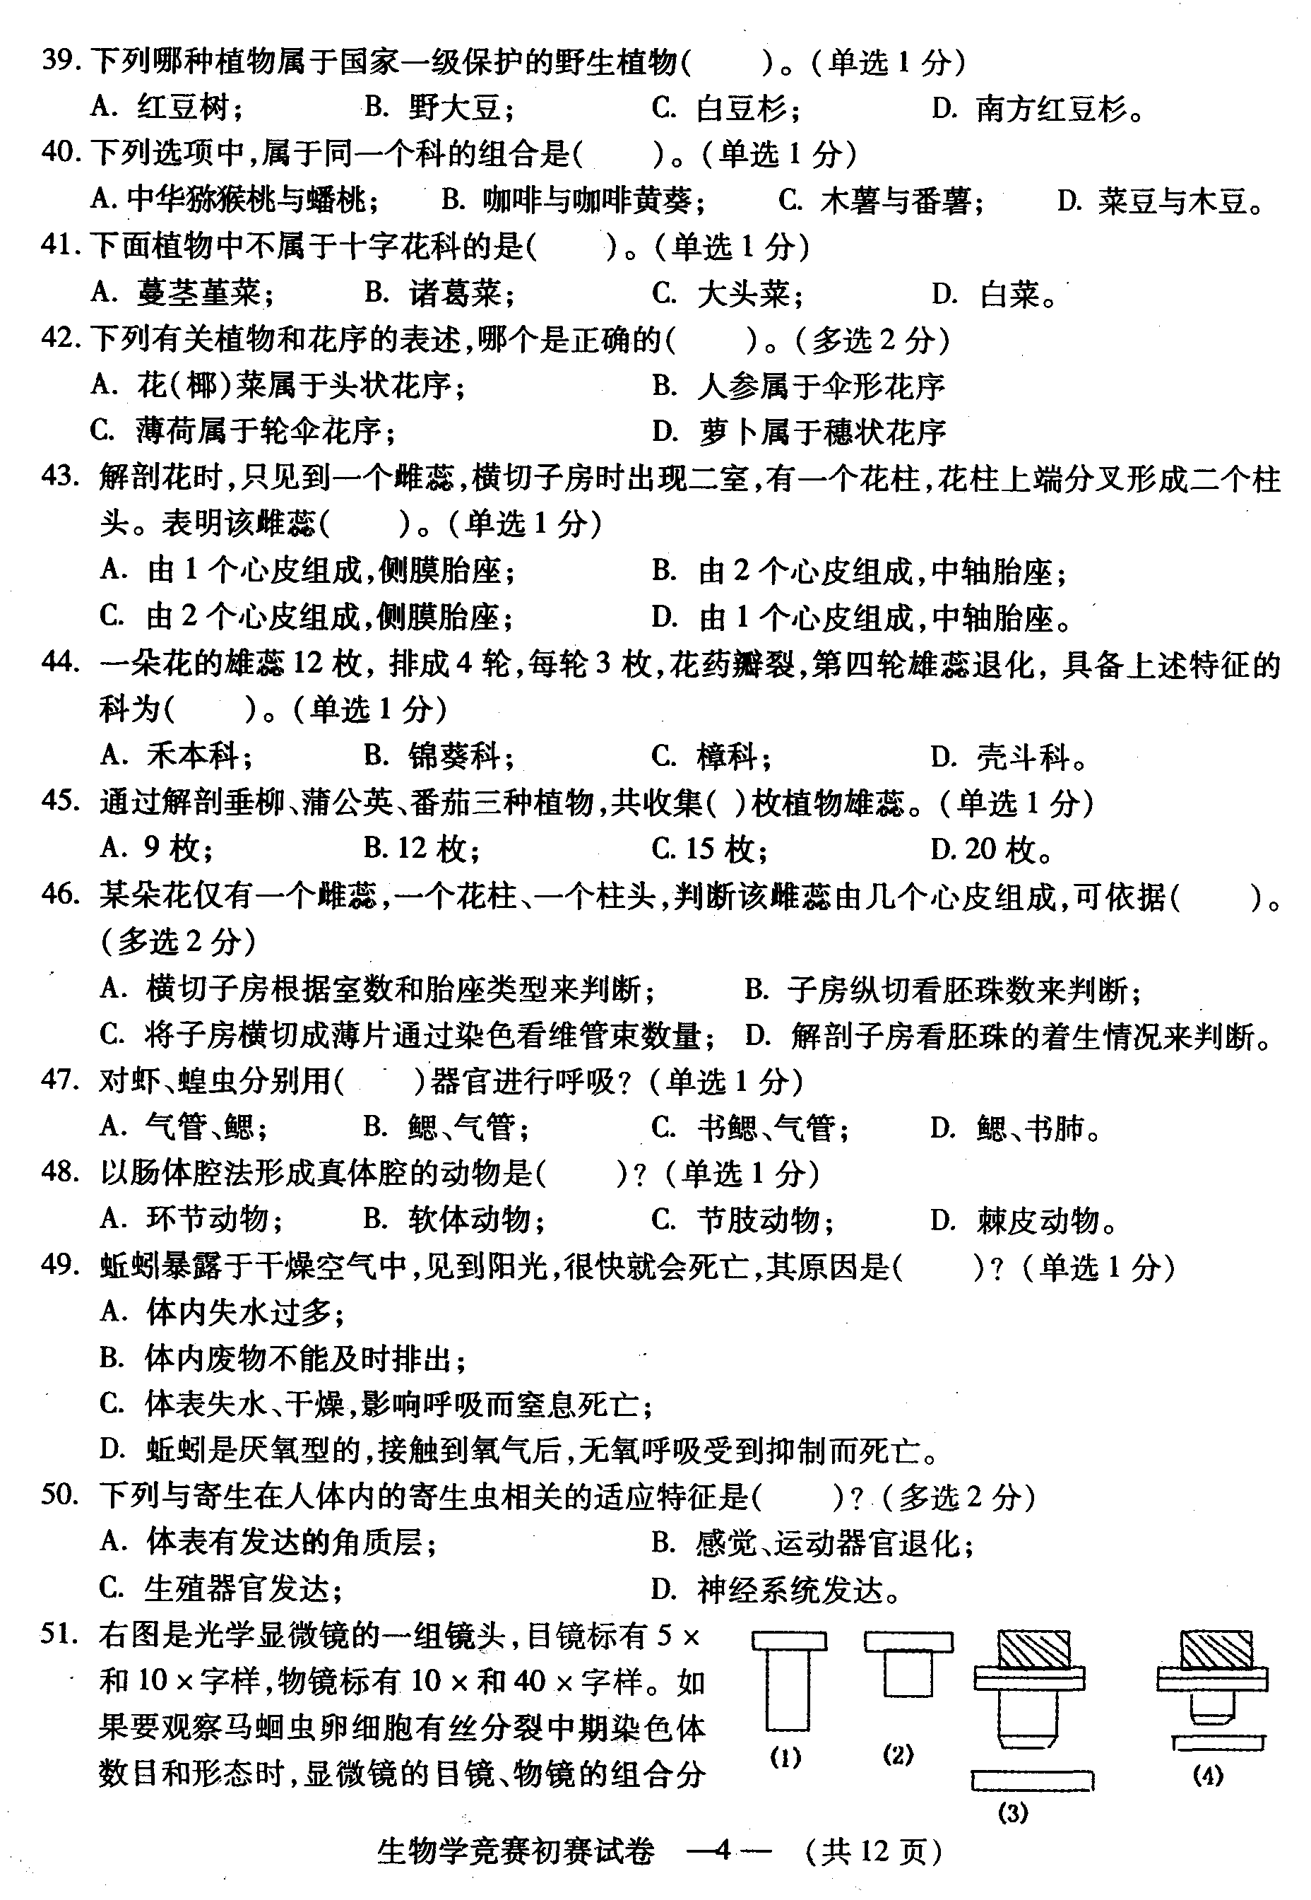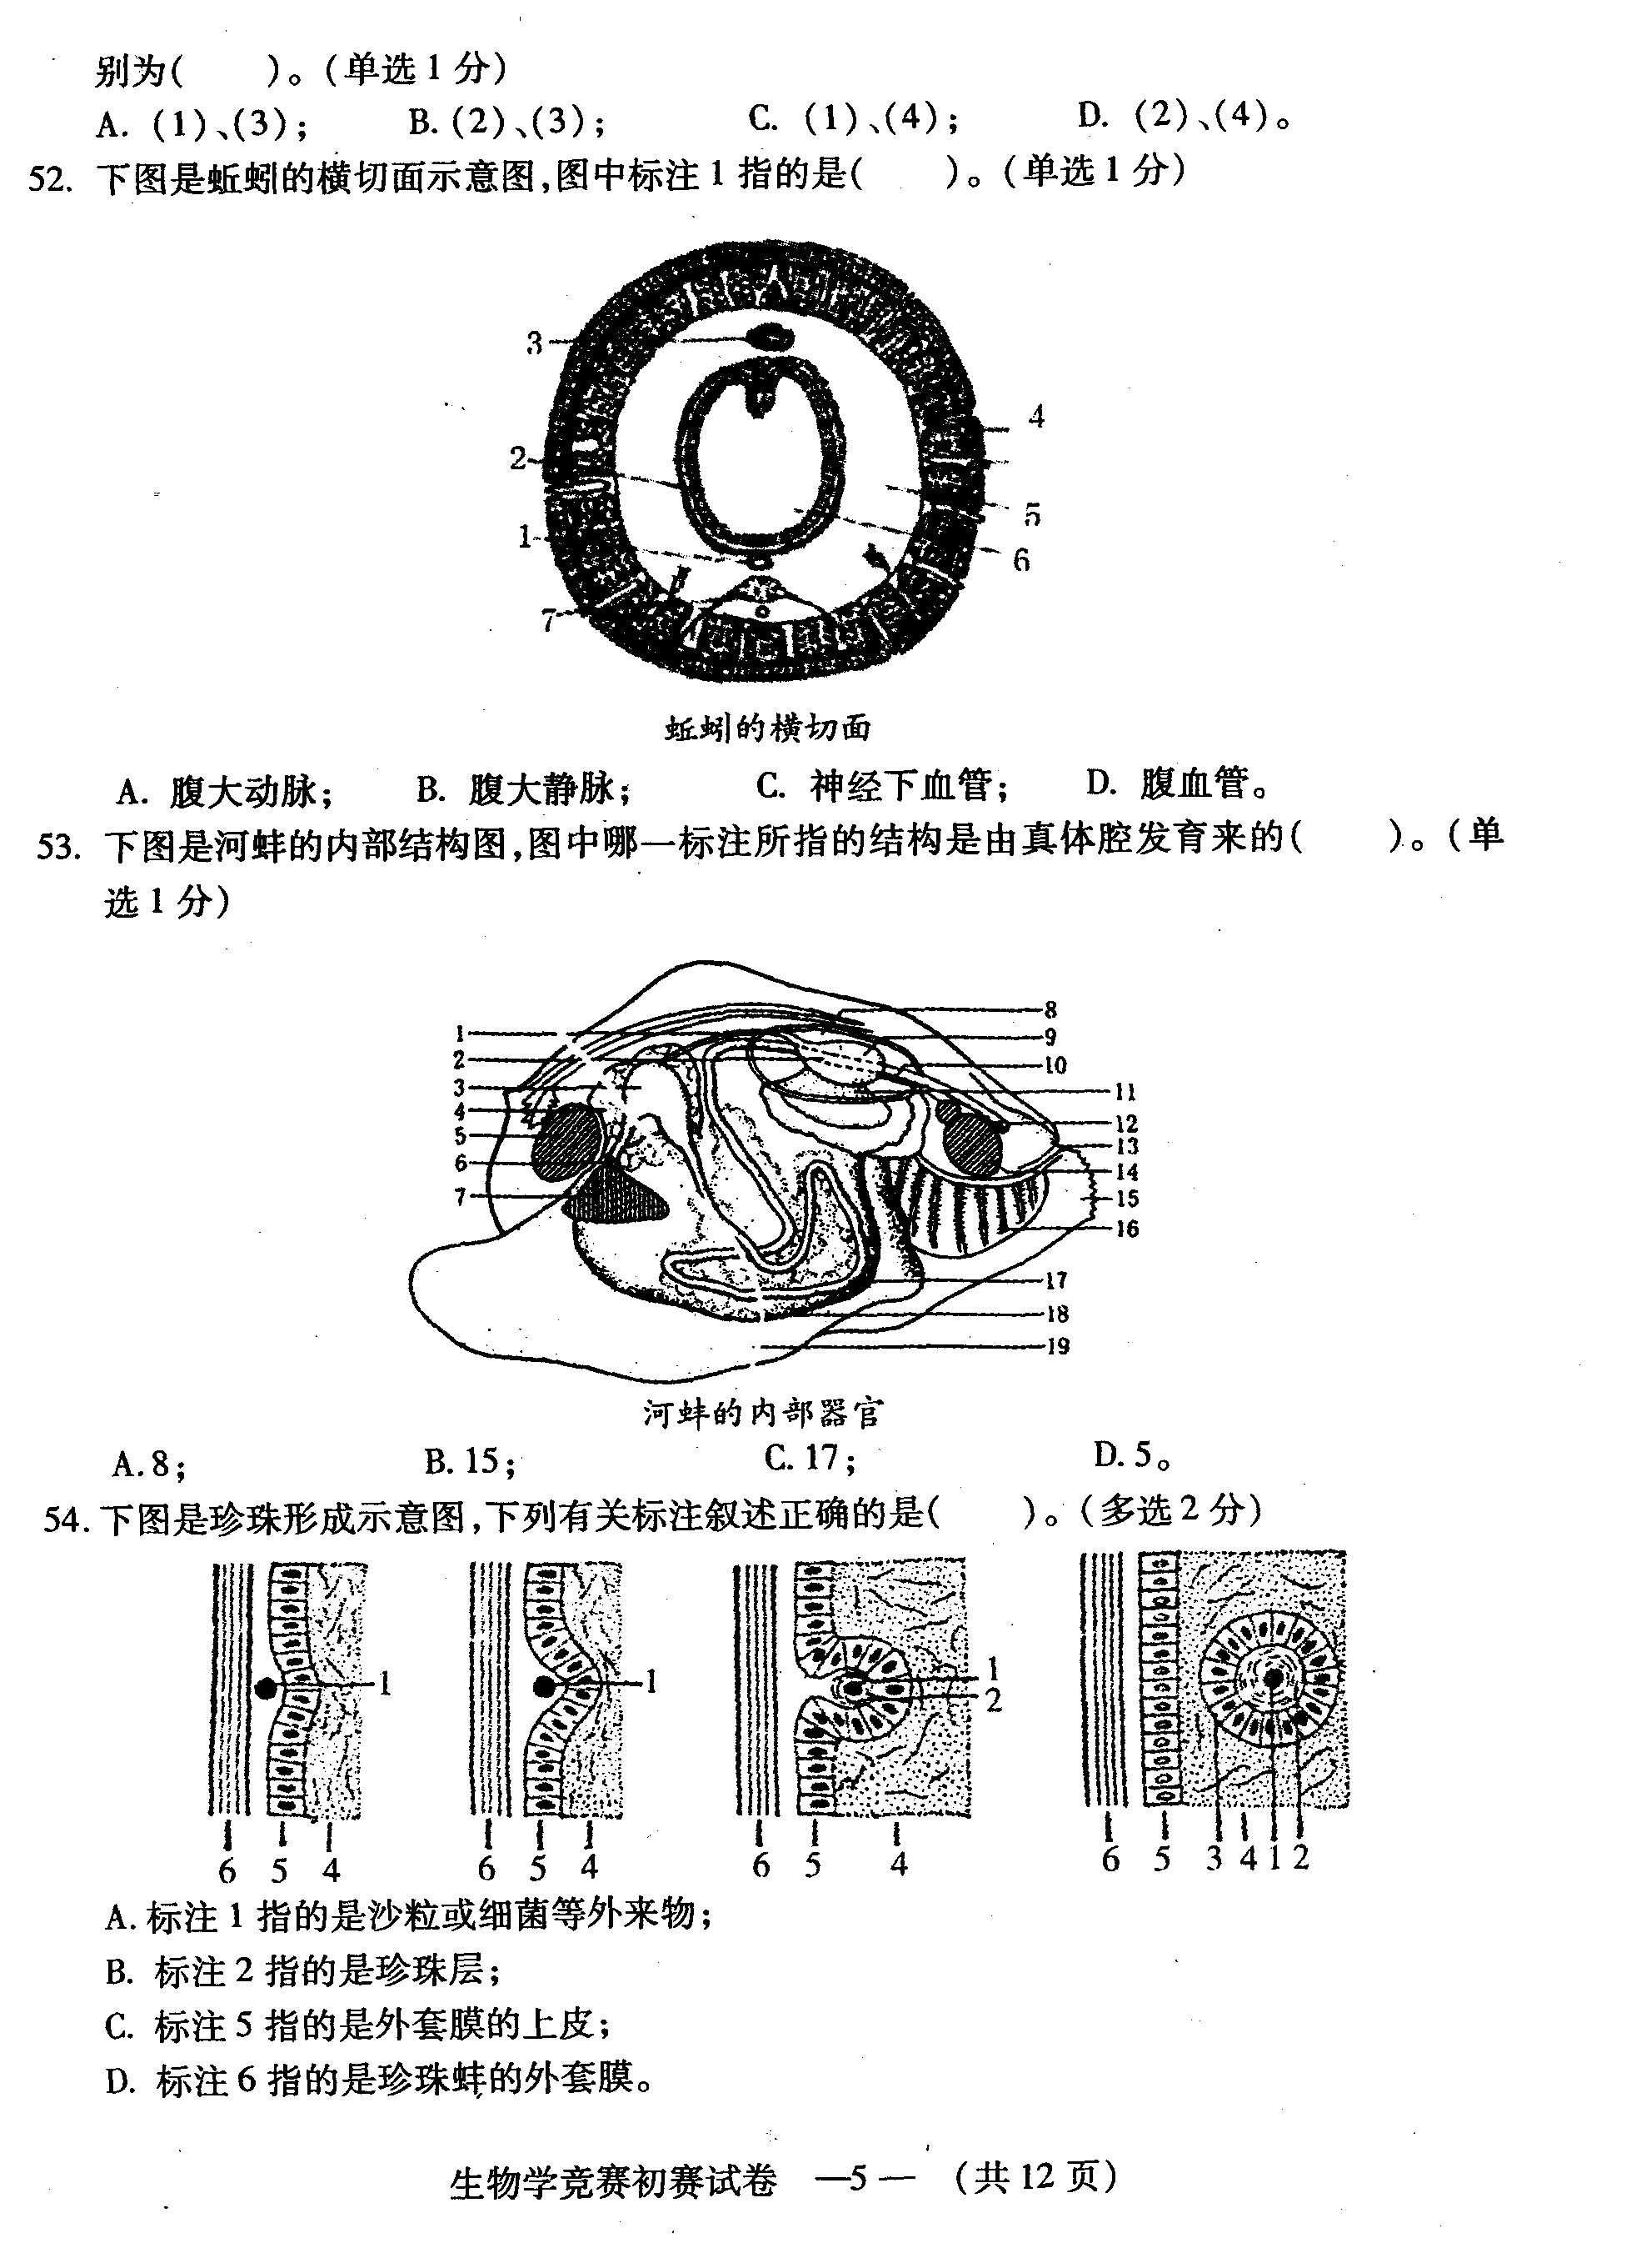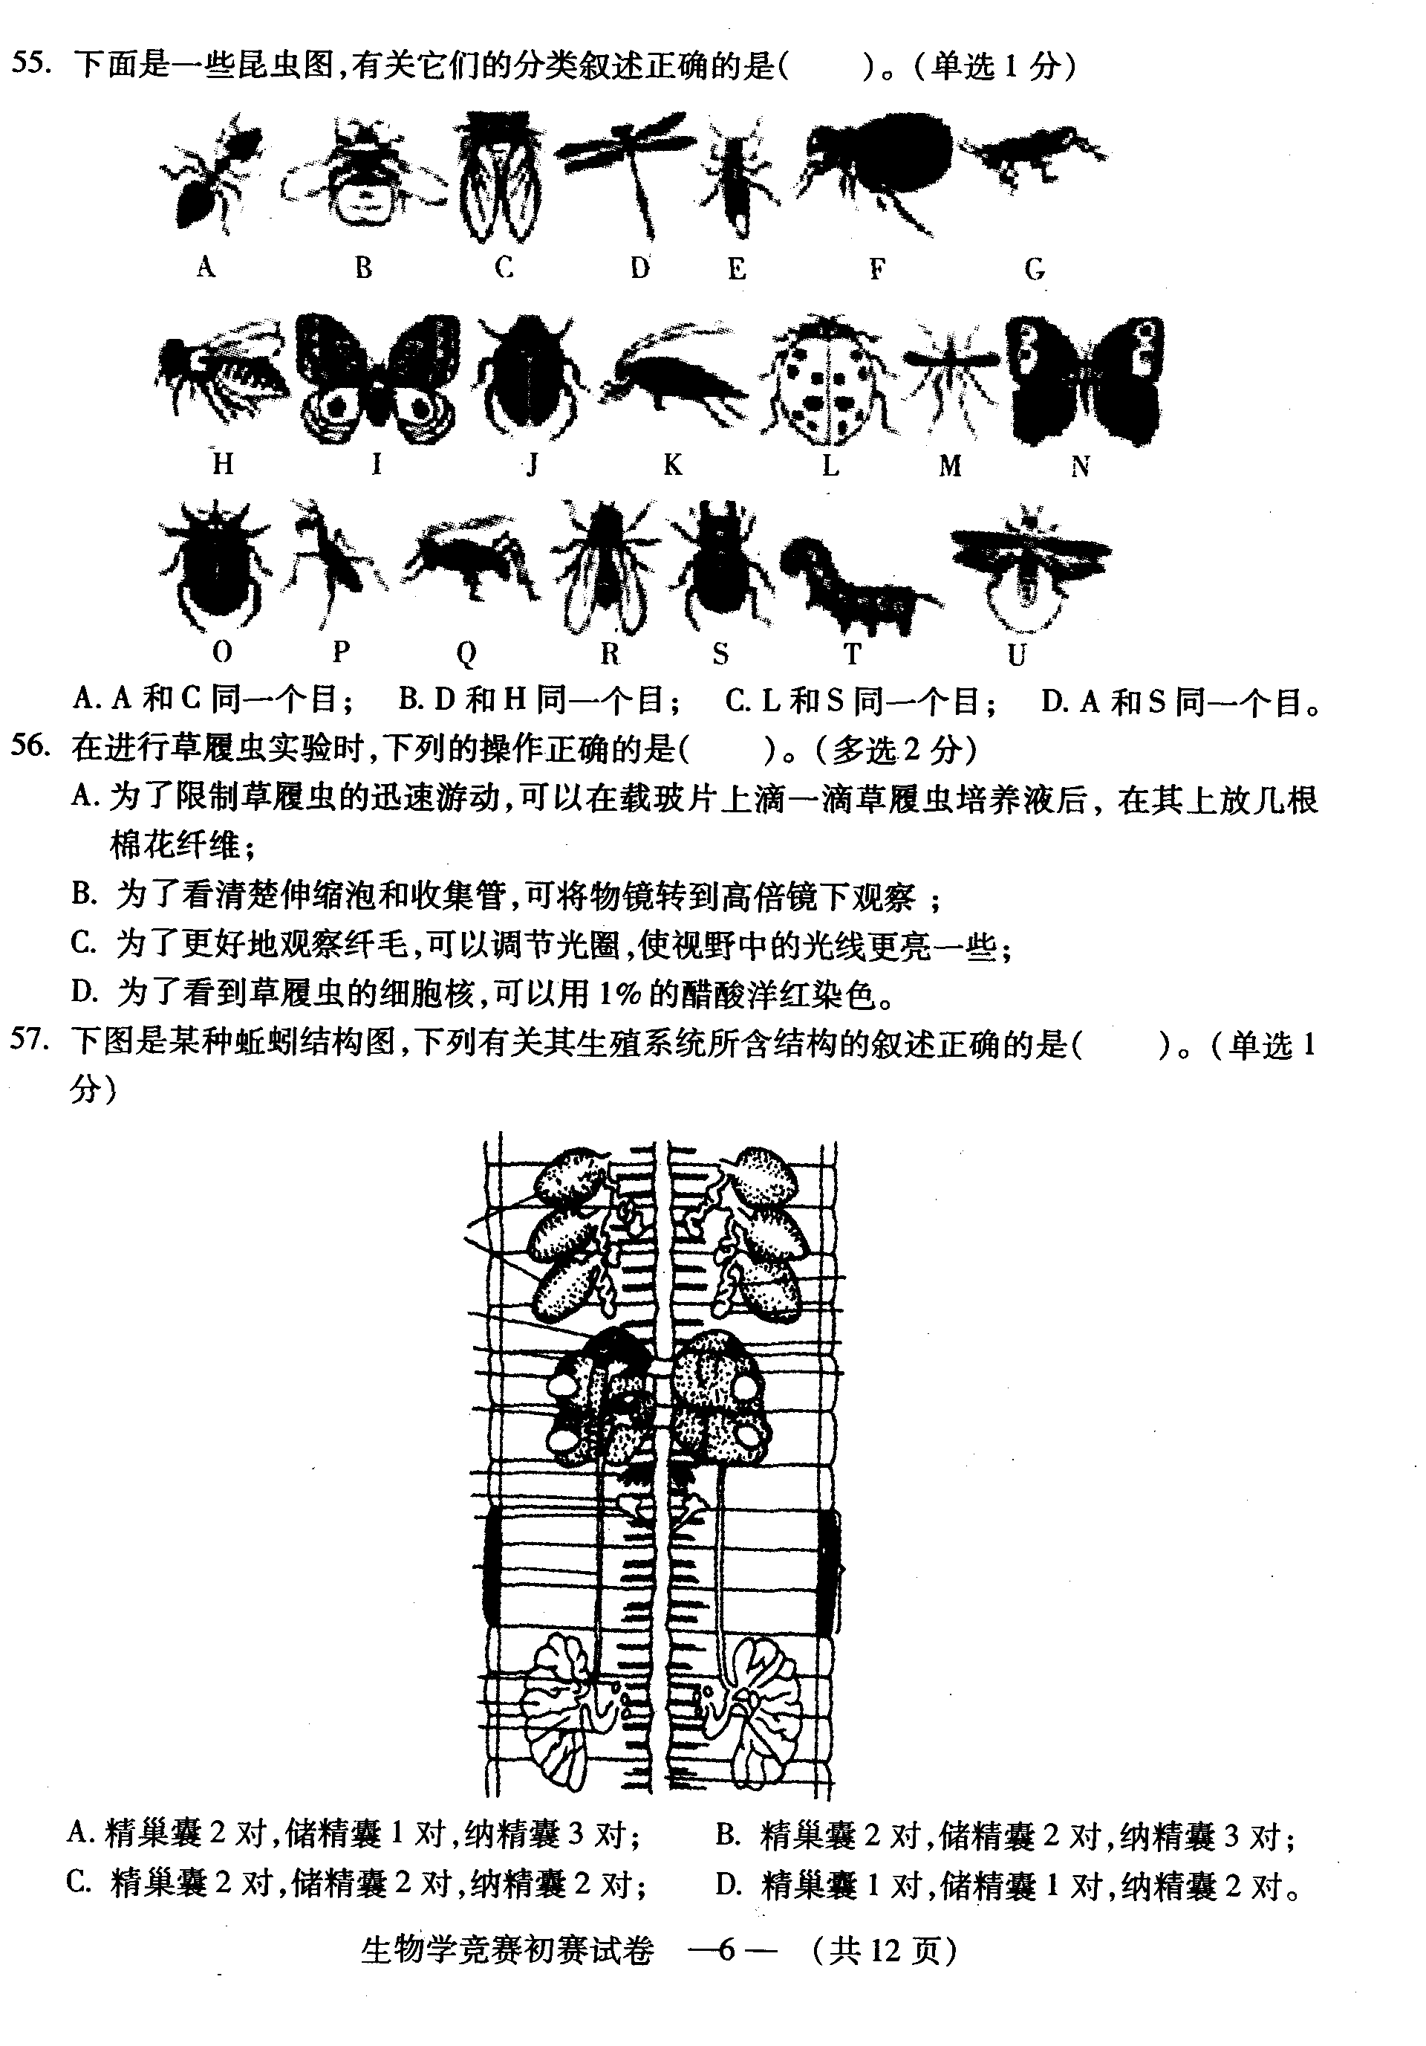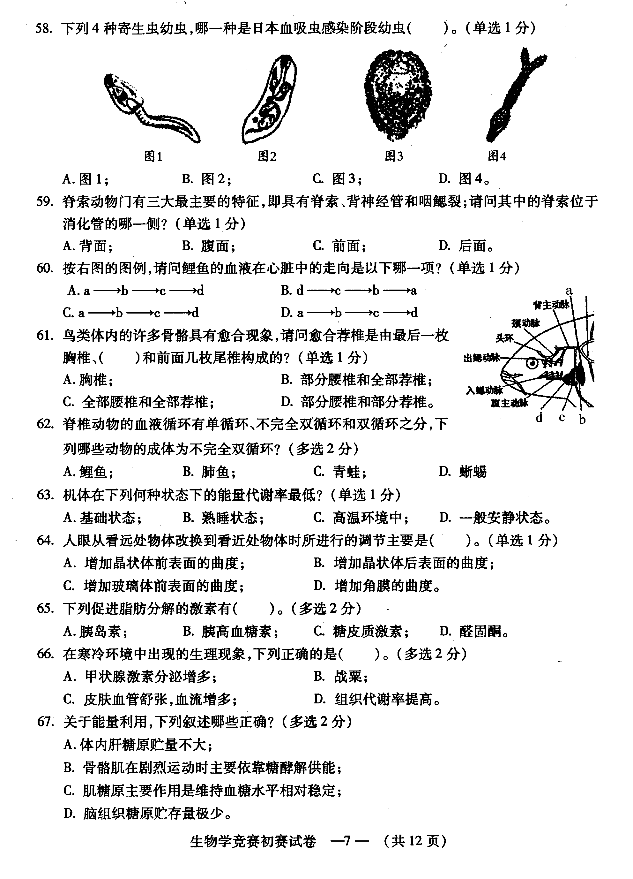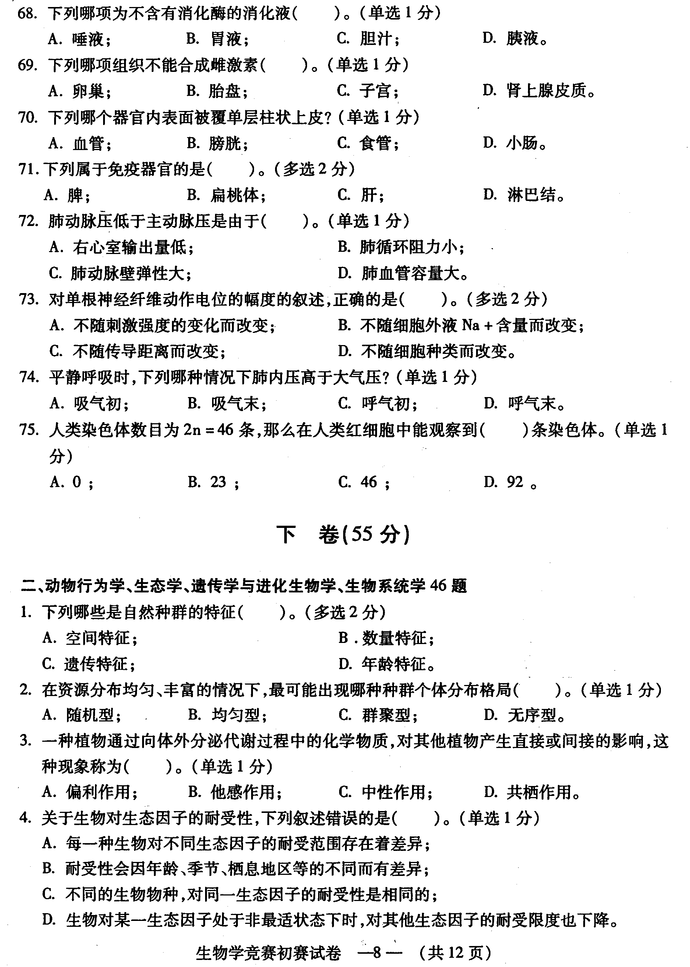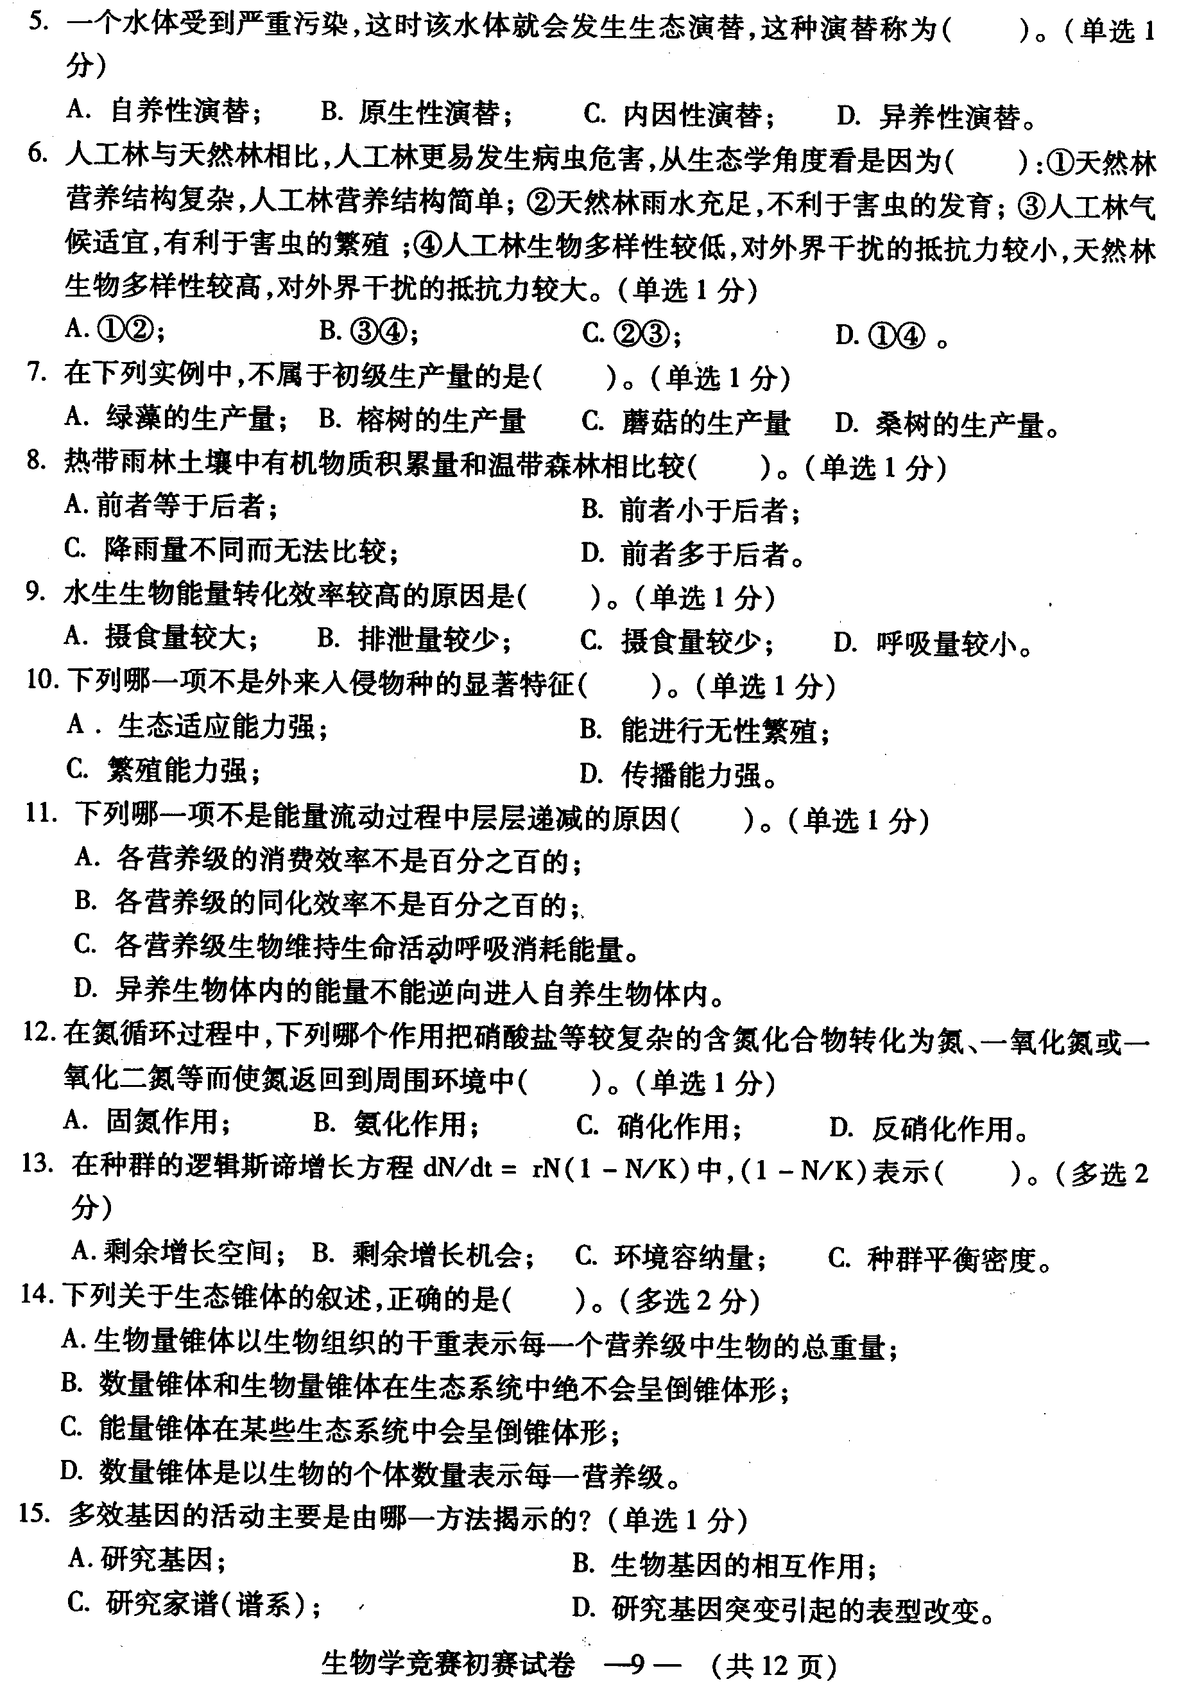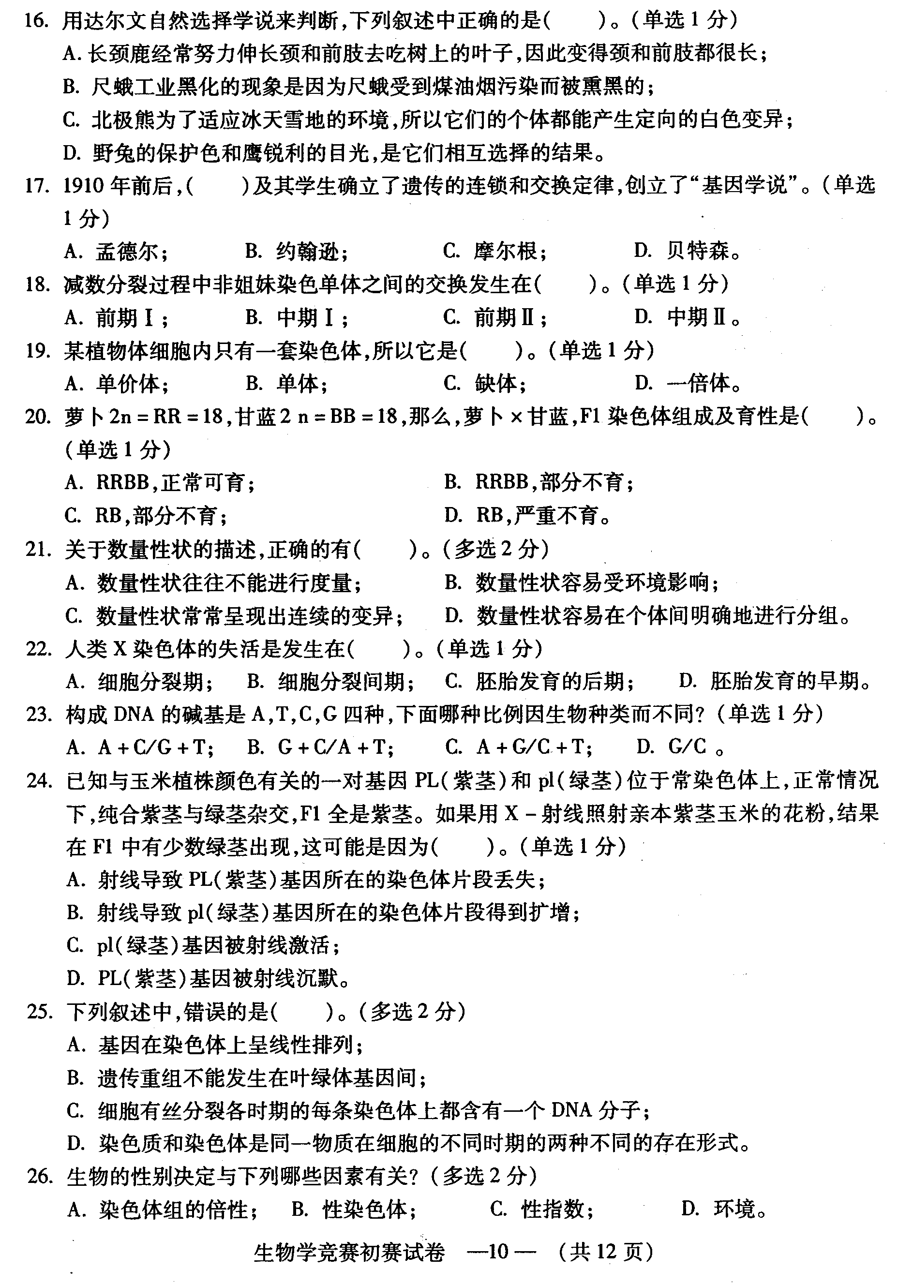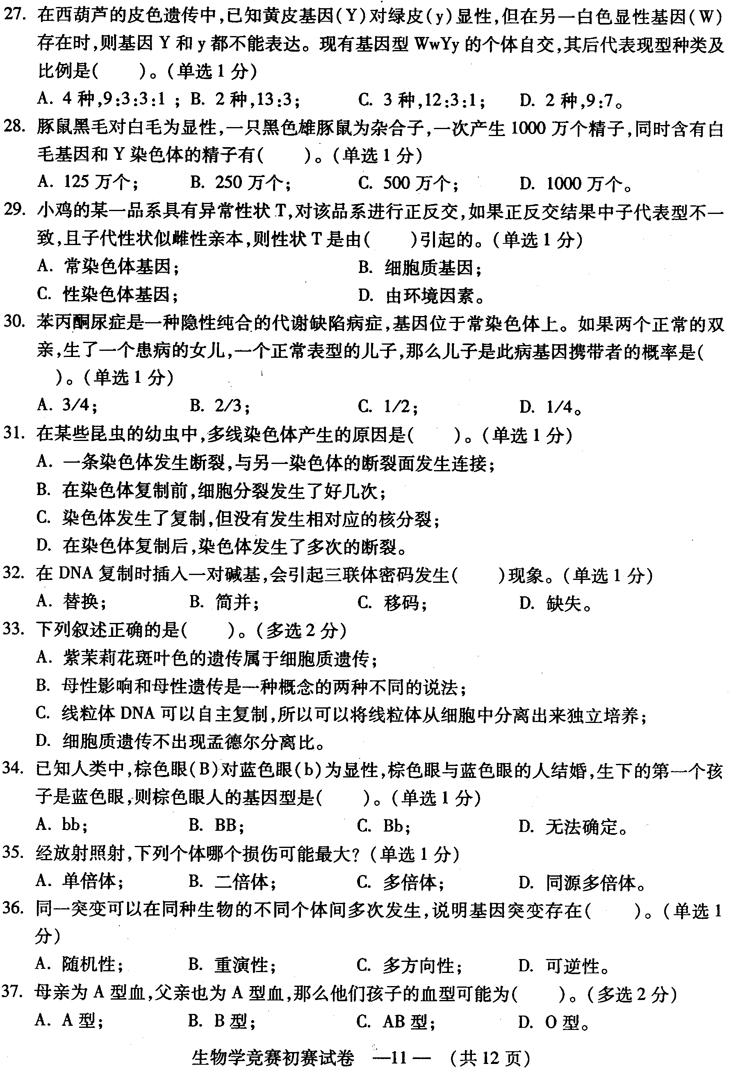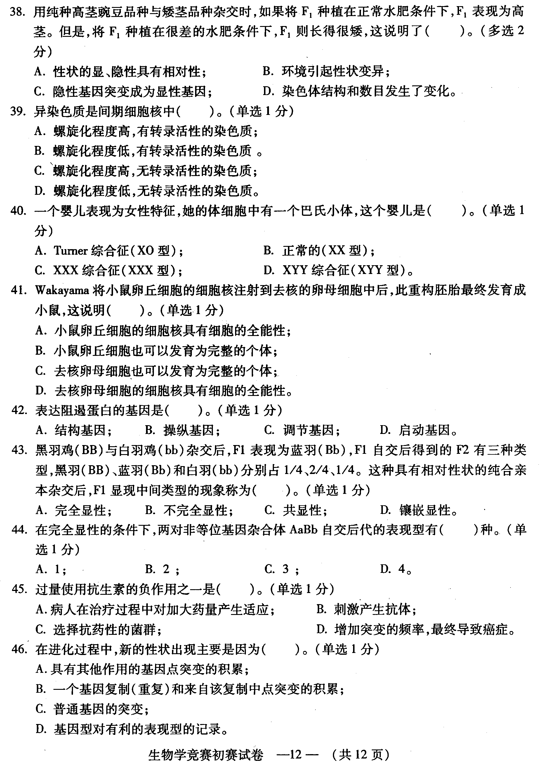

题号 | 答案 | 分值 | 题号 | 答案 | 分值 | 题号 | 答案 | 分值 | 题号 | 答案 | 分值
1 | A | 1 | 41 | A | 1 | 1 | ABC | 2 | 41 | A | 1
2 | A | 1 | 42 | BC | 2 | 2 | A | 1 | 42 | C | 1
3 | B | 1 | 43 | B | 1 | 3 | B | 1 | 43 | B | 1
4 | D | 1 | 44 | C | 1 | 4 | C | 1 | 44 | D | 1
5 | D | 1 | 45 | B | 1 | 5 | D | 1 | 45 | C | 1
6 | D | 1 | 46 | AC | 2 | 6 | D | 1 | 46 | B | 1
7 | C | 1 | 47 | B | 1 | 7 | C | 1
8 | D | 1 | 48 | D | 1 | 8 | B | 1
9 | A | 1 | 49 | C | 1 | 9 | D | 1
10 | ABC | 2 | 50 | ABC | 2 | 10 | B | 1
11 | AC | 2 | 51 | A | 1 | 11 | D | 1
12 | ACD | 2 | 52 | D | 1 | 12 | D | 1
13 | D | 1 | 53 | A | 1 | 13 | AB | 2
14 | C | 1 | 54 | ABC | 2 | 14 | AD | 2
15 | B | 1 | 55 | C | 1 | 15 | D | 1
16 | D | 1 | 56 | ABD | 2 | 16 | D | 1
17 | B | 1 | 57 | B | 1 | 17 | C | 1
18 | B | 1 | 58 | D | 1 | 18 | A | 1
19 | B | 1 | 59 | A | 1 | 19 | D | 1
20 | B | 1 | 60 | A | 1废 | 20 | D | 1
21 | B | 1 | 61 | C | 1 | 21 | BC | 2
22 | AD | 2 | 62 | BCD | 2 | 22 | D | 1
23 | AB | 2 | 63 | B | 1 | 23 | B | 1
24 | ACD | 2 | 64 | A | 1 | 24 | A | 1
25 | A | 1 | 65 | BC | 2 | 25 | BC | 2
26 | D | 1 | 66 | ABD | 2 | 26 | ABCD | 2
27 | C | 1 | 67 | ABD | 2 | 27 | C | 1
28 | C | 1 | 68 | C | 1 | 28 | B | 1
29 | BCD | 2 | 69 | C | 1 | 29 | B | 1
30 | ABCD | 2 | 70 | D | 1 | 30 | B | 1
31 | B | 1 | 71 | ABD | 2 | 31 | C | 1
32 | A | 1 | 72 | B | 1 | 32 | C | 1
33 | C | 1 | 73 | AC | 2 | 33 | AD | 2
34 | C | 1 | 74 | C | 1 | 34 | C | 1
35 | AD | 2 | 75 | A | 1 | 35 | A | 1
36 | B | 1 |  |  |  | 36 | B | 1
37 | A | 1 |  |  |  | 37 | AD | 2
38 | B | 1 |  |  |  | 38 | AB | 2
39 | D | 1 |  |  |  | 39 | C | 1
40 | D | 1 |  |  |  | 40 | B | 1

