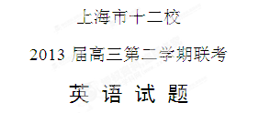
第Ⅰ卷 （共 105 分）
I. Listening Comprehension
Section A
Directions: In Section A, you will hear ten short conversations between two speakers. At the end of each conversation, a question will be asked about what was said. The conversations and the questions will be spoken only once. After you hear a conversation and the question about it, read the four possible answers on your paper, and decide which one is the best answer to the question you have heard.
1. A. January. B. June C. December D. November
2. A. The director. B. The woman. C. The guide. D. His uncle.
3. A. It doesn’t work. B. It only works temporarily.
C. It’s really effective. D. It has strong side effects.
4. A. The woman rejected the man’s apology.
B. The woman much appreciated the man’s offer.
C. The man had forgotten the whole thing.
D. The man had hurt the woman’s feelings.
5. A. She stole money from others.
B. She fell down and got hurt.
C. She was unhappy for being wronged.
D. She lost some of her money.
6. A. They are going swimming. B. They are going hiking.
C. They are going shopping. D. They are going diving.
7. A. He needs another job as a research assistant.
B. He asked Professor Williams for assistance.
C. He assists Professor Williams with his teaching.
D. He is doing research with Professor Williams
8. A. She thought there were no tickets left for the show.
B. She thought the seats on the left side were fully occupied.
C. The show was planned a long time ago.
D. The audience were deeply impressed by the show.
9. A. She plans to go to graduate school.
B. She will drop out of school.
C. She will stop working and concentrate on her studies.
D. She will take a part-time job.
10. A. The bank. B. In a school.
C. In a clothing store. D. In a barber shop.

Section B
Directions: In Section B, you will hear two short passages, and you will be asked three questions on each of the passages. The passages will be read twice, but the questions will be spoken only once. When you hear a question, read the four possible answers on your paper and decide which one would be the best answer to the question you have heard.
Questions 11 through 13 are based on the following passage.
11. A. Because the bird couldn’t repeat his master’s name.
B. Because the bird screamed all day long.
C. Because the bird said the wrong word.
D. Because the bird failed to say the name of the town.
12. A. The cruel master. B. The woman in the kitchen.
C. The pet bird. D. The fourth chicken.
13. A. The bird had finally understood her threat.
B. The bird managed to escape from the chicken house.
C. The bird had learned to scream back at her.
D. The bird was living peacefully with the chickens.

Questions 14 through 16 are based on the following news.
14. A. To inform parents and schools. B. To pick out good students.
C. To compare teachers. D. To expose poor schools.
15. A. They have no trust in doctors. B. They cannot afford the medical fee.
C. They fear things like injections. D. They doubt the medical treatment.
16. A. Teachers’ difficult life. B. Harm of divorce to families.
C. Ways to become loveable kids. D. Kids’ attention-seeking behavior.
[来源:Zxxk.Com]
Section C
Directions: In Section C, you will hear two longer conversations. The conversations will be read twice. After you hear each conversation, you are required to fill in the numbered blanks with the information you have heard. Write your answers on your answer sheet.
Blanks 17 through 20 are based on the following conversation.
Status | Karen Finch is a __17__ of BBC, who is now in Los Angles.  Bo Lundquist is a __18__ from Sweden.
Daily Training | *Start training at 5:30 a.m., practise about __19__ hours, and then have a short break for breakfast.  *Usually finish training at about __20__
Complete the form. Write ONE WORD for each answer.

Questions 21 through 24 are based on the following conversation.
What do Cindy and Steve have to do? | They have to __21__ their classes they missed.
Why is Cindy sad to hear the news? | Because she’s afraid she might __22__the trip.
Why don’t they add extra days before summer? | Because __23__ can’t be changed.
When does the conversation probably take place? | Before __24__
Complete the form. Write NO MORE THAN THREE WORDS for each answer.

II. Grammar and Vocabulary
Section A
Directions: Beneath each of the following sentences there are four choices marked A, B, C and D. Choose the one answer that best completes the sentence.
25. Undoubtedly, life teaches us not to regret over yesterday, for it has passed and is ___ our control.
A. against B. beyond C. among D. in
26. After a careful discussion, the two parties have made a rough plan but the details ________________ out later.
A. are worked B. being worked
C. to be worked D. are to be worked
27. _________ has teaching experience can apply for the job.
A. No matter who B. Whoever C. Anyone D. Who
28. Neither of the two debaters has been able to convince the other that his country’s social system is ___ of the two.
A. better B. a better one C. the better D. the best one
29. Hard work with a little wisdom _________ that John succeeded in his job.
A. made possible B. was made possible
C. made it possible D. made it possibly
30. ___________, I think, and the problem could be settled.
A. As you keep up your spirits B. A bit more effort
C. If you double your effort D. Making great efforts
31. _________ the customers, the company said that the amount of the chemical in the diet pills wouldn’t harm people’s health.
A. Having calmed B. Calming C. Calmed D. To calm
32. ---What do you think is the matter with your car?
---Well, it _____ start at all. I mean I turned the key and nothing happened.
A. shan’t B. mustn’t C. won’t D. shouldn’t
33. The newly-founded company is faced with lots of trouble, ___________ the financial problem is the worst.
A. which B. of which C. to which D. with which
34. The seven-year-old boy put up a picture of Apple Former Steve Jobs beside the bed to keep himself ______ of his own dream.
A. reminding B. to remind
C. reminded D. remind
35. Although the small room is ____ the large one, it is more beautifully decorated.
A. one-third of the size B. the one-third size of
C. one-third the size of D. the size of one-third
36. Having been ill in bed for nearly a month, Kate had a hard time ___ the exam.
A. pass B. to pass C. passed D. passing
37. Out of one man’s painful experiences ____ sensitive insights for us all.
A. do it come B. comes C. does it come D. come
38. Hours of playing violent video games can affect the way the brain works, ___ damage to certain cells of brain.
A. to cause B. causing C. cause D. caused
39. Kids should be encouraged to take part in community service ___ the voluntary spirit can take root in their minds from childhood.
A. in that B. now that C. so that D. provided that
40. It is uncertain _____ side effect the medicine will bring about, although about two thousand patients have taken it.
A. that B. what C. how D. whether

Section B
Directions: Complete the following passage by using the words in the box. Each word can only be used once. Note that there is one word more than you need.
A. expensive | B. crisis | C. cheap | D. compared | AB. promote[来源:学+科+网]
AC. deserve | AD. available | BC. feed | BD. reduced | CD. politics
Ever since they were first put on the market in the early 1990s, genetically modified (GM, 转基因) foods have been increasingly developed and marketed in many countries in the word, mainly on the basis of their promise to end the worldwide food __41__. But can GM technology solve world hunger problems? Even if it would, is it the best solution?
Despite what it promises, GM technology actually has not increased the production potential of any crop. In fact, studies show that the most widely grown GM crop, GM soybeans, has suffered __42__ productivity. For instance, a report that analyzed nearly two decades of research on major GM food crops shows that GM engineering has failed to significantly increase US crop production.
Something else, however, has been on the rise. While GM seeds are __43__, GM companies tell farmers that they will make good profits by saving money on pesticides（杀虫剂）. On the contrary, US government data show that GM crops in the US have produced an overall increase in pesticide use __44__ to traditional crops. “The promise was that you could use less chemicals and __45__ production. But neither is true,” said Bill Christison, President of the US National Farm Coalition.
At the same time, the authors of the book World Hunger: Twelve Myths argue that there actually is more than enough food in the world and that the hunger crisis is not caused by production, but by problems in food distribution and __46__. These indeed __47__ our efforts and money. Meanwhile, the rise in food prices results from the increased use of crops for fuel rather than food, according to a World Bank report.
As a matter of fact, scientists see better ways to __48__ the world. Another World Bank report concluded that GM crops have little to offer to the challenges of worldwide poverty and hunger, because better ways out are __49 __, among which “green” farming is supposed to be the first choice.

III. Reading Comprehension
Section A
Directions: For each blank in the following passage there are four words or phrases marked A, B, C and D. Fill in each blank with the word or phrase that best fits the context.

For many parents, raising a teenager is like fighting a long war, but years go by without any clear winner. Like a border conflict between neighboring countries, the parent-teen war is about boundaries: Where is the line between what I __50__ and what you do?
Both sides want peace, but neither feels it has any power to stop the __51__. In part, this is because neither is willing to admit any responsibility for __52__. From the parents’ point of view, the only cause of their fight is their adolescents’ complete unreasonableness. And of course, the teens see it in exactly the same way, except__53__ . Both feel trapped.
In this article, I’ll describe three no-win situations that commonly __54__ between teens and parents and then suggest some ways out of the trap. The first no-win situation is quarrels over __55__ things. Examples include the color of the teen’s hair, the cleanliness of the bedroom, the __56__ style of clothing, the child’s __57__ to eat a good breakfast before school, or his __58__ to sleep until noon on the weekends. Second, __59__. The goal of a blaming battle is to make the other admit that his bad attitude is the reason why everything goes wrong. Third, needing to be __60__. It doesn’t matter what the __61__ is —politics, the laws of physics ,or the proper way to break an egg —the point of these __62__ is to prove that you are right and the other person is wrong, for both wish to be considered an __63__—someone who actually knows something — and therefore to command__64__. Unfortunately, as long as parents and teens continue to assume that they know more than the other, they’ll continue to fight these battles forever and never make any real progress.

- A. display B. control C. forgive D. motivate
- A. pressure B. intention C. conflict D. misunderstanding
- A. starting B. recognizing C. indentify D. releasing
- A. occasionally B. completely C. precisely D. oppositely
- A. loss B. arise C. decline D. obtain
- A. unimportant B. unique C. specific D. significant
- A. reasonable B. preferred C. changeable D. granted
- A. desire B. attempt C. passion D. failure
- A. willingness B. right C. tendency D. promise
- A. blaming B. gossiping C. shouting D. commanding
- A. powerful B. knowledgeable C. instructive D. right
- A. question B. topic C. hint D. article
- A. problems B. difference C. arguments D. obstacles
- A. authority B. instructor C. opponent D. advisor
- A. information B. image C. knowledge D. respect

Section B
Directions: Read the following four passages. Each passage is followed by several questions or unfinished statements. For each of them there are four choices marked A, B, and C. Choose the one that fits best according to the information given in the passage you have just read.
(A)
Does it feel right?
This is an excerpt from Oprah Winfrey’s 2008 Stanford Commencement (毕业典礼) Address:
A year after I left college, I was given the opportunity to co-anchor (共同主持) the 6 o’clock news in Baltimore…Yet, it didn’t feel right. The first sign, as President Hennessy was saying, was when they tried to change my name. The news director said to me at the time: “Nobody’s going to remember Oprah. So, we want to change your name. We’ve come up with a name we think that people will remember and people will like. It’s a friendly name: Suzie.”… I grew up not loving the name, but once I was asked to change it, I thought, well, it is my name and do I look like a Suzie to you? So, I thought, no, it doesn’t feel right. I’m not going to change my name. And if people remember it or not, that’s OK.
And then they said they didn’t like the way I looked… So, they sent me to a salon where they gave me a perm (烫发), and after a few days all my hair fell out and I had to shave my head. And then they really didn’t like the way I looked, because now I am black and bald and sitting on TV. Not a pretty picture.
But even worse than being bald, I really hated, hated, hated being sent to report on other people’s tragedies as a part of my daily duty, knowing that I was just expected to observe, when everything in my instinct told me that I should be doing something, (and that) I should be lending a hand…
It felt right. And that’s where everything that followed for me began. And after eight months, I lost that job. They said I was too emotional. I was too much. But since they didn’t want to pay out the contract, they put me on a talk show in Baltimore. And the moment I sat down on that show, the moment I did, I felt like I’d come home. I realized that TV could be more than just a playground, but a platform for service, for helping other people’s lives improve. And the moment I sat down, doing that talk show, it felt like breathing.
And I got that lesson. When you’re doing the work you’re meant to do, it feels right and every day is a bonus (意外收获), regardless of what you’re getting paid.
65. Why did Oprah refuse to change her name to Suzie?
A. She wanted to be herself.
B. It would be inconvenient.
C. The name Suzie was too ordinary.
D. She was fond of her own name.
66. What was the most important reason for why Oprah hated her job reporting the news?
A. Reporting tragedies all day made her sad.
B. She didn’t like just standing around and talking.
C. She hoped she could decide what to report.
D. She was asked to change her name and shave her hair off.
67. What does “that lesson” in the last paragraph refer to?
A. Listening to your heart.
B. A good beginning makes a good ending.
C. Don’t hesitate to find a better job.
D. Helping people improve.
68. Which of the following best describes Oprah?
A. Understanding and optimistic.
B. Careful and considerate.
C. Persuasive and emotional.
D. Determined and sympathetic.
(B)
We have designed all our bank cards to make your life easier.
How to use your NatWest Servicecard
As a Switch card, it lets you pay for all sorts of goods and services, wherever you see the Switch logo. The money comes straight out of your account, so you can spend as much as you like as long as you have enough money or an agreed overdraft (透支) to cover it. It is also a cheque guarantee for up to the amount shown on the card. And it gives you free access to your money from over 31,000 cash machines across the UK.
How to use your NatWest Cashcard
You can use your Cashcard as a Solo card to pay for goods and services wherever you see the Solo logo. It can also give you access to your account and your cash from over 31,000 cash machines nationwide. You can spend or withdraw what you have in your account, or as much as your agreed overdraft limit.
Using your card abroad
You can also use your Servicecard and Cashcard when you're abroad. You can withdraw at cash machines and pay for goods and services wherever you see the Cirrus or Maestro logo displayed.
We take a commission charge (手续费) of 2.25% of each cash withdrawal you make (up to ￡4) and a commission Charge of 75 pence every time you use Maestro to pay for goods or services. We also apply a foreign-exchange transaction fee of 2.65%.
How to use your NatWest Credit Card
With your credit card you can do the following:
* Pay for goods and services and enjoy up to 56 days interest-free credit.
* Pay in over 24 million shops worldwide that display the Mastercard or Visa logos.
* Collect one AIR MILE for every ￡20 of spending that appears on your statement
(结算单).
(This does not include foreign currency or traveler's cheques bought, interest and other charges.)

69. If you carry the Servicecard or the Cashcard, ________.
A. you can use it to guarantee things as you wish
B. you can draw your money from cash machines conveniently
C. you can spend as much money as you like without a limit
D. you have to pay some extra money when you pay for services in the UK
70. If you withdraw ￡200 from a cash machine abroad，you will be charged ________.
A. ￡4 B. ￡4.5 C. ￡5.25 D. ￡5.3
71. Which of the following is TRUE about using your NatWest Credit Card?
A. You have to pay back with interest within 56 days.
B. You will be charged some interest beyond two months.
C. You can use the card in any shop across the world.
D. You will gain one air mile if you spend ￡20 on traveler’s cheques.
(C)
Many people think the search for cleaner energy leads only to renewable resources like sun, wind and water. But it also leads to a fossil fuel. Natural gas is considered the cleanest of the fossil fuels, the fuels created by plant and animal remains over millions of years.
Burning it releases fewer pollutants than oil or coal. The gas is mainly methane(甲烷). It produces half the carbon dioxide of other fossil fuels. So it may help cut the production of carbon gases linked to climate change.
Russia is first in what are called "proved reserves" of natural gas. The United States is sixth. Over the years, big oil and gas companies recovered much of the easily reached supplies of gas in America. They drilled straight down into formations where gas collects. As these supplies were used up, big drillers looked for similar formations in other countries.
But now the industry is taking a new look. Companies are developing gas supplies trapped in shale rock two to three thousand meters underground. They drill down to the shale（页岩）, then go sideways and inject high-pressure water, sand or other material into the rock. This causes the rock to break, or fracture, releasing the gas. Huge fields of gas shale are believed to lie under the Appalachian Mountains, Michigan and the south-central states.
Gas shale exploration is being done mainly by small to medium sized companies. Eric Potter is a program director in the Bureau of Economic Geology at the University of Texas at Austin.
ERIC POTTER: "The types of opportunities that are left for natural gas exploration in the U.S. have changed. So it's a different class of resource -- not as easy to develop, and not even recognized as something worth pursuing, say, twenty years ago."
He says more than half the gas in the United States is now coming from these new reserves.
But hydraulic fracturing can also produce debate and anger over the risk of groundwater pollution. This method of drilling is not federally supervised under the Safe Drinking Water Act. Some in Congress want to end that exemption （免除）from the law.
Natural gas provides Americans with about one-fourth of their energy. And, unlike oil, most of it is produced in America. Gas producers invested heavily in reaching new supplies when prices were high. But prices are down sharply now because the recession（经济衰退） cut demand for energy. So energy expert Eric Potter says it is too early to know how the new gas shale reserves will affect the market.

72. Which of the following statements is TRUE about fossil fuels?
A. Fossil fuels are a kind of renewable resource just like sun, wind and water.
B. Burning natural gas releases more pollutants than oil or coal.
C. Fossil fuels were created millions of years ago by plant and animal remains.
D. Using fossil fuels may help change the climate.
73. What does the writer mean by saying “now the industry is taking a new look”?
A. The U.S. will be ranked first in natural gas because it has huge fields of gas shale.
B. People gain natural gas from shale rock using a method different from the traditional ones.
C. Gas shale exploration will bring human beings abundant supply of natural gas.
D. There should be no concern over the energy shortage because the industry is developing.
74. When did gas producers invest heavily in finding new supplies of natural gas?
A. When people’s demand for energy increased.
B. When natural gas provided Americans with about one-fourth their energy.
C. When Americans began to look for cleaner energy
D. When the economy was in recession.
75. Which one is TRUE about gas shale exploration?
A. It is against the Safe Drinking Water Act.
B. It was considered not worth doing twenty years ago.
C. It will release pollutants to the water.
D. It will bring down the price of natural gas.

Section C
Directions: Read the following text and choose the most suitable heading from A-F for each paragraph. There is one extra heading which you do not need.

A. Relocate the meaning of life.
B. Say goodbye to guilt and regret.
C. Avoid repetition.
D. Do something new.
AB. Give to get.
AC. Put yourself in the fun zone.
Five Secrets of High-Energy People
76.
Very little that’s new occurs in our lives. The impact of this sameness on our emotional energy is gradual, but huge: It’s like a tire with a slow leak. You don’t notice it at first, but eventually you’ll get a flat. Here’s a challenge: If it’s something you wouldn’t ordinarily do, do it. Try a dish you’ve never eaten. Listen to music you’d ordinarily tune out. You’ll discover these small things add to your emotional energy.
77.
The first step in solving this meaning shortage is to figure out what you really care about, and then do something about it. A case in point is Ivy, 57, a pioneer in investment banking. “I mistakenly believed that all the money I made would mean something,” she says. “But I feel lost, like a 22-year-old wondering what to do with her life.” Ivy’s solution? She started a program that shows Wall Streeters how to donate time and money to poor children. In the process, Ivy filled her life with meaning.
78.
Most of us grown-ups live a dull life. High-energy people have the same day-to-day work as the rest of us, but they manage to find something enjoyable in every situation. A real estate broker I know keeps herself amused on the job by mentally redecorating the houses she shows to clients. “I love imagining what even the most run-down house could look like with a little tender loving care,” she says. “It’s a challenge—and the least desirable properties are usually the most fun.”
79.
Everyone’s past is filled with regrets that still cause pain. But from an emotional energy point of view, they are dead weights that keep us from moving forward. While they can’t merely be willed away, I do recommend you remind yourself that whatever happened is in the past, and nothing can change that. Holding on to the memory only allows the damage to continue into the present.
80.
Emotional energy has a kind of magical quality; the more you give, the more you get back. This is the difference between emotional and physical energy. With the latter, you have to get it to be able to give it. With the former, however, you get it by giving it. After all, if it’s true that what goes around comes around, why not make sure that what’s circulating around you is the good stuff?
Section D
Directions: Read the passage carefully. Then answer the questions or complete the statements in the fewest possible words.

Many of the problems facing today’s world aren’t news to us. The environment is in dire need of help because it’s being damaged, hunger is widespread throughout the world, and workers in third world countries are continuously being exploited. Therefore, individuals across the globe need to band together for a cause and use their collective efforts to make all the difference in the world.
For instance, one person recycling a can or a bottle doesn’t seem like much. But if every household in a given city were to recycle and conserve energy, that city could make a huge positive impact on environmental damage. Similarly, there are countless ways to help fight world hunger—whether it’s to donate money to a dedicated worldwide charity, donate canned goods to your local charity, or even make lifestyle changes like going vegetarian. World hunger is a massive problem—but it doesn’t mean individuals themselves can’t make a difference.
Worker exploitation is another huge problem. All across the world—particularly in third world countries—workers are forced to labor long hours, with close to no pay. Yet these workers continue to show up to such a way of life, because they have no other options.
So, how can people like us help fight such a big problem? Simply raising awareness of the products you buy in stores—from clothing to food—is a massive start. For example, if you see two similar products side by side in a food shop, but one of them is labeled “fair trade”， you’ll know immediately that the workers who labored to produce that product were given a fair price for their goods. And true, fair trade products might cost a little bit more, but buying them is a significant start to help fight worker exploitation.
In short, each of us should be socially conscious to make a difference to widespread social problems.
(Note: Answer the questions or complete the statements in NOT MORE THAN 10 words.)
81. According to the passage, what are the problems facing today’s world？
_________________________________________________________.
82. To overcome the problems facing today’s world, people should ________________
_________________________________________________________.
83. We can fight world hunger by ___________________________________________.
84. If you ______________________________________, you are helping fight worker exploitation.[来源:学.科.网]

第II卷 （45分）
I. Translation
Directions: Translate the following sentences into English, using the words given in the brackets.

1. 看来他不能胜任律师这一职业。（qualify）
2. Bob很纳闷什么时候会轮到他进办公室面试。（it）
3. 张教授为了女儿的健康， 放弃了她自己颇有前途的事业。（sake）
4. 情况虽然复杂， 但侦探们一定会充分利用已收集的线索查出真相。（as）[来源:学科网ZXXK]
5. 政府呼吁市民出行使用公共交通工具，而非私家车，以缓解交通压力和空气污染。（instead of）

II. Guided Writing
Directions: Write an English composition in 120 --- 150 words according to the instructions given below in Chinese.
年轻学子往往有各种负面情绪，例如寂寞、压抑、紧张、悲伤等等，请选择一种你所经历过的情绪，并说说你是如何积极应对的。

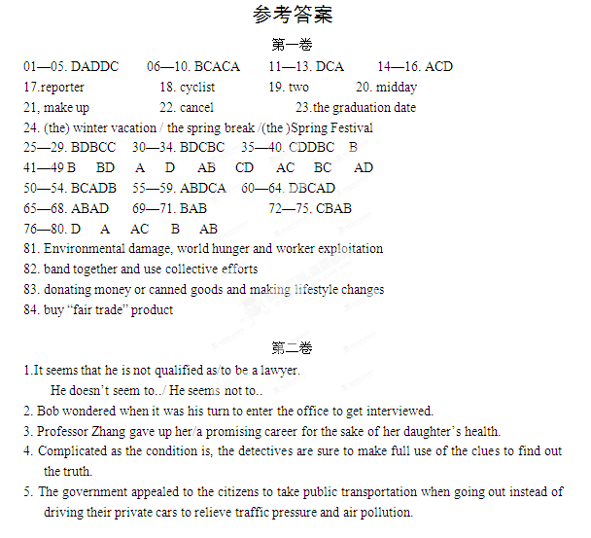
Listening Comprehension
Section A
- M: I had no idea there were so many preparations to make for Christmas.
W: Yes, mother began shopping for Christmas before December even arrived.
Q: When did mother start to prepare for Christmas? (D)
- M: Could you tell me where the director’s office is?
W: I happen to be on my way there to meet my uncle and I’ll guide you.
Q: Who is the man looking for?(A)
- M: Is it true that you can’t take this medicine?
W: Yes, it works well, but the side effects are really strong.
Q: Why doesn’t the woman use the medicine?(D)
- M: Juana, I am awfully sorry. I didn’t mean to hurt you. Shall we have a beer and forget the whole thing?
W: OK, we can drop it this time. But don’t do it again.
Q: What do we learn from the conversation?(D)
- M: Laura seems a little down today. Do you know why?
W: Greg accused her of stealing his money. But we know she is innocent.
Q: What happened to Laura?(C)
- W: Why are you wearing a jacket? It’s so warm today?
M: You never know what the weather will be like on the mountain.
Q: What are the two speakers probably going to do?(B)
- W: John, are you doing research for Professor Williams this semester?
M: Actually, I am working as his teaching assistant?
Q: What does the man mean? ( C )
- M: I heard there are a few seats left for the show tonight.
W: Really? I was under the impression that the tickets were sold out a long time ago.
Q: What do we know from the woman’s reply?(A)
- M: Are you going to return to your present job after the vacation?
W: No, I plan to graduate next semester. That means I’ll have to be a full-time student.
Q: What will the woman do? (C )
- W: You seem very confident about the job interview, don’t you?
M: Yes, I feel ready for it. I bought a good suit and I had my hair cut. I had studied almost everything about fiancé and economics.
Q: Where is the man probably going to work? (A)

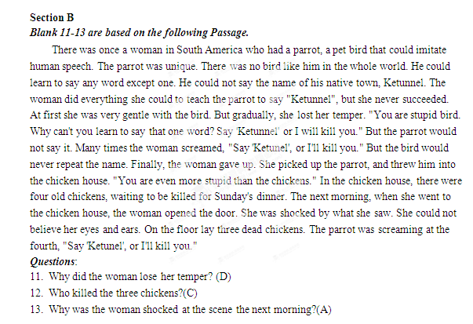
Blank 14-16 are based on the following speech.
Now it’s ten o’clock and time for a summary of the news. Schools where children are failing in reading and writing tests will publicly identified under new government plans. The government also plans to introduce six new tests including mathematics and science for all school children. Education minister David Camp said no schools should be afraid of being exposed. The main purpose is to inform parents and schools. They’ll have exact information and the students’ problems will be known.
A psychologist has found one in ten students fears injections, blood and injury so much that they run away from doctors. These young patients may miss out treatment. They are more likely to have fainted when they face with injections, blood and injury. The fear could disturb appropriate medical care.
Research has been done on kids who were making trouble all the time at school. They made the teachers’ life very difficult. Researchers found that many of those troublemakers were from divorced families. What they really want is the attention from parents and teachers. Once they could get attention from parents and teachers, those kids could be very appealing.
Questions:
- What is the main purpose of introducing the new tests?(A)
- Why do some young patients run away from doctors?(C)
- What is the last piece of news mainly about?(D)

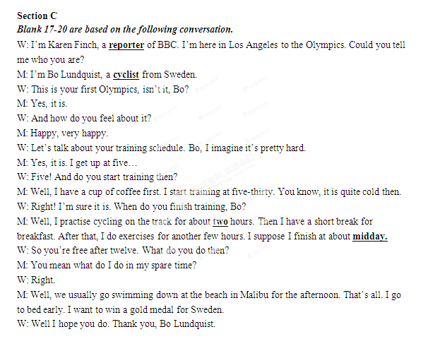
Blank 21-24 are based on the following conversation.
M: Cindy! Have you heard the news?
W: No, Steve. What do you mean?
M: You know all the classes we’ve missed because of the snow?
W: Uh oh…
M: Yup, we’re going to have to make them up and the dean says it will have to be during the spring break.
W: Steve! We have our vacation all set! What are we going to do? Do the others know?
M: I don’t know, but I certainly can’t afford to miss five days of classes this semester, with that week I was sick…
W: But I really don’t want to cancel our trip. All of us have already made our plane reservations!
M: I can try to call the travel agency; maybe they can refund our money. But before we do anything we need to speak with our professors.
W: You think they’ll excuse us from class?
M: Probably not. But I was talking to Kevin this morning and he said one of his professors told him that they could make up the class at a different time.
W: Wow---that’s great! Which professor was it?
M: I don’t know. But we’re going to have to speak to all of them anyway.
W: Why don’t they add extra days at the end of the semester before summer?
M: Because of the graduation date, which can’t be changed.
W: Are other colleges around here doing the same thing?
M: I would imagine so--- it’s been such a bad winter and we’ve missed so many classes. We do really need to make them up.
W: I know, I know. I was just really looking forward to this vacation. The idea of the sun and the beach!
M: Oh, look, there’s Professor Hampton right now!
W: Come on, let’s go talk to her!

