2013届（2012学年）上海市高三英语一模——作文题目

（长宁）
下图是一个孩子被父母送出国留学时的一幕。请针对图片反映的社会现象，谈谈你对此事的看法。你的作文必须包括：

- 描述图片内容
- 谈谈你的看法
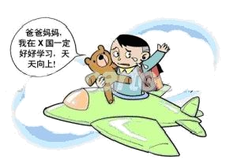

（闸北）
假如你是李华，你班拟策划在学校发起“为孤儿募捐日”（Fund-raising Day for Orphans)活动。
写ー篇此活动策划书。策划书的内容必须包括：
此项活动的意义；
此项活动的策划建议。
注：文中不得出现真实的个人信息

（杨浦）
最近中央电视台开展了以“你幸福吗？”为话题的调查，请根据你的经历或理解，谈谈你眼中的幸福是什么。

（徐汇）
假设你叫李华，你的同班同学小明觉得自己的手机太旧，想买个最新的Iphone5，可是他的父母不同意，为此他很苦恼。请你给他写封信，谈谈你的看法。
(注意：短文中不得出现考生姓名、校名及其他相关信息，否则不予评分。)

（松江）
随着生活节奏的不断加快，现代人所面临的压力越来越大，“减压”（to relieve pressure)成了人 们津津乐道的话题。调查表明：网上聊天(chatting online)、旅游(travelling)、读书(reading)、听

音乐(listening to music)等是最受人们欢迎的“减压”方式。请你结合自己的生活实际从中选择 两至三种你最喜欢的“减压”方式，并分别说说它们如何起到减压的效果。

（青浦）
请就教材中的《文学品读（A taste of literature）》板块，谈谈你的观点。你的作文必须包括：
=你是否认同高三（senior three）现阶段进行文学作品阅读赏析；
=你的理由。
（注：不能提到真实姓名和学校。）

（普陀）
假设你是王林，最近，你校英语老师在课堂上采用了现代化教学手段，带来了若干变化。请你根据下表所提供的信息，用英语给某报社写一封信，客观地介绍一下这些变化情况。

过 去 | 现 在
老师说，学生记，无思考余地 | 视、听、说齐全，积极思考
内容难懂，难记 | 化难为易，便于理解记忆
枯燥乏味，不感兴趣 | 生动活泼，乐于学习

（浦东）
请简要描述图片内容，并联系生活实际谈谈你的感想。
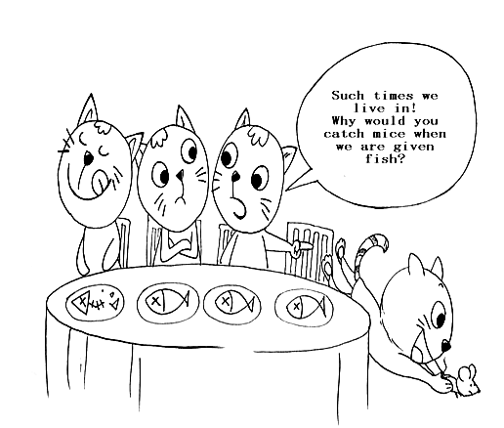

（闵行）
1．简要描述图片内容
2．简要分析造成这种现象的原因
3．简要谈谈你的想法
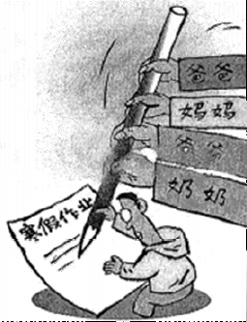

（静安）
假定你是李华，写信给好友张林。谈谈通过体育锻炼，你的体质有所增强。你的信必须包括 以下内容：
简要描述你在体育锻炼前的身体状况；
通过体育锻炼，你的体质是如何增强的；
简要分析一下产生这种变化的原因。

（金山）
你的表弟Jack即将踏入高中学习，你写信给他。信的内容应包括：
1． 简要描述你自己的高中学习生活。
2． 给他的高中生活提些建议。（建议可包括：规划好日常生活、找到适合自己的学习方法、多参加课外活动等……）

（嘉定）
我国部分省份己经开始了教科书的循环使用（recycling textbooks)，请就此用英文写一篇短文。内容主要包括：
1. 表明支持该做法；
2. 陈述自己的理由；
3. 提出用书应注意的事项。
（黄浦）
联系高三学习生活，详细描述一件令你印象最深刻的事
（文中请不要出现真实的校名和人名。）
Sample 1
Away flows time. There are so many unforgettable things in my school life which are worth mentioning. The most wonderful one, which I’ll remember for good is taking part in the English speech contest.
I used to be a shy boy who lacked confidence. At the beginning of the senior three year my best friend encouraged me to participate in the speech contest. Afraid of delivering an address on the stage, I declined. I, in the end, agreed as he insisted. He helped me practice my speech skills as well as gestures and standing position. My skills were improved, modestly but steadily.
Then came the day of the contest. Nervous as I was, I walked onto the stage, smile on face. With so many people seated in the hall, I felt anxious and my speech was not fluent at first. When I saw my friend listening attentively, I remembered the nights we spent together practicing speech. I was inspired and the speech flowed on successfully. The audience applauded with appreciation at the end of the speech while I happily found I was no longer the shy boy. It was the support from my friend that enabled me to gain confidence.
While life in senior three is occupied, wonderful things take place every day, the precious friendliness has left such a deep impression on my mind that I will never forget it. (231 words)
(9+9+4=23)

Sample 2
The thing that impressed most in grade 12 took place on a Sunday morning. That was when I took part in an English contest, in the final stage.
The contest was so difficult that I thought the only thing I could do was to wish myself good luck. The listening comprehension was unlike what I’d prepared for, so I just tried my best. But when I moved to the reading part, the situation got better. What I’d thought to be greek turned out to be just the combination of words I knew the meaning of. I felt a little bit happier. As to the writing, I had wanted to give it up and let my creation fly, but I surprisingly found that I had a lot to say about the topics. I even used the stories of a scientist I’d read about to support my idea! Then it was an oral exam. Although it was a contest, I still told the teachers exact what I had in mind. I didn’t have anything fancy to say, but the thoughts were genuine.
The result came and I won the third prize! At first I thought it was sheer luck, but then I realized that what I had learned helped a lot. I didn’t mean to prepare for it, but what I had done brought me what I deserved. Even though I’m no faced with the college entrance exam, I still know that what really matters is the process of learning. Do your job and the result won’t fail you! (257 words)
(8+8+4=20)

Sample 3
Do you have the fear of acting on the stage? Well, I do, at least before I was asked to perform at the school’s Arts Festival.
As the Arts Festival drew near, the teachers asked me to read an English poem, which made my heart jump. This would be a perfect chance to show my English talents, but not in front of the whole school! I was a shy boy that even freaked out when speaking in front of my class. As I strongly opposed to this kind offer, the teacher told me, “You’ll never know how things go unless you give it a try.”
Encouraged as I was, I repeated the poem in front of the mirror for countless times, being more confident every time. The day finally came and I was on the stage, sharing the beauty of English with the whole school. I managed to read the poem in an idiomatic accent without a single mistake and I wasn’t really that nervous as I thought I would be. I was filled with pride as the sound of applause rose in every corner of the auditorium.
Just as my teacher said, taking the first step toward the unknown is the greatest achievement, I will pump myself up for all the coming challenges in life and I will never forget my first step on the stage. (227 words)
(6+8+3=17)

Sample 4
The life of Senior 3 is like a chocolate having lots of tastes. My most impressive taste is the experiences of participating in the Physics Olympics.
The days that I spent preparing for the contest are full of depression and happiness. I enjoyed the moment when I worked out a difficult problem. My pals and I often argued about a ambiguous problem for a long time. However, the taste was terrible sometimes. I read the reference books till midnight and did a lot of exercises. I believed that my dream would come true if I worked hard enough.
To my disappointment, I failed to get the award. But I think the tears and experiences will become my most valuable wealth in the future. (123 words)
（7+7+2=16）

（虹口）
请认真观察下面的漫画，然后简要描述漫画内容，并根据你对该漫画的理解，谈谈自己的思考和看法。
参考词汇：缸：vat； 漏出来：leak out； 漏洞：loophole

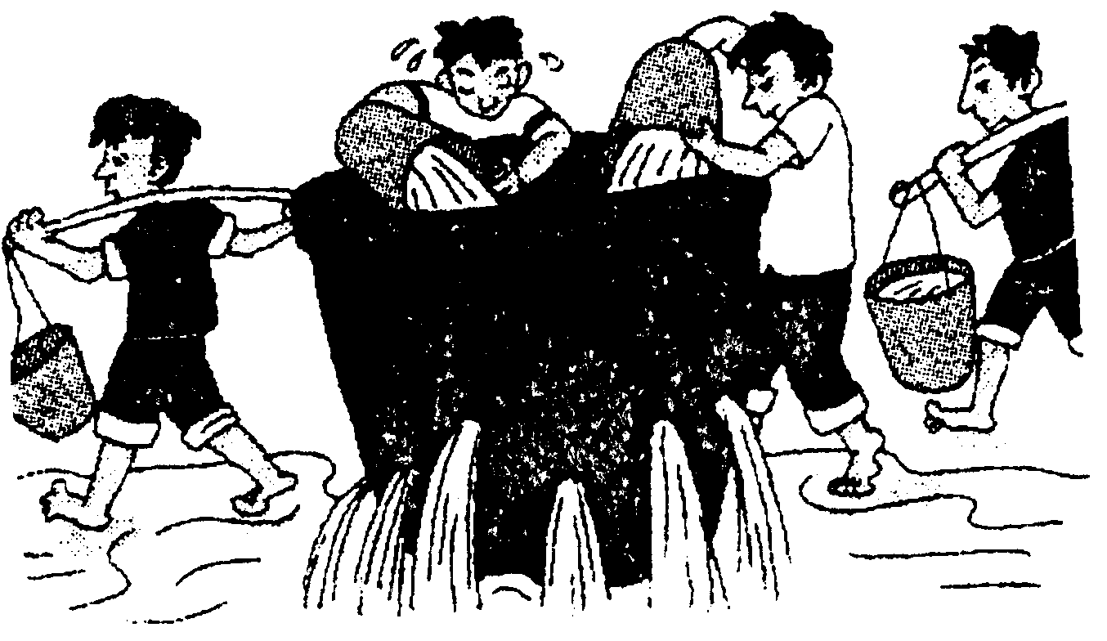

In the picture, four people are trying to fill a vat with water. Two men are carrying water while two others are pouring water into the vat. However, with so many loopholes at the bottom of the vat, they’ll never store any water, because no one tries to mend the holes.
It reminds me of the problems in our study. While studying, we always try to read more books and do more exercises. However, we seldom pay attention to the mistakes we’ve made, nor do we try to correct them. Therefore, “holes” are left. Day by day, the “holes”, or rather the shortages, become more and more. No matter how many books we’ve read, we have never mastered any knowledge. They have leaked out because of the hole.
So we should pay attention to the mistakes we’ve made and the holes we have in our study. Only in this way can we learn much knowledge and fill up our mind with it.

（奉贤）

假定你校将举行ー个成人仪式，你将作为代表在仪式上发言。请你按以下内容要点准备ー篇 英文发言稿。

1. 过去对成人的美好向往；
- 现在对成人的初步认识。
注意：1. 发言稿的开头与结束语已为你写好（不计入总词数）； 2. 文中不能出现真实的姓名、身份信息。

Good morning, everyone!

Thank you for listening.

（宝山）
下图是向阳中学高一（2）班上英语课时小组活动的一个场景，请根据图片写一篇报道（不要使用真实姓名和校名）。内容包括：
- 描述图片内容；
- 结合自己的经历简单谈谈你对课堂教学中小组活动的看法。
